Descriptive Statistics

Michael T. Haneline, DC, MPH

Descriptive statistics (DS) characterize the shape, central tendency, and variability of a set of data. When referring to a population, these characteristics are known as parameters; with sample data, they are referred to as statistics.

Data (plural) are the measurements or observations of a variable. A variable is a characteristic that can be observed or manipulated and can take on different values.

Below is an example study spreadsheet containing the kinds of data typically seen in chiropractic-related research:

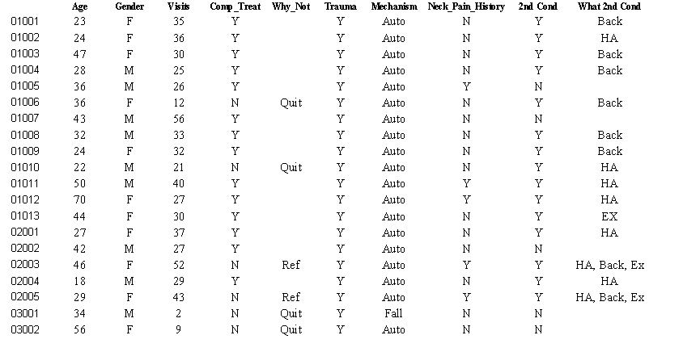
DS provide summaries about various aspects of a sample or a population and can be distinguished from inferential statistics (where hypotheses may be tested).

DS include measures of:
- Distribution - frequencies of the values of the observations
- Central tendency - define the middle of a distribution of values
- Dispersion - the spread of values around the central region of a distribution

For example, we could use DS to characterize the number of visits provided to patients in the following study:

Case # Total Visits
1 7
2 2
3 2
4 3
5 4
6 3
7 5
8 3
9 4
10 6
11 2
12 3
13 7
14 4

Distribution:
- Defined by the frequencies of each of the values. There are 3 – 2s, 4 – 3s, and so on . . .
2 – 3
3 – 4
4 – 3
5 – 1
6 – 1
7 – 2
- In addition to frequencies, the percentage of each of the values and cumulative percentages further help describe the data. This table is usually provided by statistical software packages.
Frequency Percent Cumulative %
2 – 3 21.4 21.4
3 – 4 28.6 50.0
4 – 3 21.4 71.4
5 – 1 7.1 78.5
6 – 1 7.1 85.6
7 – 2 14.3 100.0

- The ranges of values for a study are also frequently given in a research paper.
Lowest = 2
Highest = 7
- Histograms (a type of bar graph) are used to visually depict a frequency distribution. This type of graph merely utilizes bars to depict the same numbers generated in the above frequency distribution.

Histogram of the above hypothetical study:

The following table is produced by most statistical programs (from Microsoft Excel in this case):

Descriptive Statistics
Mean | 3.93
Standard Error | 0.46
Median | 3.50
Mode | 3.00
Standard Deviation | 1.73
Sample Variance | 3.00
Kurtosis | -0.54
Skewness | 0.75
Range | 5.00
Minimum | 2.00
Maximum | 7.00
Sum | 55.00
Count | 14.00

Measures of Central Tendency
- Mean
  - Most commonly used descriptive statistic (parameter)
  - Also known as the average
  - The mean is easily calculated by adding all values of a series of numbers, and then dividing by the number of elements.
- Mode
  - The most frequently occurring value
- Median
  - The number that divides a series in half when all elements are listed in order.

Formulas for calculating the mean ($\overline{X}$ refers to a sample and $μ$ refers to a population)
$\overline{X}=\frac{ΣX}{n}$
- Mean of a sample

$μ=\frac{ΣX}{N}$
- Mean of a population

The modal value is the one that occurs most frequently; 3 in this case, which occurs 4 times:
2 – 3
3 – 4
4 – 3
5 – 1
6 – 1
7 – 2

The median divides a series in half when all elements are listed in order. When there are an odd number of values, it’s merely the middle value. When there are an even number of values, count from each end of the series toward the middle and average the 2 middle values:

2 2 2 3 3 3 3 4 4 4 5 6 7 7

Median = (3 + 4)/2 = 7/2 = 3.5

A frequency distribution of most biological data would be symmetrical along the X-axis forming a bell-shaped curve. This is known as a normal curve and the associated data has a normal distribution. The theory of the normality of data is very important to hypothesis testing.

Normal curve

The normal distribution has defined properties with the mean, median and mode all being equal and at the middle of the normal curve. This divides the normal curve into equal halves that have similar properties.

X = Median = Mode
Symmetric

The data from our hypothetical study do not have similar$\overline{X}$, median, and mode, so the data are referred to as being skewed (lopsided distribution caused by extreme values).

Mode = 3
Median = 3.5
X = 3.93

This distribution is skewed to the right (skew is always to the direction of the longer tail)

When standard deviations are calculated for the following distributions, data that are more spread out will result in correspondingly higher SDs.
Narrow spread
= lower SD

Wider spread
= higher SD

Properties of the normal distribution:

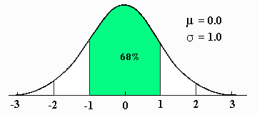
68% of scores will be
Properties of the normal curve: within ±1 s of the mean

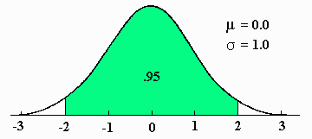
95% of scores will be
within ±2 s of the mean

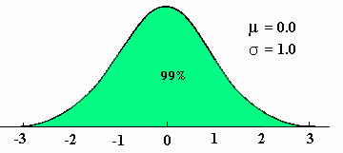
99% of scores will be
within ±3 s of the mean

Actually, it’s 68.26%,
95.44%, and 99.72%.

Using the properties of a normal distribution, we can make accurate statements about the underlying data. For instance, we can say something like: we are 95% confident that a certain value lies within 2 standard deviations of the mean or that we are 95% confident that 2 given values define the upper and lower limits of the interval (i.e., a 95% confidence interval).

Levels of Measurement

There are four levels of measurement, each one having specific rules for the operation and interpretation of associated data. Comprehending and applying these rules is imperative in deciding which mathematical operations are allowed and in determining which statistical test should be used.

- Nominal measurement –
  - AKA classificatory scale because individuals or objects are classified into categories
  - A code in the form of a number, name, or letter is assigned to each category
  - Examples
    - Male (may be coded as 0) and female (coded as 1)
    - Agree (0) disagree (1)
    - Hair color – blonde (0), brunette (1), red (2), black (3)
  - Counting of the categories is the only permissible mathematical operation (i.e., 25 males and 30 females).

- Ordinal measurement –
  - Includes categories, but they are rank-ordered
  - Examples
    - Lieutenant, captain, major, colonel, general
    - Normal, minimal, moderate, severe
  - Ordinal value only represents position of order, not quantity. Therefore, no mathematical operations are possible.

- Interval measurement –
  - Exhibit equal intervals between ordered measurements
  - Does not have a true zero
  - Examples
    - Fahrenheit scale – has zero, but does not signify the absence of heat
    - Height, weight, and age qualify as interval, but also qualify at a higher level of measurement . . . ratio.

- Ratio measurement –
  - There are equal intervals and a true zero
  - The most advanced level of measurement
  - Examples
    - Cervical range of motion
    - A patient’s capacity for lifting
  - Does a measurement qualify as being ratio?
    - Does a measurement of zero represent an absence of the characteristic being tested?
    - Do differences between consecutive measured numbers represent equal amounts of a characteristic?

Nominal
Ordinal
Interval
Ratio
The mnemonic NOIR can help you remember the order of these terms

When to use mean, median, or mode –

Measurement scale | Best measure of “middle”
Nominal | Mode
Ordinal | Median
Interval | Symmetrical – Mean  Skewed – Median
Ratio | Symmetrical – Mean  Skewed – Median

