Title: Trends in chiropractic care and physical rehabilitation use among adults with low back pain or back-related leg pain in the United States, 2002 to 2018

Supplemental Tables and Figures
Supplemental Table 1. Characteristics of 52644 adult participants reporting back-related leg pain in the prior 3 months in the National Health Interview Survey (NHIS), 2002 to 2018
Supplemental Table 2. Weighted frequencies and odds of nonpharmacologic treatment use among adults with back-related leg pain in the United States, 2002 to 2018.
Supplemental Figure 1. Flow diagram
Supplemental figure 2. Use of chiropractic care and OT/PT among adults with low back pain, stratified by sociodemographic characteristics, from 2002 to 2018
Panel a. Age (18-44, 45-64, and >65) for chiropractic care and OT/PT use
Panel b. Sex (male, female) for chiropractic care and OT/PT use
Panel c. Race (White, Black, Native American, Asian, Other), for chiropractic care and OT/PT use
Panel d. Ethnicity (Hispanic, non-Hispanic), for chiropractic care and OT/PT use

Supplemental Table 1. Characteristics of 52644 adult participants reporting back-related leg pain in the prior 3 months in the National Health Interview Survey (NHIS), 2002 to 2018
Characteristic | Unweighted  n | Weighted  %
Survey year
2002 | 2735 | 4.7 (4.5-4.9)
2003 | 2920 | 5.3 (5.0-5.5)
2004 | 3091 | 5.5 (5.2-5.7)
2005 | 3129 | 5.4 (5.1-5.6)
2006 | 2369 | 5.6 (5.3-5.9)
2007 | 2043 | 4.9 (4.6-5.2)
2008 | 2039 | 5.0 (4.7-5.3)
2009 | 2652 | 5.5 (5.2-5.8)
2010 | 2959 | 6.0 (5.7-6.2)
2011 | 3810 | 6.7 (6.4-7.0)
2012 | 3610 | 5.9 (5.6-6.1)
2013 | 3870 | 6.5 (6.3-6.8)
2014 | 3913 | 6.0 (5.8-6.3)
2015 | 3970 | 6.9 (6.6-7.2)
2016 | 3807 | 6.7 (6.4-7.1)
2017 | 2772 | 6.2 (5.8-6.6)
2018 | 2955 | 7.3 (6.9-7.7)
Age groups
18-24 | 1489 | 3.0 (2.8-3.1)
25-34 | 5319 | 10.1 (9.8-10.5)
35-44 | 8210 | 15.4 (15.0-15.8)
45-54 | 11408 | 21.8 (21.3-22.2)
55-64 | 12141 | 23.0 (22.6-23.5)
65-74 | 7937 | 14.8 (14.4-15.2)
75+ | 6140 | 11.9 (11.5-12.3)
Sex
Male | 20031 | 39.0 (38.5-39.5)
Female | 32613 | 61.0 (60.5-61.5)
Race
White | 41469 | 82.2 (81.7-82.8)
Black | 8368 | 13.4 (12.9-13.9)
American Indian/Native Alaskan | 815 | 1.4 (1.3-1.6)
Asian/Pacific Islander | 1557 | 2.4 (2.2-2.5)
Other | 435 | 0.6 (0.5-0.7)
Ethnicity
Non-Hispanic | 44104 | 88.3 (87.8-88.8)
Hispanic | 8540 | 11.7 (11.2-12.2)
Educational level
No degree | 12210 | 21.0 (20.5-21.5)
GED or high school diploma | 15393 | 29.8 (29.3-30.3)
Some College | 16329 | 31.9 (31.4-32.4)
College degree or higher | 8417 | 17.3 (16.9-17.8)
Income
Below poverty threshold | 13059 | 22.8 (22.3-23.3)
1 to 2 times above threshold | 13414 | 24.8 (24.4-25.3)
>2 to 5 times above threshold | 18131 | 35.7 (35.1-36.2)
>5 times above threshold | 8040 | 16.7 (16.2-17.2)
Census region
Northeast | 8807 | 17.3 (16.7-17.9)
Midwest | 10807 | 22.7 (22.0-23.4)
South | 20462 | 39.2 (38.3-40.0)
West | 12568 | 20.8 (20.1-21.5)
Citizenship
Citizen | 49441 | 95.5 (95.3-95.7)
Non-Citizen | 3133 | 4.5 (4.3-4.7)
Nativity
US native | 44429 | 87.2 (86.8-87.7)
Born outside of US | 8179 | 12.8 (12.3-13.2)
Insurance coverage
no insurance | 7343 | 13.2 (12.8-13.6)
Public insurance only | 20525 | 37.3 (36.7-37.9)
Private insurance only | 17255 | 34.7 (34.2-35.3)
Public and Private insurance | 7402 | 14.7 (14.4-15.1)
Chiropractic care
No | 43649 | 82.4 (82.0-82.8)
Yes | 8983 | 17.6 (17.2-18.0)
OT/PT
No | 41201 | 77.8 (77.3-78.2)
Yes | 11412 | 22.2 (21.8-22.7)
Chiropractic care or OT/PT
No | 35112 | 65.7 (65.2-66.2)
Yes | 17532 | 34.3 (33.8-34.8)

Supplemental Table 2. Weighted frequencies and odds of nonpharmacologic treatment use among adults with back-related leg pain in the United States, 2002 to 2018
 | Chiropractic use |  |  | OT/PT use |  |  | Chiropractic or OT/PT use
Characteristic | % (95% CI) | OR (95% CI) |  | % (95% CI) | OR (95% CI) |  | % (95% CI) | OR (95% CI)
Survey year
2002 | 18.2 (16.7-19.7) | Ref |  | 20.1 (18.3-21.9) | Ref |  | 33.1 (31.2-35.0) | Ref
2003 | 18.8 (17.1-20.4) | 1.04 (0.89-1.21) |  | 21.4 (19.7-23.1) | 1.08 (0.93-1.25) |  | 34.8 (32.8-36.8) | 1.08 (0.96-1.22)
2004 | 19.2 (17.8-20.6) | 1.07 (0.93-1.23) |  | 22.1 (20.6-23.7) | 1.13 (0.97-1.31) |  | 35.7 (33.8-37.5) | 1.12 (1.00-1.26)
2005 | 18.0 (16.3-19.6) | 0.99 (0.85-1.15) |  | 21.9 (20.2-23.6) | 1.11 (0.97-1.28) |  | 34.2 (32.3-36.2) | 1.05 (0.93-1.19)
2006 | 17.5 (15.8-19.1) | 0.95 (0.81-1.11) |  | 21.3 (19.6-23.1) | 1.08 (0.93-1.25) |  | 33.8 (31.7-35.9) | 1.03 (0.91-1.18)
2007 | 16.7 (14.9-18.5) | 0.90 (0.76-1.07) |  | 21.0 (18.9-23.2) | 1.06 (0.89-1.26) |  | 33.5 (30.9-36.0) | 1.02 (0.88-1.18)
2008 | 17.2 (15.4-19.0) | 0.93 (0.79-1.11) |  | 21.4 (19.3-23.5) | 1.08 (0.91-1.28) |  | 34.0 (31.6-36.4) | 1.04 (0.90-1.20)
2009 | 19.3 (17.6-21.1) | 1.1 (0.92-1.26) |  | 21.9 (20.0-23.9) | 1.12 (0.95-1.31) |  | 35.3 (33.0-37.6) | 1.10 (0.96-1.27)
2010 | 16.7 (15.3-18.0) | 0.90 (0.78-1.04) |  | 22.1 (20.5-23.8) | 1.13 (0.97-1.31) |  | 33.2 (31.5-35.0) | 1.01 (0.89-1.14)
2011 | 16.9 (15.6-18.2) | 0.91 (0.79-1.05) |  | 20.6 (19.2-22.1) | 1.03 (0.90-1.19) |  | 32.3 (30.5-34.1) | 0.97 (0.85-1.09)
2012 | 16.5 (15.1-17.9) | 0.89 (0.77-1.03) |  | 19.3 (17.9-20.8) | 0.95 (0.82-1.10) |  | 31.1 (29.4-32.8) | 0.91 (0.81-1.03)
2013 | 17.4 (16.0-18.8) | 0.95 (0.82-1.10) |  | 22.0 (20.5-23.5) | 1.12 (0.97-1.29) |  | 34.4 (32.6-36.2) | 1.06 (0.94-1.20)
2014 | 16.6 (15.2-18.0) | 0.89 (0.77-1.05) |  | 23.7 (22.0-25.4) | 1.23 (1.07-1.43) |  | 33.9 (32.1-35.8) | 1.04 (0.92-1.17)
2015 | 16.7 (15.3-18.2) | 0.90 (0.78-1.05) |  | 22.0 (20.4-23.6) | 1.12 (0.97-1.29) |  | 33.0 (31.2-34.8) | 1.00 (0.88-1.13)
2016 | 18.2 (16.6-19.7) | 1.00 (0.86-1.16) |  | 23.5 (21.8-25.1) | 1.22 (1.05-1.41) |  | 35.0 (33.2-36.8) | 1.09 (0.97-1.23)
2017 | 18.0 (16.4-19.6) | 0.99 (0.85-1.15) |  | 25.7 (24.0-27.4) | 1.37 (1.19-1.58) |  | 37.6 (35.7-39.5) | 1.22 (1.08-1.38)
2018 | 17.5 (16.0-19.0 | 0.95 (0.82-1.11) |  | 26.1 (24.3-27.8) | 1.40 (1.21-1.62) |  | 37.5 (35.6-39.5) | 1.22 (1.08-1.38)
Age groups
18-24 | 21.8 (19.2-24.3) | 1.01 (0.87-1.19) |  | 14.9 (12.9-16.9) | 0.71 (0.60-0.84) |  | 30.8 (28.0-33.6) | 0.81 (0.71-0.94)
25-34 | 22.4 (21.1-23.7) | 1.05 (0.95-1.16) |  | 18.2 (17.0-19.4) | 0.90 (0.81-1.00) |  | 33.7 (32.1-35.2) | 0.93 (0.85-1.01)
35-44 | 21.6 (20.5-22.6) | Ref |  | 19.9 (18.9-20.9) | Ref |  | 35.4 (34.1-36.6) | Ref
45-54 | 17.7 (16.9-18.5) | 0.78 (0.72-0.85) |  | 20.6 (19.8-21.4) | 1.05 (0.96-1.14) |  | 33.3 (32.3-34.3) | 0.91 (0.85-0.98)
55-64 | 16.3 (15.6-17.1) | 0.71 (0.65-0.77) |  | 23.5 (22.6-24.3) | 1.23 (1.14-1.34) |  | 34.2 (33.3-35.2) | 0.95 (0.89-1.02)
65-74 | 15.5 (14.6-16.4) | 0.67 (0.61-0.73) |  | 25.8 (24.6-26.9) | 1.40 (1.28-1.52) |  | 35.9 (34.6-37.1) | 1.02 (0.95-1.10)
75+ | 12.0 (10.9-13.0) | 0.50 (0.44-0.55) |  | 26.8 (25.5-28.2) | 1.48 (1.34-1.62) |  | 34.5 (33.0-35.9) | 0.96 (0.88-1.05)
Sex
Male | 18.2 (17.6-18.9) | Ref |  | 21.2 (20.5-21.8) | Ref |  | 33.9 (33.1-34.6) | Ref
Female | 17.1 (16.6-17.7) | 0.93 (0.88-0.98) |  | 22.9 (22.4-23.5) | 1.11 (1.05-1.16) |  | 34.6 (33.9-35.2) | 1.03 (0.99-1.08)
Race
White | 18.5 (18.1-19.0) | Ref |  | 22.2 (21.7-22.7) | Ref |  | 35.2 (34.6-35.8) | Ref
Black | 12.2 (11.3-13.1) | 0.61 (0.56-0.67) |  | 23.4 (22.4-24.4) | 1.07 (1.01-1.14) |  | 29.8 (28.6-30.9) | 0.78 (0.73-0.83)
American Indian/Native Alaskan | 16.2 (13.0-19.4) | 0.85 (0.67-1.08) |  | 17.1 (14.1-20.1) | 0.73 (0.59-0.90) |  | 29.7 (26.1-33.4) | 0.78 (0.65-0.93)
Asian/Pacific Islander | 16.0 (14.0-18.1) | 0.84 (0.72-0.98) |  | 19.5 (17.2-21.8) | 0.85 (0.73-0.99) |  | 30.4 (27.8-33.0) | 0.80 (0.71-0.91)
Other | 18.8 (14.2-23.3) | 1.02 (0.75-1.37) |  | 27.5 (21.8-33.2) | 1.33 (1.00-1.77) |  | 37.9 (32.0-43.8) | 1.12 (0.88-1.44)
Ethnicity
Not Hispanic | 17.9 (17.5-18.3) | Ref |  | 22.8 (22.3-23.2) | Ref |  | 35.2 (34.6-35.8) | Ref
Hispanic | 15.0 (14.0-15.9) | 0.81 (0.75-0.87) |  | 18.3 (17.3-19.3) | 0.76 (0.71-0.82) |  | 27.5 (26.4-28.7) | 0.70 (0.66-0.74)
Educational level
No degree | 11.5 (10.9-12.2) | 0.68 (0.63-0.74) |  | 16.4 (15.7-17.2) | 0.76 (0.71-0.82) |  | 24.4 (23.6-25.3) | 0.69 (0.65-0.74)
GED or high school diploma | 16.1 (15.4-16.7) | Ref |  | 20.5 (19.7-21.3) | Ref |  | 31.9 (31.0-32.8) | Ref
Some College | 19.9 (19.2-20.6) | 1.31 (1.22-1.40) |  | 24.2 (23.5-25.0) | 1.24 (1.16-1.32) |  | 38.0 (37.1-38.8) | 1.31 (1.24-1.38)
College degree or higher | 23.4 (22.3-24.4) | 1.60 (1.48-1.72) |  | 28.7 (27.5-29.8) | 1.56 (1.45-1.67) |  | 44.0 (42.8-45.2) | 1.68 (1.58-1.79)
Income
Below poverty threshold | 11.4 (10.7-12.1) | 0.49 (0.45-0.53) |  | 20.7 (19.9-21.6) | 0.87 (0.81-0.94) |  | 27.5 (26.6-28.4) | 0.63 (0.59-0.67)
1-2 times above threshold | 13.9 (13.1-14.6) | 0.61 (0.57-0.66) |  | 20.2 (19.4-21.1) | 0.85 (0.79-0.91) |  | 29.9 (29.0-30.9) | 0.71 (0.67-0.75)
>2 to 5 times above threshold | 20.9 (20.2-21.6) | Ref |  | 23.1 (22.3-23.9) | Ref |  | 37.6 (36.7-38.5) | Ref
>5 times above threshold | 25.5 (24.3-26.7) | 1.30 (1.20-1.40) |  | 25.7 (24.4-27.0) | 1.15 (1.06-1.25) |  | 43.1 (41.8-44.3) | 1.26 (1.18-1.34)
Census region
South | 13.7 (13.1-14.3) | Ref |  | 19.6 (19.0-20.3) | Ref |  | 29.0 (28.2-29.7) | Ref
Northeast | 19.3 (18.3-20.3) | 1.51 (1.39-1.63) |  | 25.2 (24.0-26.3) | 1.38 (1.28-1.48) |  | 37.8 (36.5-39.0) | 1.49 (1.39-1.59)
West | 19.8 (18.9-20.6) | 1.55 (1.44-1.67) |  | 23.2 (22.2-24.2) | 1.24 (1.16-1.33) |  | 36.9 (35.9-38.0) | 1.44 (1.35-1.52)
Midwest | 21.0 (20.0-21.9) | 1.67 (1.55-1.81) |  | 23.6 (22.7-24.5) | 1.27 (1.19-1.35) |  | 38.5 (37.4-39.6) | 1.54 (1.45-1.63)
Citizenship
U.S. Citizen | 17.7 (17.3-18.1) | Ref |  | 22.7 (22.2-23.1) | Ref |  | 34.9 (34.3-35.4) | Ref
Non-Citizen | 14.5 (13.1-16.0) | 0.79 (0.70-0.90) |  | 13.2 (11.8-14.7) | 0.52 (0.46-0.59) |  | 22.4 (20.7-24.2) | 0.54 (0.49-0.60)
Nativity
US native | 17.9 (17.4-18.3) | Ref |  | 22.6 (22.1-23.1) | Ref |  | 35.1 (34.5-35.7) | Ref
Born outside of US | 15.5 (14.6-16.5) | 0.85 (0.78-0.92) |  | 19.8 (18.7-20.8) | 0.84 (0.79-0.90) |  | 28.9 (27.7-30.0) | 0.75 (0.71-0.80)
Insurance coverage
No insurance | 14.1 (13.2-15.1) | 0.49 (0.45-0.53) |  | 10.3 (9.4-11.1) | 0.42 (0.38-0.46) |  | 21.3 (20.2-22.4) | 0.41 (0.38-0.44)
Public insurance only | 12.0 (11.5-12.6) | 0.41 (0.38-0.43) |  | 24.7 (24.0-25.4) | 1.20 (1.13-1.27) |  | 31.9 (31.2-32.7) | 0.71 (0.68-0.75)
Private insurance only | 25.2 (24.4-25.9) | Ref |  | 21.6 (20.8-22.3) | Ref |  | 39.8 (38.9-40.6) | Ref
Public and private insurance | 16.9 (15.8-17.9) | 0.60 (0.55-0.66) |  | 28.3 (27.1-29.6) | 1.44 (1.34-1.55) |  | 39.3 (38.0-40.7) | 0.98 (0.92-1.05)
Ref: Reference group, when reporting odds ratios, the reference group is 1.00

Supplemental Figure 1. Flow diagram
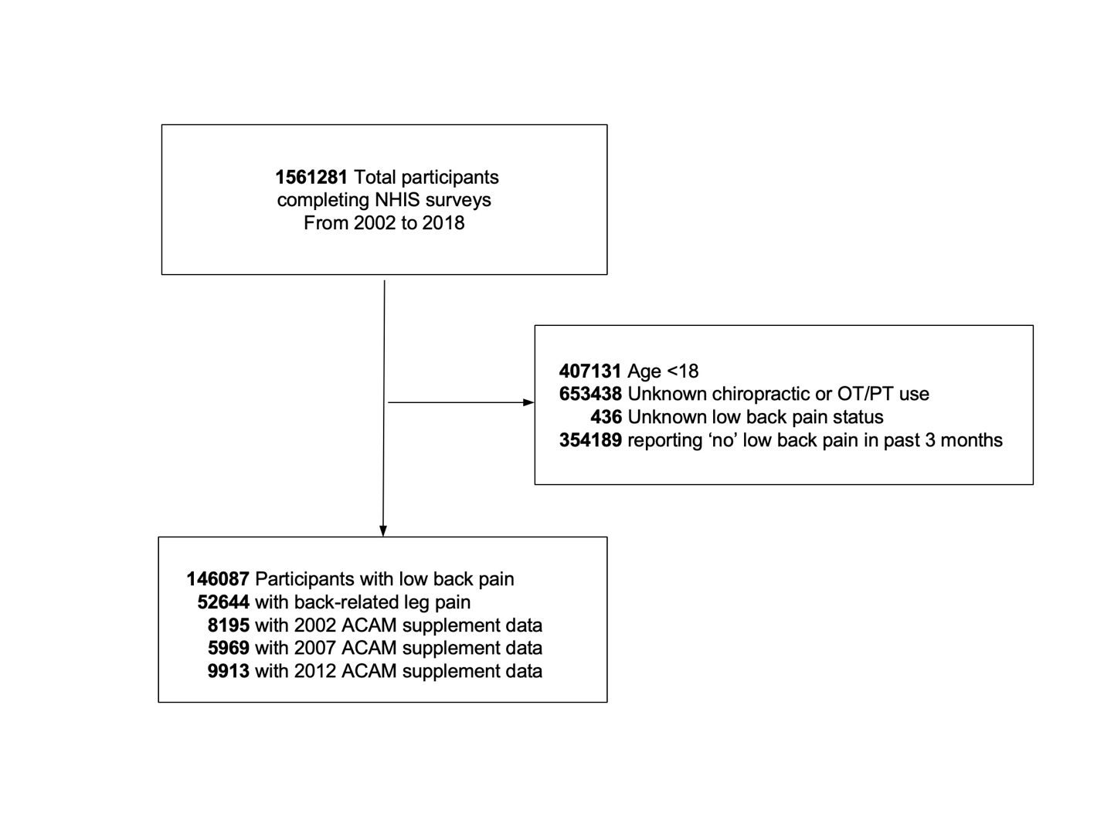

Supplemental Figure 2a. Age (years 18-44, 45-64, and >65)

Figure 2b. Sex (male, female)

Figure 2c. Race (White, Black, Native American, Asian)

Figure 2d. Ethnicity (Hispanic, non-Hispanic)

