Supplemental Material 1:
Search strategy:

#1 food*[tiab] OR whole grain*[tiab] OR refined grain*[tiab] OR cereal*[tiab] OR pasta*[tiab] OR rice*[tiab] OR potato*[tiab] OR vegetable*[tiab] OR fruit*[tiab] OR nut*[tiab] OR legume*[tiab] OR bean*[tiab] OR egg*[tiab] OR dairy[tiab] OR dairies[tiab] OR milk[tiab] OR yogurt[tiab] OR cheese[tiab] OR fish[tiab] OR seafood[tiab] OR meat[tiab] OR processed meat[tiab] OR sugar sweetened beverage*[tiab]
#2 mortality[tiab] OR death[tiab]
#3 prospective OR cohort OR longitudinal OR follow-up OR case-cohort OR nested case-control
#4 (#1 AND #2 AND #3)

Supplemental Table 1:
Food group | Amount
Refined grains/whole grains | 30 grams
Vegetables/fruits | 80 grams
Nuts | 28 grams
Legumes | 100 grams
Eggs | 55 grams
Dairy | 200 grams
Fish | 100 grams
Red meat | 85 grams
Processed meat | 30 grams
Sugar sweetened beverages | 250 ml/grams
Conversion of 1 serving in grams

Supplemental Table 2: General study characteristics of the included studies investigating the association between whole grain intake and risk of all-cause mortality;
Author | Year | Country | Cohort name | Age at entry | Sex | Sample size | Total cases | Dietary assessment | Outcome assessment | Type of whole grains | Adjustment factors | Follow up years | Results  (high vs. low intake category)  Risk Ratio (RR)
Boggs (24) | 2015 | United States | BWHS | 30-69 | Women | 37001 | 1678 | DASH score | National Registry | Whole grains | Age, each DASH  component, energy intake, education, marital status, vigorous exercise, television watching, smoking, and alcohol intake | 16 | 0.75 (0.64, 0.89)  1.44 vs. 0.3 servings/d
Buil-Cosiales  (25) | 2014 | Spain | PREDIMED | 55-75 | Both | 7216 | 425 | FFQ | National Registry | Whole grains | Age, sex, smoking, diabetes, BMI, baseline systolic and diastolic blood pressure, and intervention group and stratified by  recruitment centre, use of statins, alcohol intake, education, physical activity, and total energy intake, vegetable and fruit consumption | 5.9 | 0.92 (0.64, 1.44)  84 vs. 0 gram/d
Huang  (26) | 2015 | United States | NIH-AARP Diet and Health Study | 50-71 | Both | 367442 | 46067 | SFFQ | National Registry | Whole grains | Age, sex, the number of cigarettes smoked per day, time of smoking cessation, race or ethnicity group, alcohol intake, education level, marital status, health status, obesity, physical activity, consumption of red meat, total fruit and total vegetables, total energy intake, hormone usage, cereal fibre | 14 | 0.94 (0.90, 0.98)  1.2 vs. 0.13 servings/d
Jacobs  (40) | 2001 | Norway | 3 Norway cohorts | 35-56 | Both | 33848 | 335 | SFFQ | Mortality files maintained by Statistics Norway | Whole grain bread score | age, energy intake, and sex. smoking, past smoking, physical activity during leisure, physical activity during work, customary use of  cod liver oil, customary use of multivitamins, saturated fat intake, systolic blood pressure, serum total cholesterol, BMI | 11-17 | 0.75 (0.65, 0.88)  Highest vs. lowest quintile of whole grains bread score
Jacobs (27) | 2007 | United States | IWHS | 55-69 | Women | 27312 | 5552 | SFFQ | National Registry | Whole grains | Age, energy intake, BMI, waist-hip ratio, smoking, education, physical activity, oestrogen use, multivitamin supplement use, and intakes of alcohol, refined grain, coffee, red meat, fish and seafood, and total fruit and vegetables | 17 | 0.79 (0.72, 0.87)  3.65 vs. 0.25 servings/d
Johnsen (28) | 2015 | Scandinavia (Norway, Sweden, Denmark) | HELGA cohort | 30-64 | Both | 119518 | 7839 | SFFQ | National Registry | Whole grain products | Age, follow-up time, education, smoking intensity, alcohol, BMI, total energy intake  and alcohol intake, whole grain types | 11.9; 11.1; 14.2 | ♀:  0.68 (0.62, 0.75)  74 vs. 21 gram/d  ♂:  0.75 (0.68, 0.81)  80 vs. 20 gram/d
Key (29) | 1996 | United Kingdom | Vegetarian Society | 45.8 | Both | 10771 | 1343 | FFQ | Death certificates | Bran cereals | Age, sex, smoking | 16.8 | 0.94 (0.86, 1.03)  Daily vs. non daily
Liu (30) | 2003 | United States | PHS | 40-84 | Men | 86190 | 3114 | SFFQ | National Registry | Whole grain cereals | Age, smoking, alcohol, physical activity, BMI, history of type 2 diabetes, hypercholesterolemia and hypertension, multivitamins | 5.5 | 0.83 (0.73, 0.94)  38 vs. 1.93 gram/d
Roswall (31) | 2015 | Sweden | WLH | 29-49 | Women | 44961 | 1855 | SFFQ | National Registry | Whole grain bread | Age, smoking, education, BMI, alcohol, red meat , processed meat, energy intake, mutually for food items | 21.3 | 0.83 (0.76, 0.91)  ≥ median vs  < median
Sahyoun (32) | 2006 | United States | Massachusetts Study | 60-98 | Both | 535 | 165 | 3 day food records | National Registry/  death certificates | Whole grains | Age, sex, race, education, marital status, smoking exercise, BMI, energy intake, energy from saturated fatty acids, antihypertensive medication, lipid lowering medication | 13.5 | 0.82 (0.52, 1.28)  2.9 vs. 0.31 servings/d
Steffen  (33) | 2003 | United States | ARIC | 45-64 | Both | 11940 | 867 | SFFQ | National Registry | Whole grains | Age, race, sex, and time-dependent energy intake, education, smoking, physical activity, alcohol, hormone replacement therapy, BMI, waist-to-hip ratio, systolic blood pressure, antihypertensive medications | 11 | 0.77 (0.61, 0.97)  3 vs. 0.1 servings/d
Tognon (39) | 2011 | Sweden | Gerontological and  Geriatric Population Studies in Gothenburg | 70 | Both | 1037 | 630 | Diet history | NA | Whole grains | Gender, BMI, waist circumference, physical activity, martial status, smoking, birth cohort, education | 8.5 | 0.85 (0.73, 1.00)  High vs. low intake
Tognon  (38) | 2012 | Sweden | Vasterbotten Intervention Program | 30-70 | Both | 77151 | 2376 | FFQ | National Registry | Whole grains | NA | 10 | 0.97 (0.89, 1.06)  High vs. low intake
van den Brandt  (34) | 2011 | Netherlands | NLCS | 55-69 | Both | 3579 | 9691 | SFFQ | National Registry | Whole grains | Age, smoking, BMI, physical activity, history of hypertension, education, energy intake | 10 | ♂:  1.01 (0.99, 1.02)  Per interquartile range  ♀:  1.00 (0.98, 1.03)  Per interquartile range
Vormund (35) | 2015 | Switzerland | Swiss MONICA | ≥16 | Both | 17861 | 3953 | 24-h recall  checklist | National Registry | Whole grains | Age, sex, and survey wave, marital status, smoking, BMI, region and nationality, mutually adjusted | 21.4 | 0.96 (0.89, 1.03)  Yes vs. no
Wang (36) | 2016 | China | Linxian NIT | 40-69 | Both | 2445 | 1501 | FFQ | Doctor visits/ Hospital records reviews/ National registry | Whole grains | Age, sex, commune, smoking, drinking, season, BMI | 26 | 0.98 (0.93, 1.05)  Per times/d
Wu (37) | 2015 | United States | NHS | 30-55 | Women | 74341 | 15106 | FFQ | National Registry | Whole grains | Age, ethnicity, BMI, smoking, alcohol, physical activity, family history of diabetes, cancer and heart disease, multivitamin use, aspirin use at least once per week, history of hypertension, high cholesterol, or diabetes at baseline, energy intake, modified alternative healthy eating index, which did not include whole grains, postmenopausal status, postmenopausal hormone use | 26 | 0.88 (0.84, 0.92)  33 vs. 4.2 gram/d
Wu (37) | 2015 | United States | HPHS | 32-87 | Men | 43744 | 11814 | FFQ | National Registry | Whole grains | Age, ethnicity, smoking, alcohol intake, physical activity, family history of diabetes, cancer and heart disease, multivitamin use, aspirin use at least once per week, history of hypertension, high cholesterol, or diabetes at baseline, energy intake, modified alternative healthy eating index, which did not include whole grains | 24 | 0.95 (0.89, 1.01)  47.8 vs. 5.9 gram/d
Yu (23) | 2015 | United States | SCCS | 40-79 | Both | 77572 | 6906 | FFQ | National Registry | Whole grains | Age, race, enrolment source, income, marital status, medical insurance, smoking, physical activity, sitting time, energy intake, BMI, menopausal status, hormone therapy, disease status, education, standardized Healthy Eating Index score without whole grains | 6.2 | 0.94 (0.92, 0.96)  Per 1 standard deviation increase

ARIC, Atherosclerosis Risk in Communities Study; BMI, Body Mass Index; BWHS, Black Women’s Health Study; DASH, Dietary approaches to Stop Hypertension; FFQ, Food frequency questionnaire; HPHS, Health Professional Follow-up study; IWHS, Iowa Women’s Health Study; NHS, Nurses’ Health Study; NIH-AARP, National Institutes of Health-American Association of Retired Persons; NIT, Nutrition Intervention Trial; NLCS, Netherlands Cohort Study; MONICA, Multinational MONItoring of trends and determinants in CArdiovascular disease; NA, not applicable; PREDIMED, PREvention with MEDiterranean Diet; PHS, Physician Health Study; SCCS, Southern Community Cohort Study; SFFQ, semiquantitative food frequency questionnaire; WLH, The Swedish Women's Lifestyle and Health cohort

Supplemental Table 3: General study characteristics of the included studies investigating the association between refined grains intake and risk of all-cause mortality;
Author | Year | Country | Cohort name | Age at entry | Sex | Sample size | Total cases | Dietary assessment | Outcome assessment | Type of refined grains | Adjustment factors | Follow up years | Results  (high vs. low intake category)  Risk Ratio (RR)
Jacobs (27) | 2007 | United States | IWHS | 55-69 | Women | 27312 | 5552 | SFFQ | National Registry | Refined grains | Age, energy intake, BMI, waist-hip ratio, smoking, education, physical activity, oestrogen use, multivitamin use, alcohol, refined grain, coffee, red meat, fish and seafood, and total fruit and vegetables | 11 | 1.01 (0.91, 1.12)  3.78 vs. 0.41 servings/d
Liu (30) | 2003 | United States | PHS | 40-84 | Men | 86190 | 3114 | SFFQ | National Registry | Refined grains | Age, smoking, alcohol intake, physical activity, BMI, history of type 2 diabetes, high  cholesterol, and hypertension, and use of multivitamins | 5.5 | 1.09 (0.95, 1.25)  ≥1 vs. 0.06 servings/d
Sahyoun (32) | 2006 | United States | Massachusetts Study | 60-98 | Both | 535 | 166 | 3 day food records | National Registry/ death certificates | Refined grains | Age, sex, race, educational, marital status, smoking, exercise, BMI,  calories, energy from saturated fatty acids, use of antihypertensive medication, and use of lipid lowering medication | 13.5 | NA  6.1 vs. 1.6 servings/d
Steffen (33) | 2003 | United States | ARIC | 45-64 | Both | 11940 | 867 | SFFQ | National Registry | Refined grains | Age, race, sex, and time-dependent energy intake, education, smoking, physical activity, alcohol intake, hormone replacement in women, BMI, waist-to-hip ratio, systolic blood pressure, antihypertensive medications | 11 | 1.08 (0.83, 1.41)  5 vs. 0.5 servings/d
Wang (36) | 2016 | China | Linxian NIT | 40-69 | Both | 2445 | 1501 | FFQ | Doctor visits/ Hospital records reviews/National registry | Refined grains | Age, sex, commune, smoking, drinking, season, BMI | 26 | 0.96 (0.92, 1.00)  Per times/d
ARIC, Atherosclerosis Risk in Communities Study; BMI, Body Mass Index; FFQ, Food frequency questionnaire; IWHS, Iowa Women’s Health Study; NIT, Nutrition Intervention Trial; PHS, Physician Health Study; SFFQ, semiquantitative food frequency questionnaire;

Supplemental Table 4: General study characteristics of the included studies investigating the association between vegetable intake and risk of all-cause mortality;
Author | Year | Country | Cohort name | Age at entry | Sex | Sample size | Total cases | Dietary assessment | Outcome assessment | Type of vegetables | Adjustment factors | Follow up years | Results  (high vs. low intake category)  Risk Ratio (RR)
Akbaraly (41) | 2011 | United Kingdom | Whitehall II | 39-63 | Both | 7319 | 534 | SFFQ | National Registry | Vegetables | Age, ethnicity, occupational grade, marital status, smoking, energy intake, physical activity, BMI categories, | 18 | 1.06 (0.96, 1.17)  Per 1 standard deviation
Atkins (63) | 2014 | United Kingdom | British Regional Heart Study | 60-79 | Men | 3269 | 933 | FFQ | National Registry | Vegetables | Age, energy intake, smoking, alcohol, physical activity, social class, BMI, and a modified version of the HDI/EDI score not containing the individual component of interest. | 11.3 | 1.05 (0.7, 1.58)  Score 4 vs. 1
Boggs (24) | 2015 | United States | BWHS | 30-69 | Women | 37001 | 1678 | DASH score | National Registry | Vegetables | Age, each DASH  component, energy intake, education, marital status, vigorous exercise, television watching, smoking, alcohol | 16 | 1.04 (0.86, 1.26)  3.28 vs. 0.28 servings/d
Buil-Cosiales (25) | 2014 | Spain | PREDIMED | 55-75 | Both | 7216 | 425 | FFQ | National Registry | Vegetables | Age, sex, smoking, diabetes, BMI, baseline systolic and diastolic arterial blood pressures, and intervention group and stratified by  recruitment centre, use of statins, alcohol, education, physical activity, energy intake, fruit and whole-grain consumption | 5.9 | 0.77 (0.55, 1.08)  503 vs. 178 g/d
Fraser (42) | 1997 | United States | AHS | 45.8 | Both | 34198 (Caucasian)  1668 (African Americans) | 1387 (Caucasian)  153 (African Americans) | SFFQ | Death records | Cooked green vegetables,  salads | Age, Smoking, physical activity | 9 | Caucasian:  Green salad: 0.91 (0.78, 1.05)  0.14 vs. ≥ 1 servings/d  African Americans:  cooked green vegetables:  0.7 (0.4, 1.1)  0.2 vs. ≥ 1 servings/d  salads:  0.7 (0.4, 1.1)  0.2 vs. ≥ 1 servings/d  tomatoes  0.7 (0.4, 1.1)  0.64 vs. 0.93 servings/d
Genkinger (43) | 2004 | United States | CLUE | 30-93 | Both | 6151 | 919 | FFQ | Death certificates | Cruciferous vegetables | Age, smoking, BMI, cholesterol concentration, energy intake | 13 | 0.78 (0.64, 0.95)  0.03 vs. 0.53 servings/d
Hays (44) | 2005 | United States | Duke EPESE | ≥65 | Men White | 1921 | 559 | Simple questions | Death certificates and National registry | Vegetables | Age, living alone, poverty, smoking, alcohol, cognitive status, and self-rated health | 4 | 0.71 (0.51, 0.99)  ≥2 vs. <2 servings/d
Hjartaker (45) | 2015 | Norway | Norwegian study | 58 | Men | 9964 | 9160 | FFQ | National Registry | Vegetables | Body Mass Index, physical activity, beer, spirits, coffee, socio-economic  status and total  smoking, fruit, berries | 20.3 | 1.00 (0.93, 1.08)  36.8 vs. 6 times/month
Key (29) | 1996 | United Kingdom | Vegetarian Society | 45.8 | Both | 10771 | 1343 | FFQ | Death certificates | Raw salad | Age, sex, smoking | 16.8 | 0.91 (0.82, 1.02)  Daily vs. non daily
Knekt (66) | 1996 | Finland | Mobile clinic study | 30-69 | Both | 5133 | 1360 | Diet history | Death register | Vegetables | Age, smoking, serum cholesterol, hypertension, BMI | 14 | 0.88 (0.73, 1.06)  Quartile 4 vs. 1
Knoops (46) | 2006 | Europe | HALE | 54 | Both | 3117 | 1382 | Dietary history | Hospital registers | Vegetables | Age, gender, physical activity, smoking, alcohol use, number of years of education, BMI, chronic disease at baseline and study centre | 10 | 0.99 (0.90, 1.09)  ≥median vs. <median
Kouris-Blazos (47) | 1999 | Australia | Melbourne cohort | >70 | both | 330 | 38 | SFFQ | Death certificates | Vegetables | Age, energy intake, sex, smoking, ethnicity | 5 | 1.02 (0.99, 1.05)  Per 20g/d
Kurotani (48) | 2016 | Japan | JPHC | 45-75 | Both | 79594 | 10183 | FFQ | Death certificates | Vegetable dishes | Age, sex, public health centre area, BMI, smoking, physical activity, history of: hypertension, diabetes, dyslipidaemia, coffee, green tea, occupation | 14.9 | 0.98 (0.97, 0.99)  1 point increment in score
Leenders (49) | 2013 | Europe | EPIC | 25-70 | Both | 451151 | 25682 | Country-specific instruments | National Registry | Vegetables | smoking, alcohol, BMI, physical activity, education,  and processed meat consumption, fruit | 12.8 | 0.90 (0.86, 0.94)  546 vs. 54 gram/d
Limongi (64) | 2016 | Italy | ILSA | 65-84 | Both | 5632 | 655 | SFFQ | Death certificates | Vegetables | Age, sex, myocardial infarction, diabetes mellitus, disability in at least one activity of daily livings, BMI, score at the Geriatric Depression Scale, score at the Mini Metal State Examination, model adjusted for all components of the Mediterranean diet score | 8 | 0.94 (0.69, 1.29)  >median vs. ≤median
Martinez-Gonzalez (50) | 2012 | Spain | SUN project | 38 (mean age) | Both | 15535 | 125 | SFFQ | National Registry | Vegetables | Age, years of university of education, BMI, smoking, physical activity, television watching, history  of depression, baseline: hypertension, hypercholesterolemia, energy intake, egg consumption, potato consumption, and adoption of special diets, all the other items in the Mediterranean Diet Score | 6.8 | 0.79 (0.53, 1.17)  ≥503 vs. <503 gram/d
Nagura (51) | 2009 | Japan | Japan Collaborative Cohort Study | 40-79 | Both | 59485 | 7606 | FFQ | Death certificates | Vegetables | Age, sex, BMI, smoking, alcohol, walking, hours of sleep, education, perceived mental stress, cholesterol intake, saturated fat, n-3 fatty acids intake, sodium, and histories of hypertension and diabetes, fruit and bean intakes | 13 | 1.03 (0.96, 1.11)  5.2 vs. 1.2 servings/d
Nguyen (52) | 2016 | Australia | Sax's Institute's 45 and Up Study | ≥45 | Both | 150969 | 6038 | Simple questions | National Registry | Vegetables | Age, sex, education level, marital status, location of residence, socio-economic status, smoking, physical activity,  multi-vitamin use, processed meat, diabetes, BMI | 6.2 | 0.93 (0.87, 0.99)  7.83 vs. 1.65 servings/d
Olsen (53) | 2011 | Denmark | The Diet, Cancer and Health | 50-64 | Both | 50290 | 4126 | SFFQ | National registry | Cabbages, root vegetables | Age, time under study, smoking, alcohol, education, physical activity, BMI, red meat, processed meat, energy intake, healthy Nordic foods | 12 | 0.92 (0.87, 0.97)  ≥16/29 vs. <16/29 gram/d
Oyebode (54) | 2014 | United Kingdom | HSE | ≥35 | Both | 65226 | 4399 | 24h recall | National Registry | Vegetables | Age, sex, social class, smoking, BMI, physical activity, education, alcohol intake, excluding deaths within a year, fruits | 7.7 | 0.68 (0.58, 0.80)  3.45 vs. 0.45 servings/d
Prinelli (65) | 2015 | Italy | NA | 40-74 | Both | 1693 | 193 | FFQ | National Registry | Vegetables | Age, sex, education, BMI, physical activity, smoking, time spent TV watching, energy intake | 20 | 0.93 (0.68, 1.27)  >median vs. ≤median
Roswall (31) | 2015 | Sweden | WLH | 29-49 | Women | 44961 | 1855 | SFFQ | National Registry | Cabbages,  root vegetables | Age, smoking, education, BMI, alcohol, red meat, processed meat, energy intake, mutually for food items | 21.3 | 0.99 (0.92, 1.07)  ≥8/10 vs. <8/10 gram/d
Sahyoun (55) | 1996 | United States | Massachusetts Nutrition Status Survey | ≥60 | Both | 725 | 217 | 3 day food record | National Registry/ death certificates | Vegetables | Age, sex, disease status, and disabilities affecting shopping, citrus fruit/juices | 10.5 | 0.49 (0.31, 0.77)  Quintile 5 vs. quintile 1
Shi (56) | 2015 | China | CLHLS | ≥80 | Both | 8949 | 6626 | FFQ interview for current and previous | Interview with a close family member | Vegetables | Age, gender, job before 60 years of age, residence, smoking, alcohol, physical activity, number of chronic diseases, fruit, vegetable | 4.3 | 0.74 (0.66, 0.83)  Daily vs. never
Stefler (57) | 2015 | Eastern Europe | HAPIEE | 57 | Both | 19333 | 1314 | SFFQ | National Registry | Vegetables | Age, sex, cohort, alcohol, smoking, education, household amenities score, marital status, energy intake, physical activity, vitamin supplement , HDI (without F&V component), fruit intake | 7.1 | 0.85 (0.72, 1.00)  371 vs. 119 gram/d
Strandhagen (58) | 2000 | Sweden | Men born in 1913 | 54 | Men | 730 | 390 | FFQ | Death certificates | Vegetables | Smoking, hypertension, cholesterol | 26 | 0.88 (0.54, 1.43)  6.5 vs. 0.5 times/d
Tognon (39) | 2011 | Sweden | Gerontolo-gical and  Geriatric Population Studies in Gothenburg | 70 | Both | 1037 | 630 | Diet history | NA | Vegetables | Gender, BMI, waist circumference, physical activity, marital status, smoking, birth cohort, education | 8.5 | 1.06 (0.90, 1.25)  High vs. low intake
Tognon (38) | 2012 | Sweden | Vasterbotten Intervention Program | 30-70 | Both | 77151 | 2376 | FFQ | National Registry | Vegetables | NA | 10 | 0.94 (0.87, 1.02)  High vs. low intake
Tognon (59) | 2014 | Denmark | Danish MONICA project | 30-60 | Both | 1849 | 553 | 7 day food record | National Registry | Vegetables | Sex, BMI, education, physical activity, smoking | 11 | 0.81 (0.68, 0.96)  ≥192 vs. <192 gram/d
Tucker (60) | 2005 | United States | BLSA | 34-80 | Men | 501 | 306 | 7 day food record | Death certificates | Vegetables | Age, energy intake, BMI, smoking, alcohol use, physical activity score and supplement use, saturated fat, secular trend | 18 | 0.94 (0.85, 1.04)  Per serving/d
van den Brandt (34) | 2011 | Netherlands | NLCS | 55-69 | Both | 3576 | 9691 | SFFQ | National Registry | Vegetables | Age, smoking, BMI, no occupational physical activity, history of hypertension, education, energy intake | 10 | 0.90 (0.85, 0.95)  Per interquartile range
Vormund (35) | 2015 | Switzerland | Swiss MONICA | ≥16 | Both | 17861 | 3953 | 24-h recall  checklist | National Registry | Vegetables | Age, sex  and survey wave; marital status, smoking, BMI, region and nationality, mutually adjusted | 21.4 | 0.99 (0.92, 1.07)  Yes vs. no
Wang (36) | 2016 | China | Linxian NIT | 40-69 | Both | 2445 | 1501 | FFQ | Doctor visits/ Hospital records reviews/ National registry | Vegetables | Age, sex, commune, smoking, drinking, season and BMI | 26 | 0.98 (0.95, 1.01)  Per times/d
Whiteman (61) | 1999 | United Kingdom | OXCHECK | 35-64 | Both | 10171 | 478 | FFQ | Death certificates | Green vegetables/salad | Age, Sex, Smoking | 9 | 0.68 (0.56, 0.83)  5.5 vs. 1.45 servings/d
Yu (23) | 2015 | United States | SCCS | 40-79 | Both | 77572 | 6906 | FFQ | National Registry | Vegetables | Age, Race, enrolment source, income, marital status, medical insurance, smoking, physical activity, sitting time, energy intake, BMI, menopausal status, hormone therapy, disease status, education, standardized HEI score without dairy | 6.2 | 1.00 (0.94, 1.06)  Per standard deviation increase
Zhang (62) | 2011 | China | SWHS | 40-70 | Women | 73360 | 3442 | SFFQ | National Registry | Vegetables | Age, education, occupation, family income, smoking, alcohol consumption, BMI, physical activity, multivitamin supplement, energy intake, saturated fat, menopausal status and hormone therapy use, and history of coronary heart disease, stroke, hypertension, or diabetes | 10.2 | 0.91 (0.81, 1.02)  506 vs. 124 gram/d
Zhang (62) | 2011 | China | SMHS | 40-74 | Men | 61436 | 1951 | SFFQ | National Registry | Vegetables | Age, education, occupation, family income, smoking, alcohol, BMI, physical activity, multivitamin supplement, energy intake, saturated fat, menopausal status and hormone therapy use, and history of coronary heart disease, stroke, hypertension, or diabetes | 4.6 | 0.75 (0.65, 0.87)  583 vs. 144 gram/d

AHS, Adventist Health Study; BLSA, The Baltimore Longitudinal Study of Aging; BWHS, Black Women’s Health Study; CLHLS, The Chinese Longitudinal Healthy Longevity Survey; CLUE, Give Us a Clue to Cancer and Heart Disease; EPESE, EPESE, Established Population for Epidemiologic Studies of the Elderly; EPIC, European Prospective Investigation Into Cancer and Nutrition; FFQ, Food frequency questionnaire; HALE, Healthy Ageing: a Longitudinal study in Europe; HAPIEE: The Health, Alcohol and Psychosocial Factors in Eastern Europe; HSE, Health Survey for England; ILSA, Italian Longitudinal Study of Aging; JPHC; Japan Public Health Center-based Prospective Study; MONICA, Multinational MONItoring of trends and determinants in CArdiovascular disease; NA, not applicable; NLCS, Netherlands Cohort Study; NIT, Nutrition Intervention Trial; SFFQ, semiquantitative food frequency questionnaire; PREDIMED, PREvention with MEDiterranean Diet; SCCS, Southern Community Cohort Study; SMHS, Shanghai Men’s Health Study; SUN, Seguimiento University of Navarra; SWHS, Shanghai Women’s Health Study; WLH, The Swedish Women's Lifestyle and Health cohort

Supplemental Table 5: General study characteristics of the included studies investigating the association between fruit intake and risk of all-cause mortality;
Author | Year | Country | Cohort name | Age at entry | Sex | Sample size | Total cases | Dietary assessment | Outcome assessment | Type of fruits | Adjustment factors | Follow up years | Results  (high vs. low intake category)  Risk Ratio (RR)
Akbaraly (41) | 2011 | United Kingdom | Whitehall II | 39-63 | Both | 7319 | 534 | SFFQ | National Registry | Fruits | Age, ethnicity, occupational grade, marital status, smoking, energy intake, physical activity, BMI | 18 | 1.02 (0.92, 1.13)  Per 1 standard deviation
Atkins (63) | 2014 | Great Britain | British Regional Heart Study | 60-79 | Men | 3269 | 933 | FFQ | National Registry | Fruits | Age, energy intake, smoking, alcohol, physical activity, social class, BMI, and a modified version of the HDI/EDI score not containing the individual component of interest | 11.3 | 0.86 (0.66, 1.12)  Score 4 vs. 1
Boggs (24) | 2015 | United States | BWHS | 30-69 | Women | 37001 | 1678 | DASH score | National Registry | Fruits | Age, each DASH  component, energy intake, education, marital status, physical activity, television watching, smoking, alcohol intake | 16 | 1.06 (0.89, 1.26)  3.43 vs. 0.22 servings/d
Buil-Cosiales (25) | 2014 | Spain | PREDIMED | 55-75 | Both | 7216 | 425 | FFQ | National Registry | Fruits | Age, sex, smoking, diabetes, BMI, baseline systolic and diastolic arterial blood pressures, and intervention group and stratified by  recruitment centre, use of statins, alcohol, educational, physical activity, energy intake, fruit and whole-grain consumption | 5.9 | 0.59 (0.42, 0.83)  613 vs. 153 gram/d
Fraser (42) | 1997 | United States | AHS | 45.8 | Both | 34198 (Caucasian)  1668 (African Americans) | 1387 (Caucasian)  153 (African Americans) | SFFQ | Death records | Fruits | Age, Smoking, physical activity | 12  (Caucasian)  9 (African Americans) | Caucasian:  0.93 (0.76, 1.15)  >2 vs. 0.06servings/d  African Americans:  0.6 (0.4, 0.9)  >2 vs. 0.06servings/d
Hjartaker (45) | 2015 | Norway | Norwegian study | 58 | Men | 9964 | 9160 | FFQ | National Registry | Fruits | BMI, physical activity, beer, spirits, coffee, socio-economic status, smoking, fruit, berries | 20.3 | 0.94 (0.88, 1.00)  79 vs. 11 gram/d
Hodgson (67) | 2016 | Australia | the Calcium  Intake Fracture Outcome Study | 75 | Women | 1456 | 607 | SFFQ | Death certificate | Fruits | Age, BMI, treatment codes, smoking, socioeconomic status, history of: diabetes CVD, cancer; hypertensive medications, cholesterol lowering medications, low-dose aspirin, physical activity, energy intake, alcohol intake | 5 | 0.93 (0.86, 1.00)  Per 129 gram/d
Key (29) | 1996 | United Kingdom | Vegetarian Society | 45.8 | Both | 10771 | 1343 | FFQ | Death certificates | Fruits | Age, sex, smoking | 16.8 | 0.79 (0.70, 0.89)  Daily vs. non-daily
Knekt (66) | 1996 | Finland | Mobile clinic study | 30-69 | Both | 5133 | 1360 | Diet history | Death register | Fruits | Age, smoking, serum cholesterol, hypertension, BMI | 14 | 0.83(0.76, 0.91)  Quartile 4 vs. 1
Knoops (46) | 2006 | Europe | HALE | 54 | Both | 3117 | 1382 | dietary history method | Hospital registers | Fruits | Age, sex, physical activity, smoking, alcohol use, education, BMI, chronic disease at baseline and study centre | 10 | 0.86 (0.78, 0.95)  ≥median vs. <median
Kurotani (48) | 2016 | Japan | JPHC | 45-75 | Both | 79594 | 10183 | FFQ | Death certificates | Fruits | age, sex, public health centre area, BMI, smoking, physical activity, history of: hypertension, diabetes, dyslipidaemia; coffee, green tea, and occupation | 14.9 | 0.98 (0.97, 0.99)  1 point increment in score
Leenders (49) | 2013 | Europe | EPIC | 25-70 | Both | 451151 | 25682 | country-specific instruments | National Registry | Fruits | Smoking, alcohol, BMI, physical activity, education,  and processed meat consumption, fruit | 12.8 | 0.97 (0.93, 1.01)  663 vs. 53 gram/d
Limongi (64) | 2016 | Italy | ILSA | 65-84 | Both | 5632 | 655 | SFFQ | Death certificates | Fruits | Age, sex, myocardial infarction, diabetes mellitus, disability in at least one activity of daily livings, BMI, score at the Geriatric Depression Scale, score at the Mini Metal State Examination, model adjusted for all components of the Mediterranean diet score | 8 | 0.82 (0.47, 1.44)  >median vs. ≤median
Nagura (51) | 2009 | Japan | Japan Collaborative Cohort Study | 40-79 | Both | 59485 | 7606 | FFQ | death certificates | Fruits | Age, sex, BMI, smoking, alcohol, walking, hours of sleep, education, perceived mental stress, cholesterol intake, saturated fat, n-3 fatty acids intake, sodium, and histories of hypertension and diabetes, vegetable and bean intakes | 13 | 0.86 (0.80, 0.92)  5.9 vs. 0.9 servings/d
Nguyen (52) | 2016 | Australia | Sax's Institute's 45 and Up Study | ≥45 | Both | 150969 | 6038 | simple questions | National Registry | fruits | Age, sex, education level, marital status, location of residence, socio-economic status, smoking, physical activity,  multi-vitamin use, processed meat, diabetes, BMI | 6.2 | 0.84 (0.76, 0.93)  3.73 vs. 0 servings/d
Olsen (53) | 2011 | Denmark | The Diet, Cancer and Health | 50-64 | Both | 50290 | 4126 | SFFQ | National registry | Fruits | Age, time under study, smoking, time since cessation, alcohol, education, physical activity, BMI, red meat, processed meat, energy intake, healthy Nordic foods | 12 | 1.00 (0.94, 1.06)  ≥71/56 vs. <71/56
Oyebode (54) | 2014 | UK | HSE | ≥35 | Both | 65226 | 4399 | 24h recall | National Registry | Fruits | Age, sex, social class, smoking, BMI, physical activity, education, alcohol intake, excluding deaths within a year, vegetables | 7.7 | 0.87 (0.78, 0.97)  4.45 vs. 0.45 servings/d
Prinelli (65) | 2015 | Italy | NA | 40-74 | Both | 1693 | 193 | FFQ | National Registry | Fruits | Age, sex, education, BMI, physical activity, smoking, time spent TV watching, energy intake | 20 | 0.70 (0.51, 0.95)  >median vs. ≤median
Roswall (31) | 2015 | Sweden | WLH | 29-49 | Women | 44961 | 1855 | SFFQ | National Registry | apples/pears | Age, smoking, education, BMI, alcohol, red meat intake, processed meat intake, energy intake, mutually for food items | 21.3 | 0.88 (0.79, 0.98)  ≥35/17 vs. <35/17
Sahyoun (55) | 1996 | USA | Massachusetts Nutrition Status Survey | ≥60 | both | 725 | 217 | 3 day food record | National Registry/ death certificates | Fruits | age, sex, disease status, and disabilities affecting shopping, citrus fruit/juices | 10.5 | 0.84 (0.53, 1.33)  Quintile 5 vs. 1
Shi (56) | 2015 | China | CLHLS | ≥80 | Both | 8949 | 6626 | FFQ interview for current and previous | Interview with a close family member | Fruits | Age, sex, job before 60 years of age, residence, smoking, alcohol, physical activity, number of chronic diseases, vegetable | 4.3 | 0.85 (0.77, 0.94)  Daily vs. never
Stefler (57) | 2015 | Eastern Europe | HAPIEE | middleaged | Both | 19333 | 1314 | SFFQ | National Registry | Fruits | Age, sex, cohort, alcohol intake, smoking, education, household amenities  score, marital status, energy intake, physical activity, vitamin supplement intake, HDI (without F&V component), fruit intake | 7.1 | 0.99 (0.83, 1.18)  482 vs. 75 gram/d
Strandhagen (58) | 2000 | Sweden | Men born in 1913 | 54 | Men | 730 | 390 | FFQ | death certificates | Fruits | Smoking, Hypertension, cholesterol | 26 | 0.64 (0.42, 0.98)  6.5 vs. 0.5 servings/d
Tognon (39) | 2011 | Sweden | Gerontolo-gical and  Geriatric Population Studies in Gothenburg | 70 | Both | 1037 | 630 | Diet history | NA | Fruits | Gender, BMI, waist circumference, physical activity, marital status, smoking, birth cohort, education | 8.5 | 1.03 (0.87, 1.22)  High vs. low intake
Tognon (38) | 2012 | Sweden | Vasterbotten Intervention Program | 30-70 | Both | 77151 | 2376 | FFQ | National Registry | Fruits | NA | 10 | 0.90 (0.83, 0.98)  High vs. low intake
Tognon (59) | 2014 | Denmark | Danish MONICA project | 30-60 | both | 1849 | 553 | 7 day food record | National Registry | Fruits | Sex, BMI, education, physical activity, smoking | 11 | 0.74 (0.62, 0.88)  ≥median vs. <median
Tucker (60) | 2005 | United States | BLSA | 34-80 | Men | 501 | 306 | 7 day food record | Death certificates | Fruits | Age, energy intake, BMI, smoking, alcohol, physical activity score and supplement use, saturated fat, secular trend | 18 | 0.93 (0.84, 1.03)  Per servings increase
van den Brandt (34) | 2011 | Netherlands | NLCS | 55-69 | Both | 3576 | 9691 | SFFQ | National Registry | Fruits | Age, cigarette smoking, number of cigarettes smoked per day, years of smoking, BMI, no occupational physical activity, history of  hypertension, education, energy intake | 10 | 0.95 (0.89, 1.01)  Per interquartile range
Vormund (35) | 2015 | Switzerland | Swiss MONICA | ≥16 | Both | 17861 | 3953 | 24-h recall  checklist | National Registry | Fruits | Age, sex  and survey wave; marital status, smoking, BMI, region and nationality, mutually adjusted | 21.4 | 0.88 (0.81, 0.96)  ≥median vs. <median
Wang (36) | 2016 | China | Linxian NIT | 40-69 | Both | 2445 | 1501 | FFQ | Doctor visits/ Hospital records reviews /National registry | Fruits | Age, sex, commune, smoking, drinking, season, BMI | 26 | 0.99 (0.96, 1.02)  Per times/d
Whiteman (61) | 1999 | United Kingdom | OXCHECK | 35-64 | Both | 10171 | 478 | FFQ | Death certificates | Fruits | Age, sex, smoking | 9 | 0.84 (0.66, 1.07)  5.5 vs. 0.5 servings/d
Yu (23) | 2015 | United Kingdom | SCCS | 40-79 | Both | 77572 | 6906 | FFQ | National Registry | Fruits | Age, Race, enrolment source, income, marital status, medical insurance, smoking, physical activity, sitting time, energy intake, BMI, menopausal status, hormone therapy, disease status, education, standardized HEI score without dairy | 6.2 | 1.04 (1.01, 1.07)  per 1-standard deviation Increase
Zhang (62) | 2011 | China | SWHS | 40-70 | Women | 73360 | 3442 | SFFQ | National Registry | Fruits | Age, education, occupation, family income, smoking, alcohol, BMI, physical activity, multivitamin supplement use, energy intake, saturated fat, menopausal status and hormone therapy use, and history of coronary heart disease, stroke, hypertension, or diabetes | 10.2 | 0.81 (0.72, 0.91)  489 vs. 62 gram/d
Zhang (62) | 2011 | China | SMHS | 40-74 | Men | 61436 | 1951 | SFFQ | National Registry | Fruits | Age, education, occupation, family income, smoking, alcohol, BMI, physical activity, multivitamin supplement use, energy intake, saturated fat, menopausal status and hormone therapy use, and history of coronary heart disease, stroke, hypertension, or diabetes | 4.6 | 0.88 (0.75, 1.03)  308 vs. 14 gram/d

AHS, Adventist Health Study; BLSA, The Baltimore Longitudinal Study of Aging; BWHS, Black Women’s Health Study; CLHLS, The Chinese Longitudinal Healthy Longevity Survey; CLUE, Give Us a Clue to Cancer and Heart Disease; EPESE, EPESE, Established Population for Epidemiologic Studies of the Elderly; EPIC, European Prospective Investigation Into Cancer and Nutrition; FFQ, Food frequency questionnaire; HALE, Healthy Ageing: a Longitudinal study in Europe; HAPIEE: The Health, Alcohol and Psychosocial Factors in Eastern Europe; HPHS, Health Professional Follow-up study; HSE, Health Survey for England; ILSA, Italian Longitudinal Study of Aging; JPHC; Japan Public Health Center-based Prospective Study; MONICA, Multinational MONItoring of trends and determinants in CArdiovascular disease; NA, not applicable; NLCS, Netherlands Cohort Study; NIT, Nutrition Intervention Trial; NHS, Nurses Health Study; SFFQ, semiquantitative food frequency questionnaire; PREDIMED, PREvention with MEDiterranean Diet; SCCS, Southern Community Cohort Study; SMHS, Shanghai Men’s Health Study; SUN, Seguimiento University of Navarra; SWHS, Shanghai Women’s Health Study; WLH, The Swedish Women's Lifestyle and Health cohort

Supplemental Table 6: General study characteristics of the included studies investigating the association between nut intake and risk of all-cause mortality;

Author | Year | Country | Cohort name | Age at entry | Sex | Sample size | Total cases | Dietary assessment | Outcome assessment | Type of nuts | Adjustment factors | Follow-up years | Results  (high vs. low intake category)  Risk Ratio (RR)
Bao (68) | 2013 | United States | NHS | 30-55 | Women | 76464 | 16200 | SFFQ | National Registry | Nuts | Age, race, BMI, physical activity, smoking, multivitamin use, aspirin use, family history of diabetes mellitus, myocardial infarction, or cancer; history of diabetes mellitus, hypertension, or  hypercholesterolemia, energy intake, alcohol, red or processed meat, fruits, and vegetables, menopausal status and hormone use | 30 | 0.79 (0.68, 0.92)  7.5 vs. 0 servings/d
Bao (68) | 2013 | United States | HPFS | 32-87 | Men | 42498 | 11229 | SFFQ | National Registry | Nuts | Age, race, BMI, physical activity, smoking, multivitamin use, aspirin use, family history of diabetes mellitus, myocardial infarction, or cancer; history of diabetes mellitus, hypertension, or  hypercholesterolemia, energy intake, alcohol, red or processed meat, fruits, and vegetables | 24 | 0.80 (0.74, 0.87)  7.5 vs. 0 servings/d
Blomhoff (72) | 2006 | United States | IWHS | 55-69 | Women | 31778 | 5451 | FFQ | State Registry of Iowa | Nuts + peanut butter | Age, energy intake, BMI, waist/hip ratio, education, physical activity, use of oestrogens, multivitamin supplements, alcohol, of whole grain and refined grain, red meat, fish and seafood, and total fruit and vegetable | 15 | 0.89 (0.81, 0.98)  39 vs. 0 gram/d
Bonaccio (73) | 2015 | Italy | Moli-sani study | 50 | Both | 19386 | 334 | FFQ | National Registry | Nuts | Age, sex, education, smoking | 4.3 | 0.55 (0.33, 0.92)  10 vs. 0 times/month
Eslamparast (69) | 2016 | Iran | Golestan Cohort Study | 40-87 | Both | 49112 | 3981 | SFFQ | Death certificates | Nuts | Age, sex, BMI, education, place of residence, smoking, opium, alcohol, physical activity, wealth score, diabetes, hypertension, total energy intake, main food groups (fish, red meat, chicken, fruit, vegetable, dairy product, egg, and total fibre), magnesium,  zinc and copper | 7 | 0.71 (0.58, 0.87)  3.95 vs. 0 servings/d
Fernandez-Montero (74) | 2014 | Spain | The SUN project | 38 | Both | 17184 | 119 | SFFQ | National Registry | Nuts | Age, sex, Body Mass Index, smoking, alcohol intake, adherence the Mediterranean diet, use of special diets, marital status, baseline hypercholesterolemia,  hypertension, physical activity, length of television watching, baseline presence of cancer, cardiovascular disease, or diabetes | 5 | 0.44 (0.23, 0.84)  2.25 vs. 0.45 servings/d
Fraser (42) | 1997 | United States | AHS | 50 | Both | 1668 (American Africans)  34198 (Caucasian) | 153 (American Africans)  1387 (Caucasian) | SFFQ | Death records | Nuts | Age, Smoking, physical activity | 9 | American Africans: 0.6 (0.30, 1.00)  6.5 vs. 0.45 servings/wk  Caucasian: 0.82 (0.70, 0.96)  6.5 vs. 0.45 servings/wk
Gopinath (70) | 2015 | Australia | BMES | ≥ 49 | Both | 2893 | 1044 | SFFQ | National Registry | Nuts | Age, sex, qualifications, total diet score, BMI, smoking, alcohol, self-rated health, walking disability, presence of hypertension and/or diabetes, doctor-diagnosed history of cancer, angina, stroke and/or acute myocardial infarction | 15 | 0.93 (0.72, 1.20)  52 vs. 0.25 gram/d
Guasch Ferre (75) | 2013 | Spain | PREDIMED | 55-80 | Both | 7216 | 323 | SFFQ | yearly questionnaires and examinations to all participants, family physicians, yearly review of medical records, and linkage to the National Death Index | nuts | Age, sex, intervention group, BMI, smoking, education, history of diabetes/ hypercholesterolemia, use of oral antidiabetic medication, use of antihypertensive medication, use of statins, energy intake, | 4.8 | 0.61 (0.45, 0.83)  >3 vs. 0 servings/d
Hshieh (76) | 2015 | United States | PHS | 56 | Men | 20742 | 2732 | SFFQ | Medical records | Nuts | Age, BMI, alcohol, smoking, physical activity, energy intake, saturated fat, fruit/vegetable, red meat | 9.6 | 0.76 (0.64, 0.89)  24 vs 0.4 gram/d
Luu (71) | 2015 | United States | SCCS | 40-79 | Both | 71764 | 6256 | SFFQ | National Registry | Nut & peanut butter | Age, sex, race, education, occupation, household income, marital status, smoking, alcohol consumption, BMI, physical activity, vitamin supplement use, Charlson Comorbidity Index, metabolic conditions energy intake, red meat intake, chicken and duck intake, seafood intake, vegetable intake, and fruit intake | 5.4 | 0.79 (0.73, 0.86)  24 vs. 0.5 gram/d
Luu (71) | 2015 | China | SMHS/  SWHS | 40-74/40-70 | Both | 134265 | 8144 | FFQ | National Registry | Peanuts | Age, sex, race, education, occupation, household income, marital status, smoking, alcohol consumption, BMI, physical activity, vitamin supplement use, Charlson Comorbidity Index, metabolic conditions energy intake, red meat intake, chicken and duck intake, seafood intake, vegetable intake, and fruit intake | 6.5/12.2 | 0.83 (0.77, 0.88)  3 vs. 0 gram/d
Mann (77) | 1997 | United Kingdom | Vegetarian Society | 16-79 | Both | 10802 | 392 | SFFQ | Death certificates | Nuts | Age, sex, social class, smoking | 13.3 | 0.77 (0.58, 1.02)  6.5 vs. 0.45 servings/d
Sluik (78) | 2014 | Europe | EPIC | 35-70 | Both | 258911 | 12135 | Country-specific instruments | National Registry | Nuts and seeds | Age, sex, prevalence of heart disease, cancer or stroke, educational attainment, diabetes medication use, and the following when there were no exposure variables: alcohol consumption, smoking, physical activity and underlying dietary patterns | 9.9 | 0.75 (0.56, 1.00)  Per 5 gram/d
van den Brandt (79) | 2015 | Netherlands | NLCS | 55-69 | Both | 120852 | 8823 | SFFQ | National Registry | Nuts | age, sex, smoking, hypertension, diabetes, body height, BMI , non-occupational physical activity, education, intake of alcohol, vegetables and fruit , energy, use of nutritional supplements, and, in women, postmenopausal hormone replacement therapy. | 10 | 0.77 (0.66, 0.90)  Per interquartile range
Wang (36) | 2016 | China | Linxian NIT | 40-69 | Both | 2445 | 1501 | FFQ | Doctor visits/Hospital records reviews/National registry | nuts | Age, sex, commune, smoking, drinking, season and BMI | 26 | 0.99 (0.96, 1.02)  Per times/d
AHS, Adventist Health Study; BMES, The Blue Mountains Eye Study; BMI, Body Mass Index; EPIC, European Prospective Investigation Into Cancer and Nutrition; EPIC, European Prospective Investigation Into Cancer and Nutrition; FFQ, Food frequency questionnaire; HPHS, Health Professional Follow-up study; IWHS, Iowa Women’s Health Study; NA, not applicable; NHS, Nurses’ Health Study; NHS, Nurses’ Health Study; NLCS, Netherlands Cohort Study; NIT, Nutrition Intervention Trial; PREDIMED, PREvention with MEDiterranean Diet; PHS, Physician Health Study; SCCS, Southern Community Cohort Study; SFFQ, semiquantitative food frequency questionnaire; SMHS, Shanghai Men’s Health Study; SUN, Seguimiento University of Navarra; SWHS, Shanghai Women’s Health Study;

Supplemental Table 7: General study characteristics of the included studies investigating the association between legume intake and risk of all-cause mortality;

Author | Year | Country | Cohort name | Age at entry | Sex | Sample size | Total cases | Dietary assessment | Outcome assessment | Type of legumes | Adjustment factors | Follow-up years | Results  (high vs. low intake category)  Risk Ratio (RR)
Atkins (63) | 2014 | United Kingdom | British Regional Heart Study | 60-79 | Men | 3269 | 933 | FFQ | National Registry | Legumes | Age, energy intake, smoking, alcohol, physical activity, social class, BMI, and a modified version of the HDI/EDI score not containing the individual component of interest | 11.3 | 0.91 (0.74, 1.12)  Score 4 vs. 1
Bongard (80) | 2016 | France | MONICA | 45-64 | Men | 960 | 150 | 3 day food record | National Registry | Legumes | Age, centre, income, obesity alcohol, smoking, physical activity, chronic disease, diet score quality | 14.8 | 1.01 (0.68, 1.50)  Tertile 3 vs. tertile 1
Fraser (42) | 1997 | United States | AHS | 50 | Both | 1668 (American Africans)  34198 (Caucasian) | 153 (American Africans)  1387 (Caucasian) | SFFQ | Death records | Nuts | Age, smoking, physical activity | 9 | American Africans:  0.80 (0.50, 1.40)  2.5 vs. 0.45 servings/wk  Caucasian:  0.97 (0.84, 1.13)  3.5 vs. 0.45 servings/wk
Kouris-Blazos (47) | 1999 | Australia | Melbourne cohort | >70 | both | 330 | 38 | SFFQ | Death certificates | Legumes | Age, energy intake, sex, smoking, and ethnic origin | 5 | 0.98 (0.85, 1.13)  Per 20 gram/d
Martinez-Gonzalez (50) | 2012 | Spain | SUN project | 38 | Women | 9264 | 37 | SFFQ | National Registry | Legumes | Age, years of university of education, BMI, smoking, physical activity, television watching, history  of depression, baseline: hypertension, hypercholesterolemia, energy intake, egg, potato, adoption of special diets, all the other items in the Mediterranean Diet Score | 6.8 | 1.02 (0.67, 1.55)  ≥median vs. <median
Nagata (81) | 2002 | Japan | Takayama Study | ≥35 | Both | 29079 | 2062 | SFFQ | National registry | Soy products | Age, energy intake, marital status, BMI, smoking, alcohol, coffee, physical activity, history of hypertension, diabetes | 7 | 0.83 (0.73, 0.94)  166 vs. 39 gram/d
Nagura (51) | 2009 | Japan | Japan Collaborative Cohort Study | 40-79 | Both | 59485 | 7606 | FFQ | Death certificates | Beans | Age, sex, BMI, smoking, alcohol, walking, hours of sleep, education, perceived mental stress, cholesterol intake, saturated fat, n-3  fatty acids, sodium, history of: hypertension and diabetes, vegetable and fruit intakes | 13 | 0.92 (0.86, 0.98)  4.5 vs. 0.8 servings/d
Prinelli (65) | 2015 | Italy | NA | 40-74 | Both | 1693 | 193 | FFQ | National Registry | Legumes | Age, sex, education, BMI, physical activity, smoking, time spent TV watching, energy intake | 20 | 0.93 (0.68, 1.27)  >median vs. ≤median
Shi (56) | 2015 | China | CLHLS | ≥80 | Both | 8915 | 6626 | FFQ interview for current and previous | Interview with a close family member | Beans | Age, gender, job before 60 years of age, residence, smoking, alcohol, physical activity, number of chronic diseases, fruit, vegetable | 4.3 | 1.05 (0.96, 1.15)  Daily vs. never
Sluik (78) | 2014 | Europe | EPIC | 35-70 | Both | 258911 | 12135 | Country-specific instruments | National Registry | Legumes | Age, sex, prevalence of heart disease, cancer or stroke, education, diabetes medication use, and the following when there were no exposure variables: alcohol consumption, smoking behaviour, physical activity and  underlying dietary patterns | 10 | 1.15 (1.00, 1.32)  Per 10 gram/increase
Stefler (57) | 2015 | Eastern Europe | HAPIEE study | 57 | Both | 19333 | 1314 | SFFQ | National Registry | Legumes | Age, sex, cohort, education, marital  status, household amenities score, smoking, physical activity, energy intake and vitamin supplement | 7 | 0.95 (0.89, 1.01)  per one-point increase in the component score
Trichopoulou (84) | 2009 | Greece | EPIC-Greece | 20-86 | Both | 23349 | 1075 | FFQ | Physicians follow up | legumes | Age, sex, education, smoking, waist to hip ratio, BMI, physical activity, energy intake | 8.5 | 0.94 (0.83, 1.06)  ≥median vs. <median
van den Brandt (34) | 2011 | Netherlands | NLCS | 55-69 | Both | 3576 | 9691 | SFFQ | National Registry | Legumes | age, smoking, BMI, physical activity, history of  hypertension, education, energy intake | 10 | 1.00 (0.95, 1.05)  Per interquartile range
Wang (36) | 2016 | China | Linxian NIT | 40-69 | Both | 2445 | 1501 | FFQ | Doctor visits/ Hospital records reviews/ National registry | Beans | Age, sex, commune, smoking, drinking, season, BMI | 26 | 0.90 (0.81, 1.00)  Per times/d
Yamasaki (83) | 2014 | Japan | The Jichi Medical  School Cohort Study | 55 | Both | 12490 | 882 | FFQ | Death certificates | Soy | Age, smoking status, drinking status, BMI, education, hypertension, diabetes, high-density lipoprotein cholesterol, menopause | 11.8 | 1.32 (1.05, 1.66)  Highest vs. lowest intake category
Yu (82) | 2014 | China | SMHS | 40-74 | Men | 61239 | 2954 | SFFQ | National Registry | Beans | Age, education, income, smoking, alcohol, multivitamin, menopausal status and hormone therapy, physical activity, BMI, waist-to-hip ratio, history of cardiovascular disease, diabetes, or hypertension, energy intake | 6.5 | 0.94 (0.91, 0.97)  by 1 standard deviation score increase
Yu (72) | 2014 | China | SWHS | 40-74 | Women | 73216 | 4348 | SFFQ | National Registry | beans | Age, education, income, smoking, alcohol, multivitamin, menopausal status and hormone therapy, physical activity, BMI, waist-to-hip ratio, history of cardiovascular disease, diabetes, or hypertension, energy intake | 12 | 0.96 (0.93, 0.99)  by 1 standard deviation score increase

AHS, Adventist Health Study; BMI, Body Mass Index; CLHLS, The Chinese Longitudinal Healthy Longevity Survey; EPIC, European Prospective Investigation Into Cancer and Nutrition; FFQ, Food frequency questionnaire; HAPIEE: The Health, Alcohol and Psychosocial Factors in Eastern Europe MONICA, Multinational MONItoring of trends and determinants in CArdiovascular disease; NA, not applicable; NIT, Nutrition Intervention Trial; NLCS, Netherlands Cohort Study; SMHS, Shanghai Men’s Health Study; SUN, Seguimiento University of Navarra; SWHS, Shanghai Women’s Health Study;
Supplemental Table 8: General study characteristics of the included studies investigating the association between egg intake and risk of all-cause mortality;

Author | Year | Country | Cohort name | Age at entry | Sex | Sample size | Total cases | Dietary assessment | Outcome assessment | Type of eggs | Adjustment factors | Follow-up years | Results  (high vs. low intake category)  Risk Ratio (RR)
Bongard (80) | 2016 | France | MONICA | 45-64 | Men | 960 | 150 | 3 day food record | National Registry | Eggs | Age, centre, income, obesity alcohol, smoking, physical activity, chronic disease, diet score quality | 14.8 | 1.11 (0.70, 1.76)  Quartile 4 vs. 1
Djousse (87) | 2008 | United States | PHS I | 40-86 | Men | 21327 | 5169 | SFFQ | Death certificates | Eggs | Age, BMI, smoking, history of hypertension, alcohol, physical activity, breakfast cereal, vegetables, treatment arm, atrial fibrillation, diabetes, hypercholesterolemia, premature myocardial infarction | 20 | 1.23 (1.11, 1.36)  7.5 vs. 0.5 eggs/wk
Mann (77) | 1997 | United Kingdom | Vegetarian Society | 16-79 | Both | 10802 | 392 | SFFQ | Death certificates | Eggs | Age, sex, social class, smoking | 13.3 | 0.92 (0.68, 1.24)  >6 vs. 0.45 servings/wk
Nakamura (85) | 2004 | Japan | National Survey on Circulatory Disorders | ≥30 | Women | 9263 | 1202 | FFQ | National Registry | Eggs | Age, serum creatinine, cholesterol, blood glucose, BMI, systolic and diastolic blood pressure, drugs, smoking, alcohol | 14 | 1.08 (0.76, 1.53)  >2 vs 1 servings/d
Qureshi (86) | 2007 | United States | NHANES-I | 25-74 | Both | 9734 | 3177 | Nutritional questionnaire | Death certificates | Eggs | Age, sex, race/ ethnicity, systolic blood pressure, diabetes, serum cholesterol, smoking,  BMI, education | 20 | 1.00 (0.90, 1.11)  8.6 vs. 0.45 servings/wk
Shi (56) | 2015 | China | CLHLS | ≥80 | Both | 8892 | 6626 | FFQ interview for current and previous | Interview with a close family member | Eggs | Age, sex, job before 60 years of age, residence, smoking, alcohol, physical activity, number of chronic diseases, fruit, vegetable | 4.3 | 1.02 (0.94, 1.11)  Daily vs. never
Sluik (78) | 2014 | Europe | EPIC | 35-70 | Both | 258911 | 12135 | Country-specific instruments | National Registry | Eggs | Age, sex, prevalence of heart disease, cancer or stroke, educational attainment, diabetes medication use, and the following when there were no exposure variables: alcohol consumption, smoking behaviour, physical activity and  underlying dietary patterns | 9.9 | 1.09 (1.06, 1.12)  Per 10 gram/d
Wang (36) | 2016 | China | Linxian NIT | 40-69 | Both | 2445 | 1501 | FFQ | Doctor visits/ Hospital records reviews/ National registry | Eggs | Age, sex, commune, smoking, drinking, season and BMI | 26 | 1.01 (0.98, 1.04)  Per times/d

AHS, Adventist Health Study; BMI, Body Mass Index; MONICA, Multinational MONItoring of trends and determinants in CArdiovascular disease; CLHLS, The Chinese Longitudinal Healthy Longevity Survey; EPIC, European Prospective Investigation Into Cancer and Nutrition; FFQ, Food frequency questionnaire; NA, not applicable; NHANES, National Health and Nutrition Examination Survey; NIT, Nutrition Intervention Trial; PHS, Physician Health Study; SCCS, Southern Community Cohort Study;

Supplemental Table 9: General study characteristics of the included studies investigating the association between dairy intake and risk of all-cause mortality;
Author | Year | Country | Cohort name | Age at entry | Sex | Sample size | Total cases | Dietary assessment | Outcome assessment | Type of dairy | Adjustment factors | Follow-up years | Results  (high vs. low intake category)  Risk Ratio (RR)
Boggs (24) | 2015 | United States | BWHS | 30-69 | Women | 37001 | 1678 | DASH score | National Registry | Low fat dairy | age, each DASH  component, total energy intake, education, marital status, physical activity, television watching, smoking, and alcohol | 16 | 0.92 (0.79, 1.07)  1.43 vs. 0 servings/d
Bongard (80) | 2016 | France | MONICA | 45-64 | Men | 960 | 150 | 3 day food record | National Registry | Milk, yoghurt & cottage,  cheese | Age, centre, income, obesity alcohol, smoking, physical activity, chronic disease, diet score quality | 14.8 | 0.92 (0.71, 1.19)  Quartile 4 vs. 1
Bonthuis (88) | 2010 | Australia | Residents of Nambour | 25-78 | Both | 1529 | 177 | SFFQ | National Registry | Dairy | Age, Sex, energy intake, smoking, physical activity, BMI, alcohol, education, dietary supplement, b-carotene treatment, medical condition, calcium | 14.4 | 0.60 (0.29, 1.24)  599 vs. 174 gram/d
Elwood (89) | 2004 | United Kingdom | The Caerphilly Cohort | 45-59 | Men | 2403 | 811 | SFFQ | NA | Milk | Age, energy intake, smoking, systolic blood pressure, BMI, social class, alcohol, fat, prior CVD | 20-24 | 1.20 (0.80, 1.80)  1.2 vs. 0 pints/d
Fortes (90) | 1999 | Italy | Elderly house in Rome | ≥65 | Both | 162 | 53 | SFFQ | National Registry | Milk and yogurt | Age, sex, education, BMI, smoking, chronic diseases, cognitive status | 5 | 0.38 (0.14, 1.03)  4.1 vs. 0.45 servings/wk
Fraser (42) | 1997 | United States | AHS | 50 | Both | 1668 (American Africans)  34198 (Caucasian) | 153 (American Africans)  1387 (Caucasian) | SFFQ | Death records | Cheese | Age, Smoking, physical activity | 9 | American Africans:  1.70 (1.00, 2.90)  3.5 vs. 0.45 servings/wk  Caucasian:  1.07(0.90, 1.27)  3.5 vs. 0.45 servings/wk
Goldbohm (91) | 2011 | Netherlands | NLCS | 55-69 | Both | Sub-cohort (4646) | 16136 | SFFQ | National Registry | Milk products | Age, energy intake, smoking, physical activity, BMI, alcohol, education, multivitamin, mono and polyunsaturated fat, fruit, vegetables | 10 | 1.04 (0.99, 1.09)  578 vs. 77 gram/d
Hays (44) | 2005 | USA | Duke EPESE | ≥65 | Both | 1921 | 559 | Simple questions | death certificates and National registry | Dairy | Age, living alone, poverty, smoking, alcohol, cognitive status, and self-rated health | 4 | 1.03 (0.80, 1.33)  ≥ 2 vs. < 2 servings/d
Huang (92) | 2014 | Taiwan | NAHSIT | 19-64 | Both | 3810 | 444 | SFFQ | National Registry | Dairy | Age, sex, BMI, region, ethnicity, education level, marriage, history of disease, smoking, alcohol, chew betel nut, supplement use, overall dietary index, calcium intake, vitamin D intake, low-fat or skim milk | 13.7 | 0.60 (0.30, 1.20)  9 vs. 0 times/wk
Knoops (46) | 2006 | Europe | HALE | 54 | Both | 3117 | 1382 | Dietary history method | Hospital registers | Milk and milk products | age, gender, physical activity, smoking, alcohol use, number of years of education, BMI, chronic disease at baseline and study centre | 10 | 1.10 (1.00, 1.21)  ≥median vs. < median
Kouris-Blazos (47) | 1999 | Australia | Melbourne cohort | >70 | Both | 330 | 38 | SFFQ | Death certificates | Dairy | Age, energy intake, sex, smoking, ethnic origin | 5 | 0.99 (0.96, 1.02)  Per 20 gram/d
Kurotani (48) | 2016 | Japan | JPHC | 45-75 | Both | 79594 | 10183 | FFQ | Death certificates | Milk | Age, sex, public health centre area, BMI, smoking, physical activity, history of: hypertension, diabetes dyslipidaemia, coffee, green tea, occupation | 14.9 | 0.99 (0.98, 1.00)  1 point increment in score
Mann (77) | 1997 | UK | Vegetarian Society | 16-79 | Both | 10802 | 392 | SFFQ | Death certificates | Milk | Age, sex, social class, smoking | 13.3 | 0.93 (0.77, 1.12)  >0.5 vs. 0.25 pints/d
Martinez-Gonzalez (50) | 2012 | Spain | SUN project | 38 | Women | 15535 | 125 | SFFQ | National Registry | Dairy | Age, years of university of education, BMI, smoking, physical activity, television watching, history  of depression, baseline: hypertension, hypercholesterolemia, energy intake, egg consumption, potato consumption, and adoption of special diets, all the other items in the Mediterranean Diet Score | 6.8 | 1.04 (0.69, 1.57)  ≥median vs. <median
Michaelsson (93) | 2014 | Sweden | Swedish Mammography Cohort | 39-74 | Women | 61433 | 15541 | SFFQ | National Registry | milk | Age, energy intake, height, alcohol, dietary pattern, calcium, vitamin D, cortisone, living alone, education, BMI, smoking, physical activity, Charlsons comorbidity index, oestrogen use, null parity | 20.1 | 1.10 (1.03, 1.17)  700 vs. 100 gram/d
Michaelsson (93) | 2014 | Sweden | Cohort of Swedish men | 45-79 | Men | 45339 | 10112 | SFFQ | National Registry | Milk | Age, energy intake, height, alcohol, dietary pattern, calcium, vitamin D, cortisone, living alone, education, BMI, smoking, physical activity, Charlsons comorbidity index | 20.1 | 1.93 (1.80, 2.07)  700 vs. 100 gram/d
Ness (94) | 2001 | Scotland | The Collaborative study | 35-64 | Men | 5765 | 2350 | One question | National Registry | Milk | Age, smoking, diastolic blood pressure, cholesterol, BMI, , social class, father's social class, education, deprivation category, siblings, car user, angina, ischaemia, bronchitis, alcohol | 25 | 0.81 (0.61, 1.08)  1041 vs. 94 gram/d
Paganini-Hill (95) | 2008 | United States | The Leisure World Cohort Study | 44-101 | Both | 13624 | 11386 | FFQ | Death certificates | Milk | Age, sex, smoking, physical activity, BMI, alcohol, hypertension, angina, stroke, heart attack, diabetes, rheumatoid arthritis, cancer | 23 | 1.04 (0.98, 1.10)  610 vs. 0 gram/d
Prinelli (65) | 2015 | Italy | NA | 40-74 | Both | 1693 | 193 | FFQ | National Registry | Dairy | Age, sex, education, BMI, physical activity, smoking, time spent TV watching, energy intake | 20 | 1.27 (0.93, 1.73)  >median vs. ≤median
Sluik (78) | 2014 | Europe | EPIC | 35-70 | Both | 258911 | 12135 | Country-specific instruments | National Registry | Milk products | Age, sex, prevalence of heart disease, cancer or stroke, educational attainment, diabetes medication use, and the following when there were no exposure variables: alcohol, smoking, physical activity,  underlying dietary patterns | 9.9 | 1.04 (1.00, 1.08)  Per 50 gram/d
Soedamah-Muthu (96) | 2012 | United Kingdom | Whitehall II | 56 ± 6.1 | Both | 4522 | 237 | FFQ | National Registry | Dairy | Age, sex, energy intake, BMI, ethnicity, employment grade, smoking, alcohol, family history of: CHD, hypertension; physical activity, coffee, fruit, vegetables, bread, meat, fish, tea | 10 | 0.72 (0.52, 1.00)  575 vs. 246 gram/d
Trichopoulou (84) | 2009 | Greece | EPIC | 20-86 | both | 23349 | 1075 | FFQ | Physicians follow up | Dairy products | Age, sex, education, smoking, waist: hip ratio, BMI, physical activity,  energy intake. | 8.5 | 1.14 (0.99, 1.31)  ≥median vs. <median
van Aerde (97) | 2013 | Netherlands | The Hoorn Study | 50-75 | Both | 1637 | 332 | SFFQ | General practitioners and Local hospital | Dairy | Age, Sex, energy intake, smoking, physical activity, BMI, alcohol, education, meat, fish, bread, coffee, tea, fruit, vegetables | 12.4 | 0.98 (0.89, 1.07)  Per 200 gram/d
Vormund (35) | 2015 | Switzerland | Swiss MONICA | ≥16 | both | 17861 | 3953 | 24-h recall  checklist | National Registry | Dairy products | Age, sex  and survey wave; marital status, smoking, BMI, region and nationality, mutually adjusted | 21.4 | 0.89 (0.80, 0.99)  ≥median vs. median
Wang (98) | 2015 | Japan | JACC | 40-79 | Men | 94980 | 21775 | FFQ | Death certificates | Milk | Age, smoking, physical activity, sleeping duration, participation in health check-ups, BMI, alcohol, education, hypertension, diabetes, liver disease, green leafy vegetables | 19 | 0.96 (0.93, 0.99)  Per times/d
Yu (23) | 2015 | United States | SCCS | 40-79 | Both | 77572 | 6906 | FFQ | National Registry | Dairy | Age, race, enrolment source, income, marital status, medical insurance, smoking, physical activity, sitting time, energy intake, BMI, menopausal status, hormone therapy, disease status, education, standardized HEI score without dairy | 6.2 | 0.97 (0.94, 1.00)  by 1 standard deviation increase
Yu (82) | 2014 | China | SMHS | 40-74 | Men | 61239 | 2954 | SFFQ | National Registry | Dairy | Age, education, income, smoking, alcohol, multivitamin, menopausal status and hormone therapy, physical activity, BMI, waist-to-hip ratio, history of cardiovascular disease, diabetes, or hypertension, energy intake | 6.5 | 0.95 (0.91, 0.99)  by 1 standard deviation score increase
Yu (82) | 2014 | China | SWHS | 40-74 | Women | 73216 | 4348 | SFFQ | National Registry | dairy | Age, education, income, smoking, alcohol, multivitamin, menopausal status and hormone therapy, physical activity, BMI, waist-to-hip ratio, history of cardiovascular disease, diabetes, or hypertension, energy intake | 12 | 0.98 (0.94, 1.02)  by 1 standard deviation score increase

AHS, Adventist Health Study; BMI, Body Mass Index; BWHS, Black Women’s Health Study; DASH, Dietary approaches to Stop Hypertension; EPESE, Established Population for Epidemiologic Studies of the Elderly; FFQ, Food frequency questionnaire; HALE, Healthy Ageing: a Longitudinal study in Europe; JACC, Japan Collaborative Cohort; JPHC; Japan Public Health Center-based Prospective Study; MONICA, Multinational MONItoring of trends and determinants in CArdiovascular disease; NA, not applicable; NAHSIT, Nutrition and Health Survey in Taiwan; NLCS, Netherlands Cohort Study; SCCS, Southern Community Cohort Study; SMHS, Shanghai Men’s Health Study; SUN, Seguimiento University of Navarra; SWHS, Shanghai Women’s Health Study;

Supplemental Table 10: General study characteristics of the included studies investigating the association between fish intake and risk of all-cause mortality;

Author | Year | Country | Cohort name | Age at entry | Sex | Sample size | Total cases | Dietary assessment | Outcome assessment | Type of fish | Adjustment factors | Follow-up years | Results  (high vs. low intake category)  Risk Ratio (RR)
Albert (115) | 1998 | United States | PHS | 40-84 | Men | 20551 | 1652 | FFQ | generally  reported by postal authorities or  next of kin | Fish | age, aspirin and beta carotene treatment assignment, evidence of cardiovascular disease prior to 12-month questionnaire, BMI, smoking status,, history of :diabetes, hypertension, history hypercholesterolemia, alcohol consumption, vigorous exercise, and vitamin E, vitamin C, and multivitamin use | 11 | 0.73 (0.55, 0.96)  ≥5 servings/wk vs. <1 servings/month
Atkins (63) | 2014 | United Kingdom | British Regional Heart Study | 60-79 | Men | 3269 | 922 | FFQ | National Registry | fish/seafood | age, energy intake, smoking, alcohol, physical activity, social class, BMI, and a modified version of the HDI/EDI score not containing the individual component of interest | 11.3 | 0.91 (0.62, 1.34)  Score 4 vs. 1
Bell (99) | 2014 | United States | VITAL Study | 50-76 | Both | 70495 | 3051 | SFFQ | National registry | Dark fish | Age, sex, race, Marital status, education, energy intake, BMI, Alcohol, physical activity, Mammogram, Prostate-specific antigen test, sigmoidoscopy, Cholesterol medication, aspirin use, smoking, anti-inflammatory drugs, Morbidity score, trans fat, saturated fat, oestrogen, progestin therapy, fruits, vegetable, age at menopause, age at death of father and mother | 5 | 0.86 (0.76, 0.97)  50 vs. 0 servings/year
Bellavia (100) | 2016 | Sweden | SMC | 45-83 | Women | 33973 | 7168 | FFQ | Death Register | Fish | BMI, physical activity, smoking, alcohol, education, energy intake, fruit, vegetable, processed red meat, an non processed red meat | 17 | 1.12 (1.02, 1.23)  47 vs. 25 gram/d
Bellavia (100) | 2016 | Sweden | COSM | 45-83 | Men | 38549 | 9562 | FFQ | Death Register | Fish | BMI, physical activity, smoking, alcohol, education, energy intake, fruit consumption, vegetable, processed red meat, an non processed red meat | 17 | 0.99 (0.91, 1.08)  57 vs. 31 gram/d
Bongard (80) | 2016 | France | MONICA | 45-64 | Men | 960 | 150 | 3 day food record | National Registry | Fish& seafood | Age, centre, income, obesity, alcohol, smoking, physical activity, chronic disease, diet score quality | 14.8 | 0.81 (0.52, 1.26)  Quartile 4 vs. 1
Daviglus (101) | 1997 | United States | Chicago Western Electric Study | 40-55 | Men | 1822 | 1042 | Questionnaire | National Registry, Death certificates | Fish | Age, education, religion, systolic blood pressure, serum cholesterol, smoking, BMI, diabetes, electrocardiographic abnormalities, energy intake, dietary cholesterol, saturated fat, monounsaturated fat, polyunsaturated fat, protein, carbohydrates, alcohol, Iron, thiamine, riboflavin, niacin, vitamin C, beta carotene, retinol | 30 | 0.85 (0.64, 1.13)  43 vs. 0 gram/d
Engeset (102) | 2015 | Europe | EPIC | 35-70 | Both | 480535 | 32587 | SFFQ | Death indices/registries | Fish | Age, energy from fat, energy from carbohydrates and proteins, dietary fibres, red meat, processed meat, vegetables, fruit, alcohol intake,  BMI, physical activity, smoking, education | 11-18 | 1.05 (0.97, 1.14)  76 vs. 21 gram/d
Folsom (103) | 2004 | United States | IWHS | 55-69 | Women | 41836 | 4653 | SFFQ | National registry | Fish | Age, energy intake, education, physical activity, alcohol, smoking, age at first life birth, oestrogen, vitamin use, BMI, waist-to hip ratio, diabetes, hypertension, whole grains, fruit, vegetables, red meat, cholesterol, saturated fat | 14 | 0.93 (0.83, 1.04)  2.9 vs. 0.2 servings/wk
Fraser (42) | 1997 | United States | AHS | ≥84 | Both | 34198 | 1387 | SFFQ | Computer tapes matching & death records | Fish | Age, sex, BMI | 12 | 0.98 (0.76, 1.26)  ≥1 vs. <1 servings/wk
Gillum (104) | 2000 | United States | NHANES I | 25-74 | Both | 8825 | 2901 | FFQ | Death certificates | Fish | Age, Smoking, history of diabetes, education, systolic blood pressure, serum Cholesterol, BMI, Alcohol, physical activity | 18.8 | 0.88 (0.73, 1.06)  1.28 vs. 0 times/wk
Kappeler (105) | 2013 | United States | NHANES III | ≥18 | Both | 17611 | 3683 | FFQ | National registry/Death certificate | Fish | Age, sex, race, marital status, socioeconomic status, BMI, alcohol, smoking, physical activity, fruit, vegetables, history of: hypertension, diabetes hypercholesterolemia, aspirin and ibuprofen, mineral and vitamin supplements, family history of: diabetes, hypercholesterolemia; hormone replacing therapy, oral contraceptive | 22 | 0.93 (0.78, 1.11)  10.5 vs. 0 times/month
Knoops (46) | 2006 | Europe | HALE | 54 | Both | 3117 | 1382 | dietary history method | Hospital registers | Fish | Age, sex, physical activity, smoking, alcohol use, education, BMI, chronic disease at baseline and study centre | 10 | 0.89 (0.82, 0.97)  ≥median vs. <median
Lee (106) | 2013 | Asia | ACC | 17-92 | Both | 296721 | 24283 | SFFQ | National Registry or active follow up | Fish | Age, BMI, education, smoking, rural/ urban residence, alcohol intake, fruit and  vegetable intake, energy intake | 6.6-15.6 | 0.95 (0.90, 1.00)  Quartile 4 vs. 1
Letois (107) | 2016 | France | Three city study | >65 | both | 9693 | 2016 | FFQ | Civil registry by systematic request for all subjects not included in follow-up visits | Fish | Sex, centre, education, income, occupation, smoking, alcohol consumption, history of CVD; BMI, depression, diabetes, hypertension, hypercholesterolemia, dependence, self-rated health, number of drugs and chronic diseases | 9 | 0.89 (0.81, 0.98)  ≥2 vs. <2 servings/wk
Limongi (64) | 2016 | Italy | ILSA | 65-84 | Both | 5632 | 655 | SFFQ | Death certificates | Fish | Age, sex, myocardial infarction, diabetes mellitus, disability in at least one activity of daily livings, BMI, score at the Geriatric Depression Scale, score at the Mini Metal State Examination, model adjusted for all components of the Mediterranean diet score | 8 | 0.69 (0.44, 1.07)  >median vs. ≤median
Mann (77) | 1997 | United Kingdom | Vegetarian Society | 16-79 | Both | 10802 | 392 | SFFQ | Death certificates | Fish | Age, sex, social class, smoking | 13.3 | 0.96 (0.76, 1.21)  ≥1 vs. <1 servings/wk
Martinez-Gonzalez (50) | 2012 | Spain | SUN project | 38 | Women | 9264 | 37 | SFFQ | National Registry | Fish | Age, years of university of education, BMI, smoking, physical activity, television watching, history  of depression, baseline: hypertension, hypercholesterolemia, energy intake, egg consumption, potato consumption, and adoption of special diets, all the other items in the Mediterranean Diet Score | 6.8 | 0.95 (0.85, 1.06)  ≥median vs. <median
Nagata (81) | 2002 | Japan | Takayama Study | ≥35 | Both | 29079 | 2062 | SFFQ | National registry | Fish | Age, energy intake, marital status, BMI, smoking, alcohol, coffee, physical activity, history of hypertension, diabetes | 7 | 0.90 (0.79, 1.03)  158/122 vs. 46/37 gram/d
Nakamura (108) | 2005 | Japan | NIPPON DATA80 | ≥30 | Both | 8879 | 1745 | FFQ | Residence records | Fish | Age, sex, smoking, alcohol drinking, hypertension, BMI, diabetes, total cholesterol | 19 | 0.99 (0.77, 1.27)  250 vs. 7 gram/d
Olsen (53) | 2011 | Denmark | The Diet, Cancer and Health | 50-64 | Both | 50290 | 4126 | SFFQ | National registry | Fish | Age, time under study, smoking, alcohol, education, physical activity, BMI, red meat, processed meat, energy intake, healthy Nordic foods | 12 | 1.07 (1.00, 1.14)  ≥41/35 vs. <41/35
Osler (109) | 2003 | Denmark | CPM studies | 30-70 | Both | 7540 | 1329 | FFQ | National Registry | Fish | Age, BMI, smoking, physical activity, alcohol, educational status, healthy diet score, total cholesterol | NA | 1.06 (0.88, 1.28)  ≥2 vs. 1 times/wk
Owen (110) | 2016 | Australia | AusDiab | ≥25 | Both | 11247 | 1265 | SFFQ | National Registry | Fish | Age, previous CVD, education, exercise, diabetes, total dietary energy and smoking | 12.6 | 0.90 (0.83, 0.98)  32 vs. 1.5 gram/d
Prinelli (65) | 2015 | Italy | NA | 40-74 | Both | 1693 | 193 | FFQ | National Registry | Fish | Age, sex, education, BMI, physical activity, smoking, time spent TV watching, energy intake | 20 | 0.98 (0.72, 1.35)  >median vs. ≤median
Roswall (31) | 2015 | Sweden | WLH | 29-49 | Women | 44961 | 1855 | SFFQ | National Registry | Fish | Age, smoking, education, BMI, alcohol intake, red meat intake, processed meat intake and energy intake, mutually for food items | 21.3 | 0.92 (0.84, 1.01)  ≥median vs. <median
Salonen (116) | 1995 | Finland | KIHD | 42-60 | Men | 1833 | 78 | 4-day food record | National Registry | Fish | Age, year of examination, ischemic exercise, maximal oxygen uptake, family history of CHD, cigarette-years, mean systolic blood pressure, diabetes, socioeconomic status, place of residence, dietary iron intakes serum apolipoprotein B, HDL cholesterol, and ferritin |  | 1.10 (0.69, 1.74)  ≥30 vs. <30 gram/d
Shi (56) | 2015 | China | CLHLS | ≥80 | Both | 8861 | 6626 | FFQ interview for current and previous | Interview with a close family member | Fish | Age, gender, job before 60 years of age, residence, smoking, alcohol, physical activity, number of chronic diseases, fruit, vegetable | 4.3 | 0.94 (0.85, 1.04)  Daily vs. never
Stefler (111) | 2015 | Eastern Europe | HAPIEE study | middle-aged | Both | 19333 | 1314 | SFFQ | National Registry | Fish | Age, sex, cohort, education, marital  status, household amenities score, smoking, physical activity, energy intake and vitamin supplement intake | 7 | 0.95 (0.88, 1.03)  per one-point increase in the component score
Takata (112) | 2013 | China | SWHS | 40-70 | Women | 73159 | 3666 | SFFQ | National registry | Fish | Age, energy intake, income, occupation, education, comorbidity index, physical activity, meat, poultry, vegetable, fruit, smoking, alcohol | 11.2 | 0.82 (0.73, 0.92)  105 vs. 10 gram/d
Takata (112) | 2013 | China | SMHS | 40-74 | Men | 61137 | 2170 | SFFQ | National registry | Fish | Age, energy intake, income, occupation, education, comorbidity index, physical activity, meat, poultry, vegetable, fruit, smoking, alcohol | 5.6 | 0.86 (0.74, 1.00)  107 vs. 10 gram/d
Tognon (39) | 2011 | Sweden | Geronto-logical and  Geriatric Population Studies in Gothenburg | 70 | Both | 1037 | 630 | Diet history | NA | Fish | Gender, BMI, waist circumference, physical activity, martial status, smoking, birth cohort, education | 8.5 | 0.96 (0.82, 1.12)  High vs. low intake
Tognon (38) | 2012 | Sweden | Vasterbotten Intervention Program | 30-70 | Both | 77151 | 2376 | FFQ | National Registry | Fish | NA | 10 | 1.04 (0.96, 1.13)  High vs. low intake
Tognon (59) | 2014 | Denmark | Danish MONICA project | 30-60 | Both | 1849 | 553 | 7 day food record | National Registry | Fish & shellfish | Sex, BMI, education, physical activity, smoking | 11 | 1.05 (0.88, 1.25)  ≥median vs. <median
van den Brandt (34) | 2011 | Netherlands | NLCS | 55-69 | Both | 3576 | 9691 | SFFQ | National Registry | Fish | Age, smoking, BMI, physical activity, history of  hypertension, education, energy intake | 10 | 1.02 (0.96, 1.08)  Per interquartile range
Villegas (113) | 2015 | United States | SCCS | 40-79 | Both | 77604 | 6914 | SFFQ | National registry | Fish | Age, energy intake, BMI, smoking, alcohol, physical activity, income, education, disease, insurance coverage, race, sex, Meat | 5.5 | 0.92 (0.84, 1.01)  109 vs. 5 gram/d
Vormund (35) | 2015 | Switzerland | Swiss MONICA | ≥16 | Both | 17861 | 3953 | 24-h recall  checklist | National Registry | Fish | Age, sex, and survey wave; marital status, smoking, BMI, region and nationality, mutually adjusted | 21.4 | 1.03 (0.91, 1.17)  ≥median vs. <median
Yamagishi (114) | 2008 | Japan | JACC | 40-79 | Both | 57972 | 7008 | FFQ | Death certificates | Fish | Energy intake, history of: hypertension, diabetes; smoking, alcohol, BMI, mental stress, walking, sports, education, cholesterol intake, saturated and omega-6 fatty acids, vegetables, fruit | 12.7 | 0.92 (0.85, 1.00)  86 vs. 21 gram/d
Yuan (117) | 2001 | China | NA | 45-64 | Men | 18244 | 2134 | FFQ | Death registry | Fish | Age, energy intake, education, BMI, current smoker at recruitment, average no. of cigarettes  smoked per day, alcoholic drinks consumed per week, history of  diabetes, and history of hypertension | 12 | 0.79 (0.69, 0.91)  Quintile 5 vs. 1
Whiteman (61) | 1999 | United Kingdom | OXCHECK | 35-64 | Both | 10032 | 477 | FFQ | Death certificates | Fish | Age, sex, smoking | 9 | 1.06 (0.71, 1.58)  5.5 vs. 0.45 times/week

ACC, Asian Cohort Consortium; AHS, Adventist Health Study; BMI, Body Mass Index; CLHLS, The Chinese Longitudinal Healthy Longevity Survey; COSM, Cohort of Swedish Men; CPM, Copenhagen County Centre for Preventive Medicine; EPIC, European Prospective Investigation Into Cancer and Nutrition; FFQ, Food frequency questionnaire; HALE, Healthy Ageing: a Longitudinal study in Europe; HAPIEE: The Health, Alcohol and Psychosocial Factors in Eastern Europe; ILSA, Italian Longitudinal Study of Aging; IWHS, Iowa Women’s Health Study; NHS, Nurses’ Health Study; JACC, Japan Collaborative Cohort; KIHD, Kuopio Ischemic Heart Disease Risk Factor Study; MONICA, Multinational MONItoring of trends and determinants in CArdiovascular disease; NA, not applicable NHANES, National Health and Nutrition Examination Survey; NLCS, Netherlands Cohort Study; PHS, Physician Health Study; SCCS, Southern Community Cohort Study; SFFQ, semiquantitative food frequency questionnaire; SMC, Swedish Mammography Cohort; SMHS, Shanghai Men’s Health Study; SUN, Seguimiento University of Navarra; SWHS, Shanghai Women’s Health Study; VITAL, the Vitamins and Lifestyle Study; WLH, Women’s Lifestyle and Health cohort;

Supplemental Table 11: General study characteristics of the included studies investigating the association between red meat intake and risk of all-cause mortality;
Author | Year | Country | Cohort name | Age at entry | Sex | Sample size | Total cases | Dietary assessment | Outcome assessment | Type of meat | Adjustment factors | Follow-up years | Results  (high vs. low intake category)  Risk Ratio (RR)
Bellavia (122) | 2016 | Sweden | COSM | 45-79 | Men | 74645 | 17909 | FFQ | National death register | Red meat | Sex, smoking, physical activity, education, BMI, alcohol, diabetes, fish, and energy intake | 16 | 1.21 (1.13, 1.30)  140 vs. 31 gram/d
Fraser (42) | 1997 | United States | AHS | ≥84 | Both | 34198 | 1387 | SFFQ | Computer tapes matching & death records | Beef | Age, sex, BMI, education, physical activity, diabetes, hypertension, past smoker | 12 | 1.08 (0.87, 1.34)  75 vs. 0 gram/d
Kappeler (105) | 2013 | United States | NHANES III | ≥18 | Both | 17611 | 3683 | FFQ | National registry/ Death certificate | Red meat | Age, sex, race, marital status, socioeconomic status, BMI , alcohol, smoking, physical activity, fruit, vegetables, history of: hypertension, diabetes, hypercholesterolemia, aspirin and ibuprofen, mineral and vitamin supplements, family history of: diabetes, hypercholesterolemia; hormone replacing therapy, oral contraceptive | 22 | 1.36 (0.92, 2.01)  52 vs. 3 times/month
Lee (106) | 2013 | Asia | ACC | 17-92 | Both | 296721 | 24283 | SFFQ | National Registry or active follow up | Red meat | Age, BMI, education, smoking habit, rural/ urban residence, alcohol, fruit and  vegetable, and energy intake | 6.6-15.6 | 0.93 (0.87, 0.99)  Quartile 4 vs. 1
Nilsson (118) | 2012 | Sweden | VIP | 30-60 | Men | 77319 | 1460 | FFQ photographs | National Registry | Red meat | Age, BMI, sedentary lifestyle, education, current smoking, alcohol, energy intake, remaining Sami diet items | 10 | 0.99 (0.91, 1.08)  ≥median vs. <median
Pan (119) | 2012 | United States | HPFS | 40-75 | Men | 37698 | 8926 | SFFQ | National Registry | Red meat | Age, BMI, alcohol, physical activity, smoking, race, family history of: diabetes, myocardial infarction,  cancer; history of: diabetes, hypertension, or hypercholesterolemia; energy intake, whole grains, fruits, and vegetables | 22 | 1.37 (1.16, 1.62)  2.07 vs. 0.25 servings/d
Pan (119) | 2012 | United States | NHS | 30-55 | Women | 83644 | 15000 | SFFQ | National Registry | Red meat | Age, BMI, alcohol, physical activity, smoking, race, family history of: diabetes, myocardial infarction,  cancer; history of: diabetes, hypertension, or hypercholesterolemia; energy intake, whole grains, fruits, and vegetables | 28 | 1.24 (1.17, 1.31)  2.17 vs. 0.51 servings/d
Rohrmann (120) | 2013 | Europe | EPIC | 35-69 | Both | 448568 | 26344 | 24h recall | National Registry | Red meat | Age, sex, study centre, education, body height, energy intake, alcohol, physical activity, smoking, smoking duration, meat intake mutually adjusted for each other. | 12.7 | 1.10 (0.98, 1.23)  200 vs 15 gram/d
Sinha (121) | 2010 | United States | NIH-AARPP | 50-71 | Both | 545653 | 71252 | SFFQ | National Registry | Red meat | Age, race, energy intake, education, marital status, family history of cancer, BMI, smoking, physical activity; alcohol, vitamin supplement, fruit, vegetable | 10 | 1.33 (1.29, 1.37)  67 vs. 9 gram/d
Takata (112) | 2013 | China | SWHS | 40-70 | Women | 74941 | 4210 | QFFQ | National Registry | Red meat | Age, energy intake, income, occupation, education, comorbidity index, physical activity level, vegetable, fruit, fish, and red meat or poultry, smoking, alcohol | 11.2 | 0.92 (0.82, 1.03)  95 vs. 15 gram/d
Takata (112) | 2013 | China | SMHS | 40-74 | Men | 61483 | 2733 | QFFQ | National Registry | Red meat | age at baseline, total Age, energy intake, income, occupation, education, comorbidity index, physical activity level, vegetable, fruit, fish, and red meat or poultry, smoking, alcohol | 5.5 | 1.18 (1.02, 1.36)  115 vs. 20 gram/d
Whiteman (61) | 1999 | United Kingdom | OXCHECK | 35-64 | Both | 10146 | 468 | FFQ | Death certificates | other fresh or frozen red meat | Age, sex, smoking | 9 | 0.71 (0.55, 0.92)  5.5 vs. 0.45 gram/d

AHS, Adventist Health Study; ACC, Asia Cohort Consortium; BMI, Body Mass Index; COSM, Cohort of Swedish Men; EPIC, European Prospective Investigation Into Cancer and Nutrition; FFQ, Food frequency questionnaire; HPHS, Health Professional Follow-up study; NHANES, National Health and Nutrition Examination Survey; NHS, Nurses’ Health Study; NIH-AARP, National Institutes of Health-American Association of Retired Persons; SFFQ, semiquantitative food frequency questionnaire; SMHS, Shanghai Men’s Health Study; SWHS, Shanghai Women’s Health Study; VIP, Västerbotten Intervention Program

Supplemental Table 12: General study characteristics of the included studies investigating the association between processed meat intake and risk of all-cause mortality;
Author | Year | Country | Cohort name | Age at entry | Sex | Sample size | Total cases | Dietary assessment | Outcome assessment | Type of meat | Adjustment factors | Follow-up years | Results  (high vs. low intake category)  Risk Ratio (RR)
Bellavia (122) | 2016 | Sweden | COSM | 45-79 | Men | 74645 | 17909 | FFQ | National Death register | Processed red meat | Sex, smoking, physical activity, education, BMI, alcohol, diabetes, fish, and energy intake | 16 | 1.13 (1.06, 1.20)  62 vs. 8 gram/d
Kappeler (105) | 2013 | United States | NHANES III | ≥18 | Both | 17611 | 3683 | FFQ | National registry/ Death certificate | Processed meat | Age, sex, race, marital status, socioeconomic status, BMI , alcohol, smoking, physical activity, fruit, vegetables, history of: hypertension, diabetes, hypercholesterolemia, aspirin and ibuprofen, mineral and vitamin supplements, family history of: diabetes, hypercholesterolemia; hormone replacing therapy, oral contraceptive | 22 | 1.06 (0.85, 1.32)  37 vs. 0 times/month
Pan (119) | 2012 | United States | HPFS | 40-75 | Men | 37698 | 8926 | SFFQ | National Registry | Processed meat | Age, BMI, alcohol, physical activity, smoking, race, family history of: diabetes, myocardial infarction,  cancer; history of: diabetes, hypertension, or hypercholesterolemia; energy intake, whole grains, fruits, and vegetables | 22 | 1.27 (1.19, 1.36)  0.74 vs. 0.02 servings/d
Pan (119) | 2012 | United States | NHS | 30-55 | Women | 83644 | 15000 | SFFQ | National Registry | Processed meat | Age, BMI, alcohol, physical activity, smoking, race, family history of: diabetes, myocardial infarction,  cancer; history of: diabetes, hypertension, or hypercholesterolemia; energy intake, whole grains, fruits, and vegetables | 28 | 1.20 (1.14, 1.26)  0.64 vs. 0.05 servings/d
Rohrmann (120) | 2013 | Europe | EPIC | 35-69 | Both | 448568 | 26344 | 24h Recall | National Registry | Processed meat | Age, sex, study centre, education, body height, energy intake, alcohol, physical activity, smoking, meat intake mutually adjusted for each other. | 12.7 | 1.43 (1.24, 1.65)  200 vs. 15 gram/d
Sinha (121) | 2010 | United States | NIH-AARPP | 50-71 | Both | 545653 | 71252 | SFFQ | National Registry | Processed meat | Age, race, energy intake, education, marital status, family history of cancer, BMI, smoking, physical activity; alcohol, vitamin supplement, fruit, vegetable | 10 | 1.20 (1.17, 1.23)  41/26 vs. 10/6 gram/d
Whiteman (61) | 1999 | United Kingdom | OXCHECK | 35-64 | Both | 10146 | 468 | FFQ | Death certificates | Processed meat | Age, sex, smoking | 9 | 1.05 (0.62, 1.78)  39 vs. 3 gram/d

BMI, Body Mass Index; COSM, Cohort of Swedish Men; EPIC, European Prospective Investigation Into Cancer and Nutrition; FFQ, Food frequency questionnaire; HPHS, Health Professional Follow-up study; NHANES, National Health and Nutrition Examination Survey; NHS, Nurses’ Health Study; NIH-AARP, National Institutes of Health-American Association of Retired Persons; SFFQ, semiquantitative food frequency questionnaire;

Supplemental Table 13: General study characteristics of the included studies investigating the association between sugar sweetened beverages intake and risk of all-cause mortality;

Author | Year | Country | Cohort name | Age at entry | Sex | Sample size | Total cases | Dietary assessment | Outcome assessment | Type of sugar sweetened beverages | Adjustment factors | Follow-up years | Results  (high vs. low intake category)  Risk Ratio (RR)
Barrington (123) | 2016 | United States | VITAL | 50-76 | Both | 69582 | 4178 | SFFQ | Washington State death records, the Social  Security Death Index, and the Western Washington  Surveillance Epidemiology and End Results cancer registry | Sugar-sweetened drinks | race/ethnicity, marital status, education, annual income, BMI, morbidity score, self-rated health, aspirin, non-aspirin  non-steroidal anti-inflammatory drug, years of oestrogen therapy, years of oestrogen  plus progestin therapy, age at menopause, age at death of father, age at death of mother, physical activity, smoking, average alcohol intake, mammogram in past 2 years, prostrate-specific antigen test in the last 2 years, number of servings/d of fruits/ vegetables, energy intake, | 7 | 1.19 (1.08, 1.31)  279 vs. 1.78 ml/d
Odegaard (124) | 2015 | China | SCHS | Both | 45-74 | 52584 | 10029 | SFFQ | Death register | Soft drinks | Age, sex, dialect, education, year of interview, moderate and vigorous activity, sleep, BMI, hypertension, non-beverages vegetable-fruit-soy rich dietary pattern score, energy intake | 16 | 0.92 (0.81, 1.04)  305 vs. 0 ml/d
Paganini-Hill (95) | 2008 | United States | The Leisure World Cohort Study | Both | 44-101 | 13624 | 11386 | FFQ | Death certificates | Cola with sugar, other SSB | Age, sex, smoking, physical activity, BMI, alcohol, hypertension, angina, stroke, heart attack, diabetes, rheumatoid arthritis, cancer | 23 | 1.02 (0.95, 1.10)  >1 vs. 0 servings/d
Sluik (78) | 2014 | Europe | EPIC | Both | 52 | 258911 | 12135 | country-specific instruments, | National Registry | Soft drink | Age, sex, prevalence of heart disease, cancer or stroke, educational attainment, diabetes medication use, and the following when there were no exposure variables: alcohol consumption, smoking, physical activity and underlying dietary patterns | 10 | 0.98 (0.96, 1.00)  Per 10 gram/d
Tasevska (125) | 2014 | United States | NIH-AARP Diet and Health Study1 | Both | 50-71 | 353751 | 43679 | SFFQ | National Registry | Sugars from beverages | age, BMI, marital status, smoking,  race, education, physical activity, energy intake, vegetables, alcohol, saturated fat, polyunsaturated fat,  red meat, hypertension, hypercholesterolemia, and use  of aspirin | 13 | 1.01 (0.98, 1.04)  Quantile 5 vs. 1

BMI, Body Mass Index; EPIC, European Prospective Investigation Into Cancer and Nutrition; FFQ, Food frequency questionnaire; NA, not applicable; NIH-AARP, National Institutes of Health-American Association of Retired Persons; SCHS, Singapore Chinese Health Study; SFFQ, semiquantitative food frequency questionnaire; VITAL, The Vitamins and Lifestyle;

Supplemental Table 14. Dose-response meta-analysis for each daily 30 gram increase in whole grains intake and all-cause mortality, stratified by low risk of bias studies, high vs. low intake, gender, follow-up, geographic location, and number of cases, and dietary assessment
Dietary factor | No of studies | RR | 95% CI | I² (%)  95% CI | Test for subgroup difference
Whole grains
High vs. low intake category | 19 | 0.88 | 0.84, 0.92 | 91 (87, 93)
Dose-response | 11 | 0.92 | 0.89, 0.95 | 80 (65, 89)
Low risk of bias | 7 | 0.92 | 0.89, 0.95 | 84
Gender
Women | 3 | 0.89 | 0.84, 0.95 | 84 | 0.40
Men | 2 | 0.94 | 0.86, 1.02 | 69 | 0.40
Men and women | 6 | 0.92 | 0.88, 0.96 | 78
Follow-up
<10 years | 2 | 0.93 | 0.83, 1.03 | 48 | 0.89
≥10 years | 9 | 0.92 | 0.89, 0.94 | 83 | 0.89
Geographic location
Europe | 2 | 0.91 | 0.81, 1.03 | 64 | 0.11
America | 8 | 0.92 | 0.89, 0.95 | 67 | 0.11
Asia & Australia | 1 | 0.98 | 0.93, 1.03 | NA | 0.11
Number of cases
<1000 | 3 | 0.90 | 0.88, 0.98 | 0 | 0.70
≥1000 | 8 | 0.92 | 0.88, 0.95 | 86 | 0.70
Dietary assessment
validated | 9 | 0.91 | 0.88, 0.94 | 81 | 0.03
not validated | 2 | 0.98 | 0.93, 1.02 | 0 | 0.03
I, Inconsistency; NA, not applicable; RR, risk ratio;
Supplemental Table 15. Dose-response meta-analysis for each daily 30 gram increase in refined grains intake and all-cause mortality, stratified by low risk of bias studies, high vs. low intake, gender, follow-up, geographic location, and number of cases, and dietary assessment
Dietary factor | No of studies | RR | 95% CI | I² (%)  95% CI | Test for subgroup difference
Refined grains
High vs. low intake category | 4 | 0.99 | 0.94, 1.05 | 26 (0, 89)
Dose-response | 4 | 0.99 | 0.97, 1.01 | 7 (0, 85)
Low risk of bias | 3 | 0.99 | 0.96, 1.02 | 33
Gender
Women | 1 | 0.99 | 0.97, 1.02 | NA | 0.71
Men | 1 | 1.01 | 0.92, 1.12 | NA | 0.71
Men and women | 2 | 0.99 | 0.93, 1.04 | 63
Follow-up
<10 years | 1 | 1.01 | 0.92, 1.12 | 33 | 0.64
≥10 years | 3 | 0.99 | 0.96, 1.02 | 32 | 0.64
Geographic location
America | 3 | 1.00 | 0.98, 1.02 | 0 | 0.10
Asia & Australia | 1 | 0.96 | 0.92, 1.00 | NA
Number of cases
<1000 | 1 | 1.01 | 0.96, 1.07 | NA | 0.31
≥1000 | 3 | 0.99 | 0.96, 1.01 | 9 | 0.31
Dietary assessment
validated | 3 | 1.00 | 0.98, 1.02 | 0 | 0.10
not validated | 1 | 0.96 | 0.92, 1.00 | NA | 0.10
I, Inconsistency; NA, not applicable; RR, risk ratio;
Supplemental Table 16. Dose-response meta-analysis for each daily 100 gram increase in vegetable intake and all-cause mortality, stratified by low risk of bias studies, high vs. low intake, gender, follow-up, geographic location, and number of cases, and dietary assessment
Dietary factor | No of studies | RR | 95% CI | I² (%)  95% CI | Test for subgroup difference
Vegetables
High vs. low intake category | 37 | 0.93 | 0.90, 0.95 | 75 (66, 82)
Dose-response | 17 | 0.96 | 0.95, 0.98 | 67 (45, 80)
Low risk of bias | 4 | 0.98 | 0.97, 0.99 | 11
Gender
Women | 2 | 0.99 | 0.94, 1.05 | 67 | 0.13
Men | 4 | 0.94 | 0.92, 0.97 | 0 | 0.13
Men and women | 11 | 0.96 | 0.93, 0.98 | 79
Follow-up
<10 years | 7 | 0.93 | 0.88, 0.98 | 85 | 0.09
≥10 years | 10 | 0.98 | 0.97, 0.99 | 8 | 0.09
Geographic location
Europe | 7 | 0.91 | 0.85, 0.97 | 84 | 0.16
America | 4 | 0.96 | 0.89, 1.04 | 60 | 0.16
Asia & Australia | 6 | 0.97 | 0.96, 0.99 | 50 | 0.16
Number of cases
<1000 | 6 | 0.95 | 0.91, 1.00 | 0 | 0.65
≥1000 | 11 | 0.96 | 0.95, 0.98 | 77 | 0.65
Dietary assessment
validated | 12 | 0.96 | 0.94, 0.98 | 71 | 0.53
not validated | 5 | 0.94 | 0.87, 1.01 | 61 | 0.53
I, Inconsistency; NA, not applicable; RR, risk ratio;

Supplemental Table 17. Dose-response meta-analysis for each daily 100 gram increase in fruit intake and all-cause mortality, stratified by low risk of bias studies, high vs. low intake, gender, follow-up, geographic location, and number of cases, and dietary assessment
Dietary factor | No of studies | RR | 95% CI | I² (%)  95% CI | Test for subgroup difference
Fruits
High vs. low intake category | 34 | 0.91 | 0.89, 0.94 | 77 (68, 83)
Dose-response | 17 | 0.94 | 0.92, 0.97 | 82 (72, 88)
Low risk of bias | 4 | 0.94 | 0.89, 0.99 | 91
Gender
Women | 2 | 0.98 | 0.91, 1.06 | 78 | 0.21
Men | 4 | 0.93 | 0.88, 0.97 | 19 | 0.21
Men and women | 11 | 0.94 | 0.91, 0.97 | 84
Follow-up
<10 years | 7 | 0.95 | 0.93, 0.97 | 53 | 0.82
≥10 years | 10 | 0.94 | 0.91, 0.98 | 81 | 0.82
Geographic location
Europe | 9 | 0.95 | 0.92, 0.98 | 81 | 0.67
America | 3 | 0.96 | 0.87, 1.05 | 64 | 0.67
Asia & Australia | 5 | 0.93 | 0.90, 0.96 | 54 | 0.67
Number of cases
<1000 | 6 | 0.92 | 0.88, 0.95 | 4 | 0.08
≥1000 | 11 | 0.95 | 0.93, 0.98 | 85 | 0.08
Dietary assessment
validated | 11 | 0.95 | 0.93, 0.98 | 87 | 0.08
not validated | 6 | 0.90 | 0.86, 0.95 | 0 | 0.08
I, Inconsistency; NA, not applicable; RR, risk ratio;

Supplemental Table 18. Dose-response meta-analysis for each daily 28 gram increase in nut intake and all-cause mortality, stratified by low risk of bias studies, high vs. low intake, gender, follow-up, geographic location, and number of cases, and dietary assessment
Dietary factor | No of studies | RR | 95% CI | I² (%)  95% CI | Test for subgroup difference
Nuts
High vs. low intake category | 16 | 0.80 | 0.74, 0.86 | 84 (75, 90)
Dose-response | 16 | 0.76 | 0.69, 0.84 | 82 (72, 89)
Low risk of bias | 5 | 0.87 | 0.78, 0.97 | 87
Gender
Women | 2 | 0.87 | 0.72, 1.04 | 92 | 0.66
Men | 2 | 0.83 | 0.79, 0.88 | 0 | 0.66
Men and women | 14 | 0.67 | 0,56, 0.80 | 84
Follow-up
<10 years | 9 | 0.61 | 0.51, 0.74 | 78 | 0.001
≥10 years | 7 | 0.86 | 0.78, 0.95 | 81 | 0.001
Geographic location
Europe | 6 | 0.62 | 0.49, 0.79 | 47 | 0.05
America | 6 | 0.83 | 0.77, 0.89 | 73 | 0.05
Asia & Australia | 4 | 0.62 | 0.37, 1.03 | 93 | 0.05
Number of cases
<1000 | 4 | 0.44 | 0.25, 0.79 | 63 | 0.06
≥1000 | 12 | 0.79 | 0.72, 0.86 | 84 | 0.06
Dietary assessment
validated | 13 | 0.75 | 0.67, 0.83 | 86 | 0.48
not validated | 3 | 0.79 | 0.70, 0.91 | 0 | 0.48
I, Inconsistency; NA, not applicable; RR, risk ratio;

Supplemental Table 19. Dose-response meta-analysis for each daily 50 gram increase in legume intake and all-cause mortality, stratified by low risk of bias studies, high vs. low intake, gender, follow-up, geographic location, and number of cases, and dietary assessment
Dietary factor | No of studies | RR | 95% CI | I² (%)  95% CI | Test for subgroup difference
Legumes
High vs. low intake category | 17 | 0.96 | 0.94, 1.00 | 48 (9, 71)
Dose-response | 6 | 0.95 | 0.91, 1.01 | 48 (0, 79)
Low risk of bias | 1 | 0.94 | 0.90, 0.98 | NA
Gender
Men and women | 6 | 0.96 | 0.90, 1.01 | 48
Follow-up
<10 years | 3 | 1.01 | 0.86, 1.19 | 73 | 0.34
≥10 years | 3 | 0.94 | 0.90, 0.97 | 0 | 0.34
Geographic location
Europe | 1 | 1.15 | 1.00, 1.32 | 65 | 0.02
America | 1 | 0.96 | 0.82, 1.12 | NA | 0.02
Asia & Australia | 4 | 0.94 | 0.91, 0.97 | 0 | 0.02
Number of cases
<1000 | 1 | 0.95 | 0.67, 1.36 | NA | 0.97
≥1000 | 5 | 0.96 | 0.90, 1.01 | 58 | 0.97
Dietary assessment
validated | 4 | 0.97 | 0.91, 1.03 | 61 | 0.36
not validated | 2 | 0.90 | 0.78, 1.04 | 27 | 0.36

I, Inconsistency; NA, not applicable; RR, risk ratio;

Supplemental Table 20. Dose-response meta-analysis for each daily 50 gram increase in egg intake and all-cause mortality, stratified by low risk of bias studies, high vs. low intake, gender, follow-up, geographic location, and number of cases, and dietary assessment
Dietary factor | No of studies | RR | 95% CI | I² (%)  95% CI | Test for subgroup difference
Eggs
High vs. low intake category | 8 | 1.06 | 1.00, 1.12 | 71 (40, 86)
Dose-response | 5 | 1.15 | 0.99, 1.34 | 87 (72, 94)
Low risk of bias | NA | NA | NA | NA
Gender
Men | 1 | 1.22 | 1.13, 1.33 | NA
Men and women | 4 | 1.13 | 0.90, 1.41 | 89
Follow-up
<10 years | 1 | 1.53 | 1.33, 1.76 | NA | 0.0003
≥10 years | 4 | 1.08 | 0.96, 1.22 | 75 | 0.0003
Geographic location
Europe | 2 | 1.20 | 0.74, 1.76 | 91 | 0.89
America | 2 | 1.12 | 0.95, 1.33 | 92 | 0.89
Asia & Australia | 1 | 1.07 | 0.87, 1.32 | NA | 0.89
Number of cases
<1000 | 1 | 0.93 | 0.72, 1.19 | NA | 0.09
≥1000 | 4 | 1.20 | 1.02, 1.41 | 89 | 0.09
Dietary assessment
validated | 1 | 1.53 | 1.33, 1.76 | NA | 0.0003
not validated | 4 | 1.08 | 0.96, 1.22 | 75 | 0.0003

I, Inconsistency; NA, not applicable; RR, risk ratio;

Supplemental Table 21. Dose-response meta-analysis for each daily 200 gram increase in dairy intake and all-cause mortality, stratified by low risk of bias studies, high vs. low intake, gender, follow-up, geographic location, and number of cases, and dietary assessment
Dietary factor | No of studies | RR | 95% CI | I² (%)  95% CI | Test for subgroup difference
Dairy
High vs. low intake category | 27 | 1.03 | 0.98, 1.07 | 94 (92, 95)
Dose-response | 16 | 0.98 | 0.94, 1.03 | 96 (95, 97)
Low risk of bias | 7 | 0.99 | 0.91, 1.07 | 98
Low fat | 4 | 1.01 | 0.98, 1.04 | 0 | 1.00
High fat | 3 | 1.01 | 0.98, 1.04 | 0 | 1.00
Gender
Women | 2 | 1.00 | 0.95, 1.07 | 40 | 0.55
Men | 3 | 1.06 | 0.89, 1.27 | 99 | 0.55
Men and women | 11 | 0.97 | 0.94, 1.01 | 75
Follow-up
<10 years | 3 | 0.91 | 0.67, 1.24 | 66 | 0.68
≥10 years | 13 | 0.98 | 0.92, 1.03 | 97 | 0.68
Geographic location
Europe | 10 | 1.00 | 0.93, 1.07 | 97 | 0.12
America | 2 | 1.00 | 0.95, 1.07 | 40 | 0.12
Asia & Australia | 4 | 0.88 | 0.76, 1.01 | 51 | 0.12
Number of cases
<1000 | 8 | 0.90 | 0.82, 0.99 | 60 | 0.03
≥1000 | 8 | 1.02 | 0.96, 1.08 | 98 | 0.03
Dietary assessment
validated | 12 | 0.99 | 0.93, 1.06 | 97 | 0.49
not validated | 4 | 0.96 | 0.89, 1.03 | 85 | 0.49
I, Inconsistency; NA, not applicable; RR, risk ratio;

Supplemental Table 22. Dose-response meta-analysis for each daily 100 gram increase in fish intake and all-cause mortality, stratified by low risk of bias studies, high vs. low intake, gender, follow-up, geographic location, and number of cases, and dietary assessment
Dietary factor | No of studies | RR | 95% CI | I² (%)  95% CI | Test for subgroup difference
Fish
High vs. low intake category | 39 | 0.95 | 0.92, 0.98 | 51 (30, 66)
Dose-response | 19 | 0.93 | 0.88, 0.98 | 53 (20, 72)
Low risk of bias | 11 | 0.94 | 0.87, 1.01 | 57
Gender
Women | 2 | 0.99 | 0.69, 1.42 | 90 | 0.84
Men | 4 | 0.91 | 0.85, 0.98 | 26 | 0.84
Men and women | 13 | 0.93 | 0.87, 1.00 | 48
Follow-up
<10 years | 5 | 0.91 | 0.83, 1.00 | 49 | 0.72
≥10 years | 14 | 0.93 | 0.87, 1.00 | 61 | 0.72
Geographic location
Europe | 5 | 1.07 | 0.99, 1.15 | 0 | 0.0005
America | 7 | 0.76 | 0.64, 0.92 | 56 | 0.0005
Asia & Australia | 7 | 0.92 | 0.88, 0.95 | 19 | 0.0005
Number of cases
<1000 | 2 | 1.13 | 0.72, 1.76 | 0 | 0.39
≥1000 | 17 | 0.93 | 0.88, 0.98 | 57 | 0.39
Dietary assessment
validated | 15 | 0.92 | 0.87, 0.97 | 58 | 0.16
not validated | 4 | 0.99 | 0.91, 1.09 | 0 | 0.16

I, Inconsistency; NA, not applicable; RR, risk ratio;

Supplemental Table 23. Dose-response meta-analysis for each daily 100 gram increase in red meat intake and all-cause mortality, stratified by low risk of bias studies, high vs. low intake, gender, follow-up, geographic location, and number of cases, and dietary assessment
Dietary factor | No of studies | RR | 95% CI | I² (%)  95% CI | Test for subgroup difference
Red meat
High vs. low intake category | 12 | 1.10 | 1.00, 1.22 | 93 (90, 95)
Dose-response | 10 | 1.10 | 1.04, 1.18 | 92 (87, 95)
Low risk of bias | 7 | 1.12 | 1.05, 1.20 | 94
Gender
Women | 2 | 1.07 | 0.87, 1.30 | 91 | 0.24
Men | 2 | 1.21 | 1.10, 1.33 | 56 | 0.24
Men and women | 6 | 1.06 | 0.97, 1.16 | 95
Follow-up
<10 years | 2 | 0.88 | 0.50, 1.53 | 90 | 0.39
≥10 years | 8 | 1.12 | 1.05, 1.19 | 92 | 0.39
Geographic location
Europe | 3 | 1.02 | 0.91, 1.15 | 89 | 0.02
America | 5 | 1.20 | 1.15, 1.25 | 71 | 0.02
Asia & Australia | 2 | 1.04 | 0.88, 1.24 | 78 | 0.02
Number of cases
<1000 | 1 | 0.65 | 0.47, 0.90 | NA | 0.001
≥1000 | 9 | 1.12 | 1.06, 1.19 | 91 | 0.001
Dietary assessment
validated | 8 | 1.12 | 1.06, 1.19 | 93 | 0.31
not validated | 2 | 0.85 | 0.50, 1.45 | 83 | 0.31
I, Inconsistency; NA, not applicable; RR, risk ratio;

Supplemental Table 24. Dose-response meta-analysis for each daily 50 gram g increase in processed meat intake and all-cause mortality, stratified by low risk of bias studies, high vs. low intake, gender, follow-up, geographic location, and number of cases
Dietary factor | No of studies | RR | 95% CI | I² (%)  95% CI | Test for subgroup difference
Processed meat
High vs. low intake category | 7 | 1.21 | 1.16, 1.26 | 56 (0, 81)
Dose-reponse | 7 | 1.23 | 1.12, 1.36 | 94 (90, 96)
Low risk of bias | 6 | 1.24 | 1.13, 1.37 | 95
Gender
Women | 1 | 1.49 | 1.34, 1.66 | NA | 0.87
Men | 1 | 1.51 | 1.35, 1.69 | NA | 0.87
Men and women | 5 | 1.14 | 1.04, 1.25 | 92
Follow-up
<10 years | 1 | 1.03 | 0.57, 1.87 | NA | 0.55
≥10 years | 6 | 1.24 | 1.13, 1.37 | 95 | 0.55
Geographic location
Europe | 3 | 1.09 | 1.06, 1.11 | 0 | 0.0008
America | 4 | 1.34 | 1.19, 1.51 | 85 | 0.0008
Number of cases
<1000 | 1 | 1.03 | 0.57, 1.87 | NA | 0.55
≥1000 | 6 | 1.24 | 1.13, 1.37 | 95 | 0.55
Dietary assessment
validated | 6 | 1.24 | 1.13, 1.37 | 95 | 0.55
not validated | 1 | 1.03 | 0.57, 1.87 | NA | 0.55
I, Inconsistency; NA, not applicable; RR, risk ratio;

Supplemental Table 25. Dose-response meta-analysis for each daily 250 ml increase in sugar sweetened beverages intake and all-cause mortality, stratified by low risk of bias studies, high vs. low intake, gender, follow-up, geographic location, and number of cases
Dietary factor | No of studies | RR | 95% CI | I² (%)  95% CI | Test for subgroup difference
SSB
High vs. low intake category | 5 | 1.02 | 0.97, 1.06 | 78 (46, 91)
Dose-response | 4 | 1.03 | 0.91, 1.18 | 68 (16, 90)
Low risk of bias | 1 | 0.98 | 0.90, 1.08 | NA
Gender
Men and women | 4 | 1.03 | 0.91, 1.18 | 71 (,)
Follow-up
<10 years | 1 | 1.14 | 1.05, 1.24 | NA | 0.03
≥10 years | 3 | 0.97 | 0.82, 1.15 | 55 | 0.03
Geographic location
Europe | 1 | 0.60 | 0.36, 1.01 | NA | 0.007
America | 2 | 1.13 | 1.05, 1.22 | 0 | 0.007
Asia & Australia | 1 | 0.98 | 0.90, 1.08 | NA | 0.007
Number of cases
≥1000 | 4 | 1.03 | 0.91, 1.18 | 71
Dietary assessment
validated | 3 | 1.01 | 0.85, 1.20 | 80 | 0.58
not validated | 1 | 1.08 | 0.90, 1.30 | NA | 0.58

I, Inconsistency; NA, not applicable; RR, risk ratio;

Dietary factor | Per intake amount | No of studies | RR | 95% CI | I² (%) | NutriGrade Score
Whole grains | 30g | 11 | 0.92 | 0.89, 0.95 | 80 | High  8
Refined grains | 30g | 4 | 0.99 | 0.97, 1.01 | 7 | Low  5
Vegetables | 100g | 17 | 0.96 | 0.95, 0.98 | 67 | Low  5.8
Fruits | 100g | 17 | 0.94 | 0.92, 0.97 | 82 | Low  5.8
Nuts | 28g | 16 | 0.76 | 0.69, 0.84 | 82 | Moderate  7
Legumes | 50g | 6 | 0.96 | 0.90, 1.01 | 48 | Moderate  6
Eggs | 50g | 5 | 1.15 | 0.99, 1.34 | 87 | Very low  3.8
Dairy | 200g | 16 | 0.98 | 0.93, 1.03 | 96 | Moderate  6
Fish | 100g | 19 | 0.93 | 0.88, 0.98 | 53 | Moderate  7.75
Red meat | 100g | 10 | 1.10 | 1.04, 1.18 | 92 | Moderate  6.5
Processed meat | 50g | 7 | 1.23 | 1.12, 1.36 | 94 | Moderate  7.5
Sugar sweetened beverages | 250ml | 4 | 1.03 | 0.91, 1.18 | 71 | Low  5.5
Supplemental Table 26: Linear dose-response meta-analysis including 12 dietary factors and the risk of all-cause mortality, and NutriGrade grading.
95% CI, confidence interval; I, Inconsistency; RR, risk ratio;

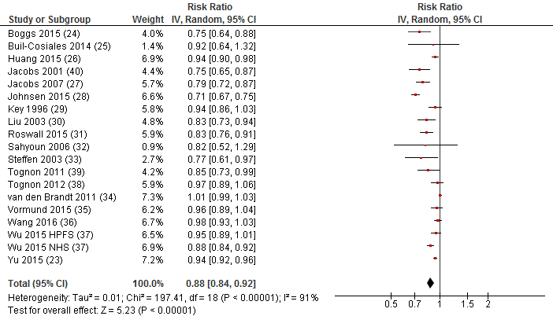
Supplemental Figure 1: Summary of risk ratio (RR) of all-cause mortality for high versus low whole grains intake. 95% CI, 95% conﬁdence interval; RR were calculated from random-effect models

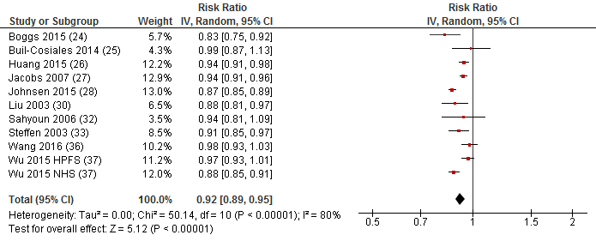
Supplemental Figure 2: Summary of risk ratio (RR) of all-cause mortality for each 30 g/d increase in whole grains intake. 95% CI, 95% conﬁdence interval; RR were calculated from random-effect models

Supplemental Figure 3: Funnel plot showing study precision against the relative risk with 95% CIs for whole grain intake (dose-response meta-analysis) and all-cause mortality. logRR, logarithm risk ratio; s.e., standard error; Egger test p=0.02

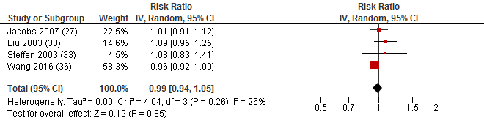
Supplemental Figure 4: Summary of risk ratio (RR) of all-cause mortality for high versus low refined grains intake. 95% CI, 95% conﬁdence interval; RR were calculated from random-effect models

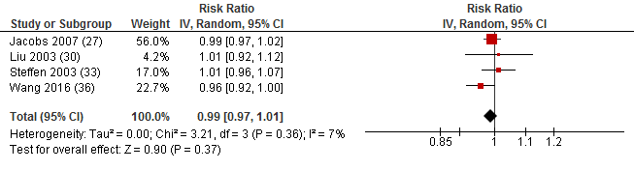
Supplemental Figure 5: Summary of risk ratio (RR) of all-cause mortality for each 30 g/d increase in refined grains intake. 95% CI, 95% conﬁdence interval; RR were calculated from random-effect models

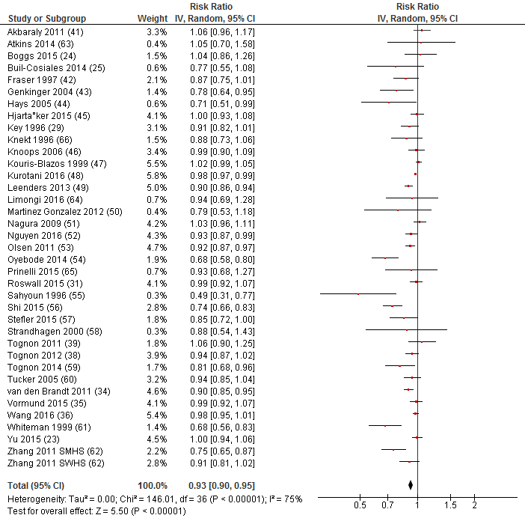
Supplemental Figure 6: Summary of risk ratio (RR) of all-cause mortality for high versus low vegetable intake. 95% CI, 95% conﬁdence interval; RR were calculated from random-effect models

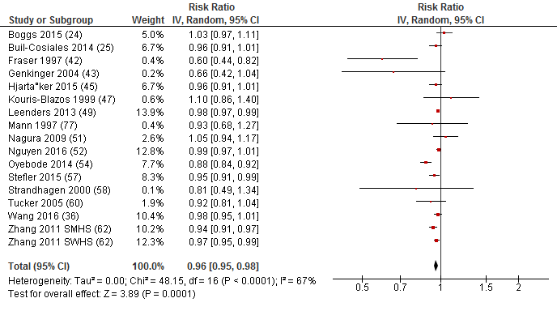
Supplemental Figure 7: Summary of risk ratio (RR) of all-cause mortality for each 100 g/d increase in vegetables intake. 95% CI, 95% conﬁdence interval; RR were calculated from random-effect models

Supplemental Figure 8: Funnel plot showing study precision against the relative risk with 95% CIs for vegetable intake (dose-response meta-analysis) and all-cause mortality. logRR, logarithm risk ratio; s.e., standard error. Egger test p=0.096
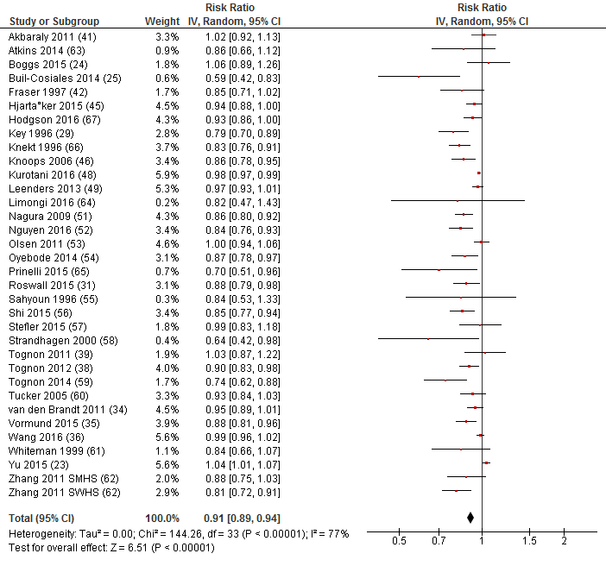
Supplemental Figure 9: Summary of risk ratio (RR) of all-cause mortality for high versus low fruit intake. 95% CI, 95% conﬁdence interval; RR were calculated from random-effect models
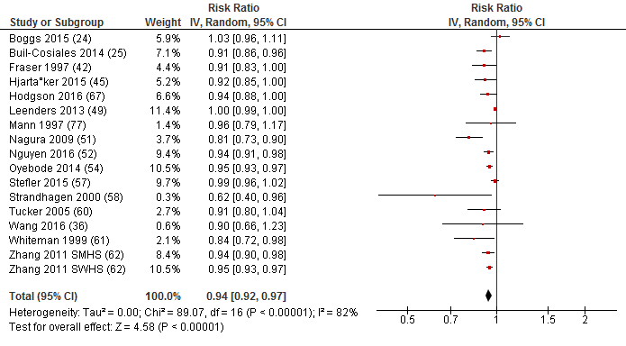
Supplemental Figure 10: Summary of risk ratio (RR) of all-cause mortality for each 100 g/d increase in fruit intake. 95% CI, 95% conﬁdence interval; RR were calculated from random-effect models

Supplemental Figure 11: Funnel plot showing study precision against the relative risk with 95% CIs for fruit intake (dose-response meta-analysis) and all-cause mortality. logRR, logarithm risk ratio; s.e., standard error. Egger test p<0.001

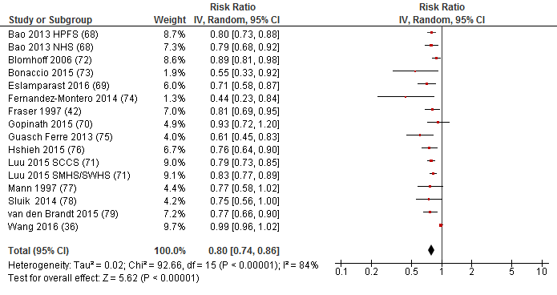
Supplemental Figure 12: Summary of risk ratio (RR) of all-cause mortality for high versus low nut intake. 95% CI, 95% conﬁdence interval; RR were calculated from random-effect models

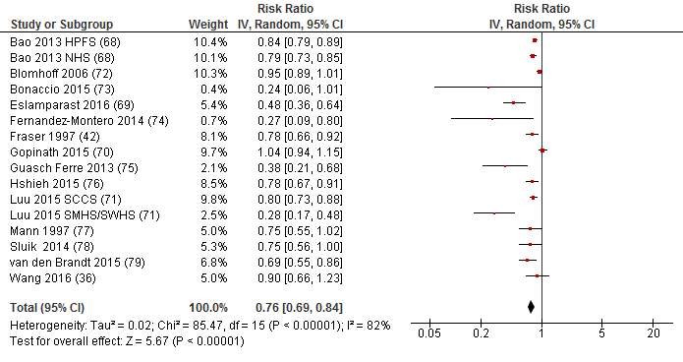
Supplemental Figure 13: Summary of risk ratio (RR) of all-cause mortality for each 28 g/d increase in nut intake. 95% CI, 95% conﬁdence interval; RR were calculated from random-effect models
Supplemental Figure 14: Funnel plot showing study precision against the relative risk with 95% CIs for nut intake (dose-response meta-analysis) and all-cause mortality. logRR, logarithm risk ratio; s.e., standard error. Egger test p<0.01

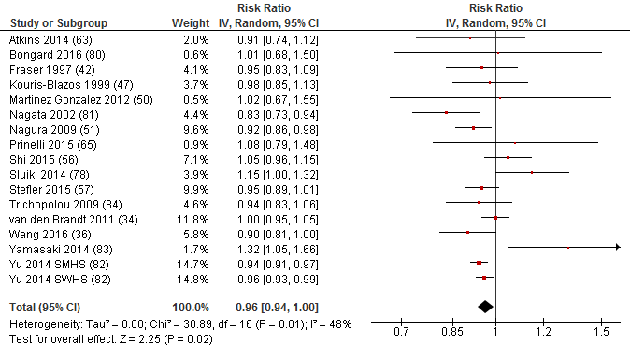
Supplemental Figure 15: Summary of risk ratio (RR) of all-cause mortality for high versus low legume intake. 95% CI, 95% conﬁdence interval; RR were calculated from random-effect models

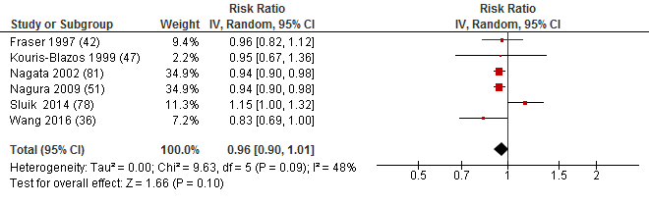
Supplemental Figure 16: Summary of risk ratio (RR) of all-cause mortality for each 50 g/d increase in legume intake. 95% CI, 95% conﬁdence interval; RR were calculated from random-effect models

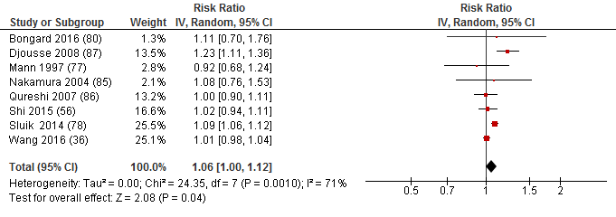
Supplemental Figure 17: Summary of risk ratio (RR) of all-cause mortality for high versus low egg intake. 95% CI, 95% conﬁdence interval; RR were calculated from random-effect models

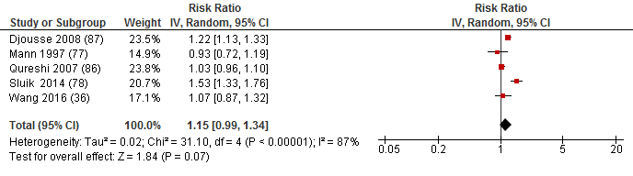
Supplemental Figure 18: Summary of risk ratio (RR) of all-cause mortality for each 50 g/d increase in egg intake. 95% CI, 95% conﬁdence interval; RR were calculated from random-effect models

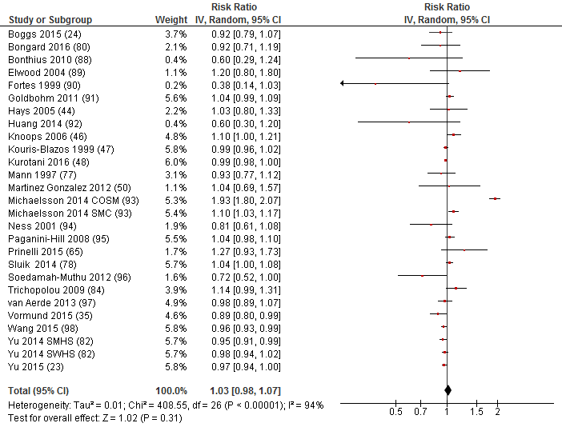
Supplemental Figure 19: Summary of risk ratio (RR) of all-cause mortality for high versus low dairy intake. 95% CI, 95% conﬁdence interval; RR were calculated from random-effect models

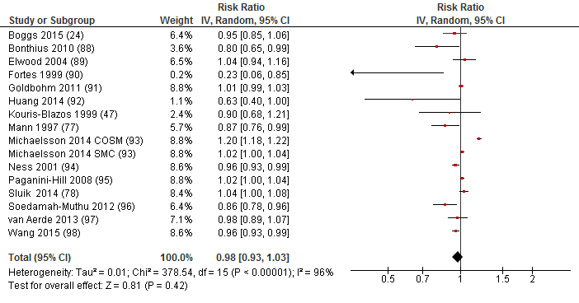
Supplemental Figure 20: Summary of risk ratio (RR) of all-cause mortality for each 200 g/d increase in dairy intake. 95% CI, 95% conﬁdence interval; RR were calculated from random-effect models

Supplemental Figure 21: Funnel plot showing study precision against the relative risk with 95% CIs for dairy intake (dose-response meta-analysis) and all-cause mortality. logRR, logarithm risk ratio; s.e., standard error. Egger test p=0.09
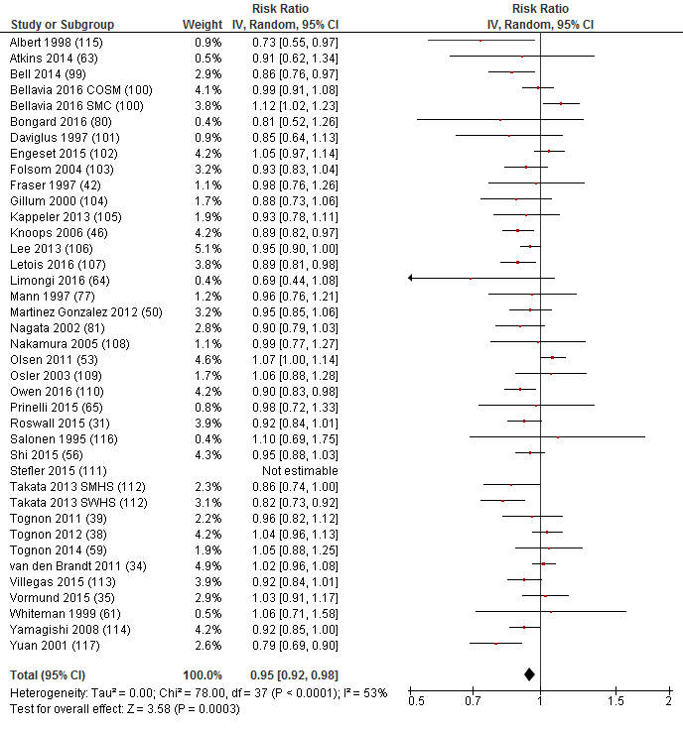
Supplemental Figure 22: Summary of risk ratio (RR) of all-cause mortality for high versus low fish intake. 95% CI, 95% conﬁdence interval; RR were calculated from random-effect models

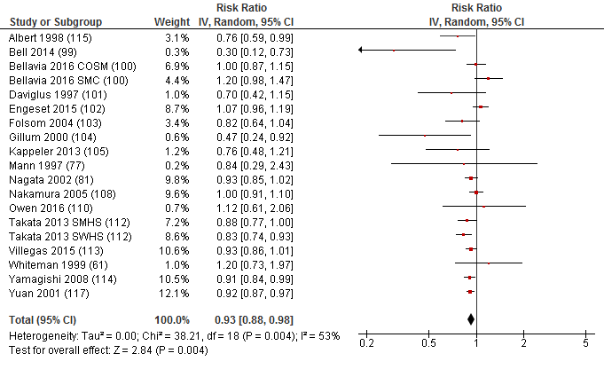
Supplemental Figure 23: Summary of risk ratio (RR) of all-cause mortality for each 100 g/d increase in fish intake. 95% CI, 95% conﬁdence interval; RR were calculated from random-effect models

Supplemental Figure 24: Funnel plot showing study precision against the relative risk with 95% CIs for fish intake (dose-response meta-analysis) and all-cause mortality. logRR, logarithm risk ratio; s.e., standard error. Egger test p=0.30

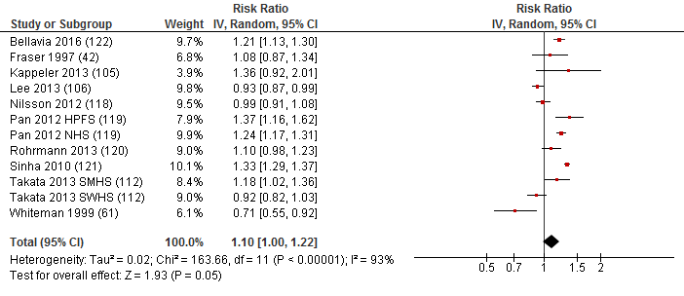
Supplemental Figure 25: Summary of risk ratio (RR) of all-cause mortality for high versus low red meat intake. 95% CI, 95% conﬁdence interval; RR were calculated from random-effect models

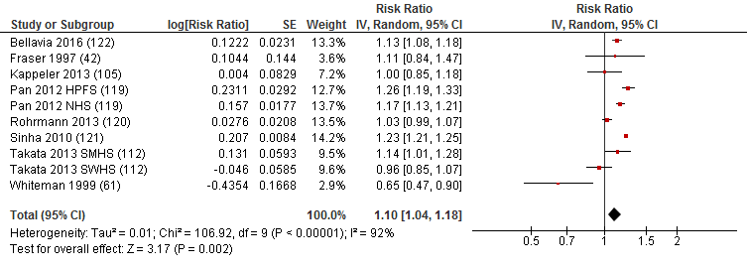
Supplemental Figure 26: Summary of risk ratio (RR) of all-cause mortality for each 100 g/d increase in red meat intake. 95% CI, 95% conﬁdence interval; RR were calculated from random-effect models

Supplemental Figure 27: Funnel plot showing study precision against the relative risk with 95% CIs for red meat intake (dose-response meta-analysis) and all-cause mortality. logRR, logarithm risk ratio; s.e., standard error. Egger test p=0.051

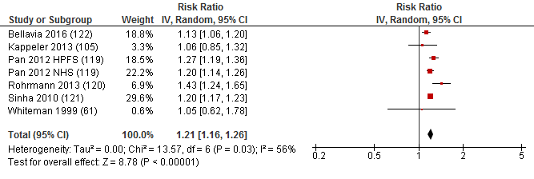
Supplemental Figure 28: Summary of risk ratio (RR) of all-cause mortality for high versus low processed meat intake. 95% CI, 95% conﬁdence interval; RR were calculated from random-effect models

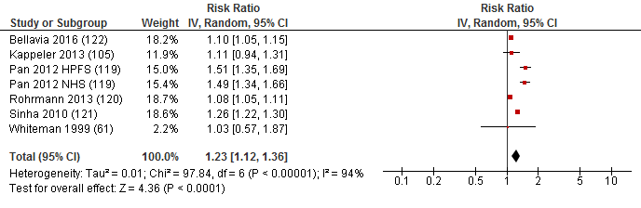
Supplemental Figure 29: Summary of risk ratio (RR) of all-cause mortality for each 50 g/d increase in processed meat intake. 95% CI, 95% conﬁdence interval; RR were calculated from random-effect models

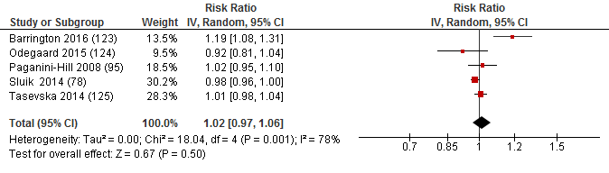
Supplemental Figure 30: Summary of risk ratio (RR) of all-cause mortality for high versus low sugar sweetened beverage intake. 95% CI, 95% conﬁdence interval; RR were calculated from random-effect models

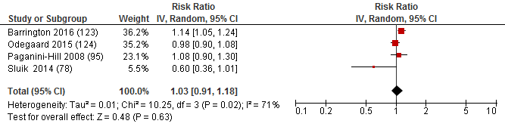
Supplemental Figure 31: Summary of risk ratio (RR) of all-cause mortality for 250 ml/d serving increase in sugar sweetened beverages intake. 95% CI, 95% conﬁdence interval; RR were calculated from random-effect models

