Table 3. Graphs

Analysis 3.1.1. Exercise treatment versus no treatment/waiting list controls: Pain intensity post-treatment
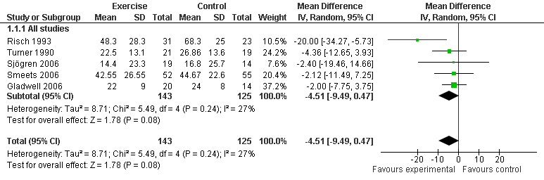

Analysis 3.1.2 Exercise treatment versus no treatment/ waiting list controls: disability post- treatment
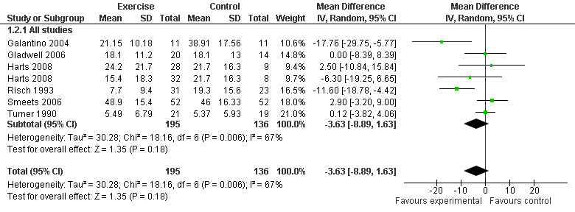

Analysis 3.1.3 Exercise treatment versus no treatment/waiting list controls: pain intensity intermediate (6 months or nearby) follow-up
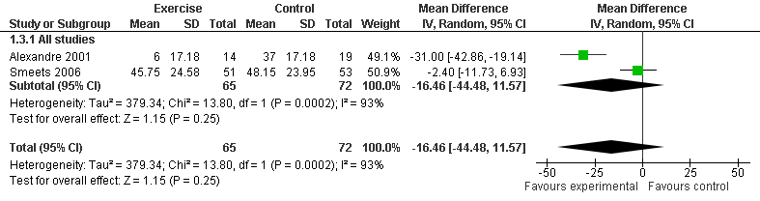

Analysis 3.2.1. Exercise therapy versus usual care: pain intensity post-treatment
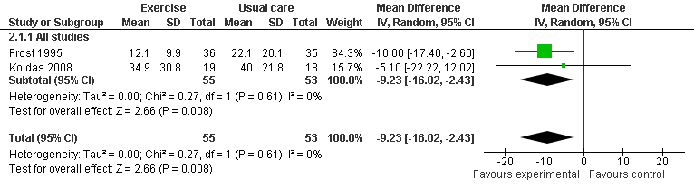

Analysis 3.2.2. Exercise therapy versus usual care: disability post-treatment
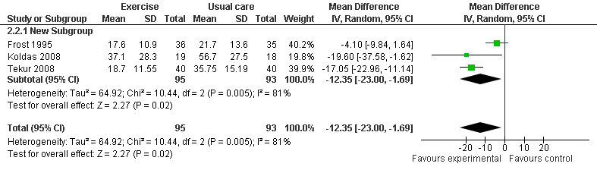

Analysis 3.2.3. Exercise therapy versus usual care: pain intensity long-term (12 months or nearby) follow-up
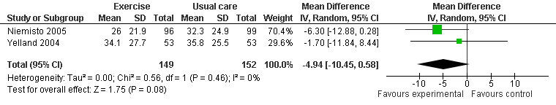

Analysis 3.2.4. Exercise therapy versus usual care: disability intermediate (6 months or nearby) follow-up
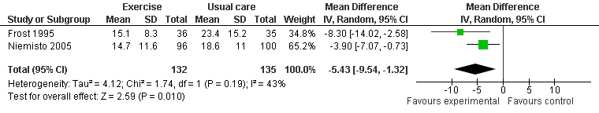

Analysis 3.2.5. Exercise therapy versus usual care: disability long-term (12 months or nearby) follow-up
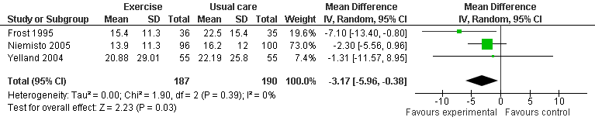

Analysis 3.3.1. Exercise therapy versus back school/education: disability post-treatment
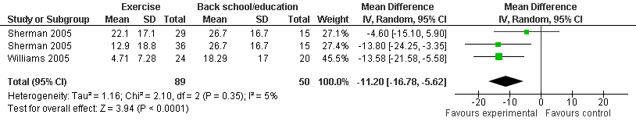

Analysis 3.3.2. Exercise therapy versus back school/education: pain intensity at short-term (3 months or nearby) follow-up
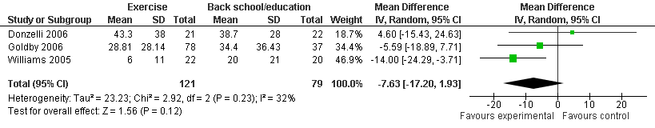

Analysis 3.3.3. Exercise therapy versus back school/ education: disability at short-term (3 months or nearby) follow-up
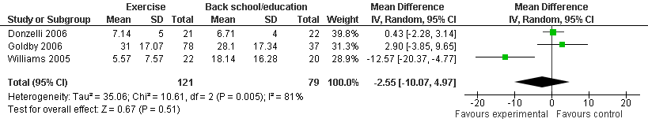

Analysis 3.3.4. Exercise therapy versus back school/education: pain intensity at intermediate (6 months or nearby) follow-up
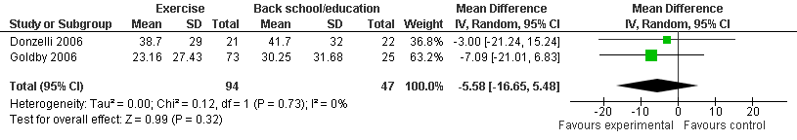

Analysis 3.2.5. Exercise therapy versus back school/ education: disability at intermediate (6 months or nearby) follow-up
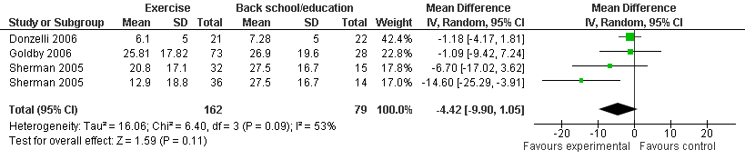

Analysis 3.3.1. Exercise therapy versus behavioural treatment: pain intensity post-treatment
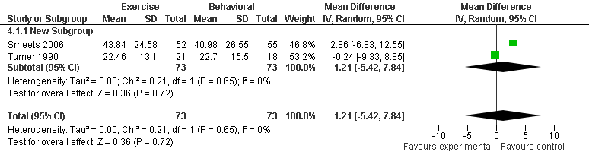

Analysis 3.3.2. Exercise therapy versus behavioural treatment: disability post-treatment
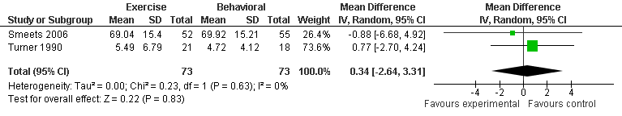

Analysis 3.3.3. Exercise therapy versus behavioural treatment: pain intensity at intermediate (6 months or nearby) follow-up
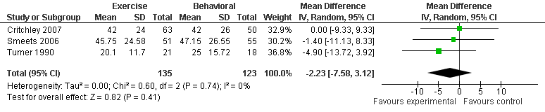

Analysis 3.3.4. Exercise therapy versus behavioural treatment: disability at intermediate (6 months or nearby) follow-up
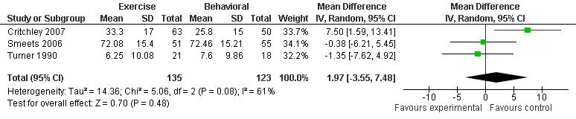

Analysis 2.3.3. Exercise therapy versus behavioural treatment: pain intensity at long-term (12 months or nearby) follow-up
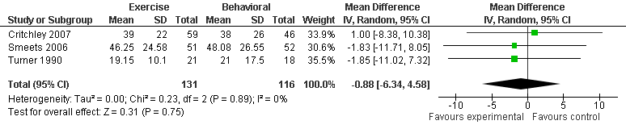

Analysis 3.3.5. Exercise therapy versus behavioural treatment: disability at long-term (12 months or nearby) follow-up
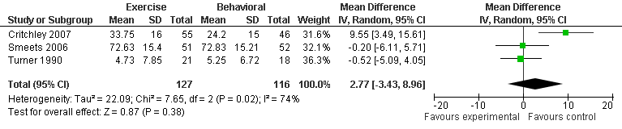

Analysis 3.4.1. Exercise therapy versus TENS/laser therapy/ultrasound/massage: pain intensity post- treatment
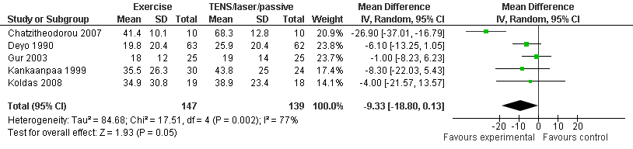

Analysis 3.4.2. Exercise therapy versus TENS/laser therapy/ultrasound/massage: disability post-treatment
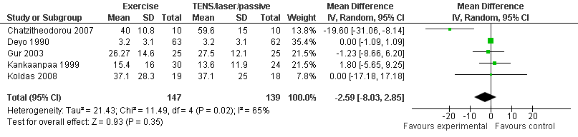

Analysis 3.4.3. Exercise therapy versus TENS/laser therapy/ultrasound/massage: pain intensity at short-term (3 months or nearby) follow-up
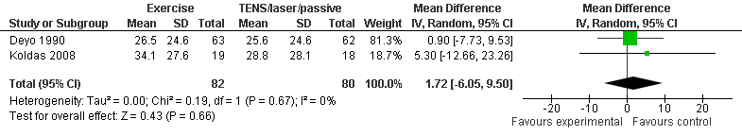

Analysis 3.4.4. Exercise therapy versus TENS/laser therapy/ultrasound/massage: disability at short- term (3 months or nearby) follow-up
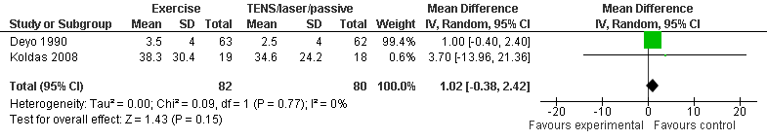

Analysis 3.5.1. Exercise therapy versus manual therapy/manipulation: pain intensity post-treatment

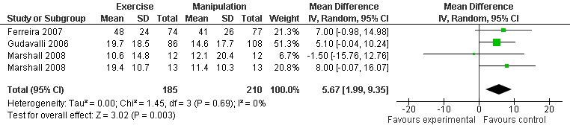

Analysis 3.5.2 Exercise therapy versus manual therapy/manipulation: disability post-treatment
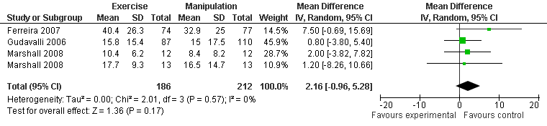

Analysis 2.5.2. Exercise therapy versus manual therapy/manipulation: pain intensity at short-term (3 months or nearby) follow-up
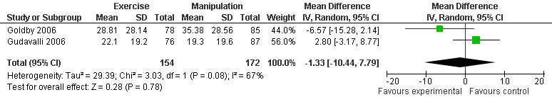

Analysis 3.5.3. Exercise therapy versus manual therapy/manipulation: disability at short-term (3 months or nearby) follow-up
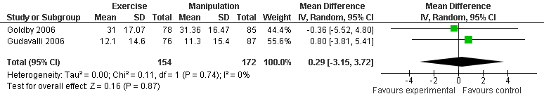

Analysis 3.5.4. Exercise therapy versus manual therapy/manipulation: pain intensity at intermediate (6 months or nearby) follow-up
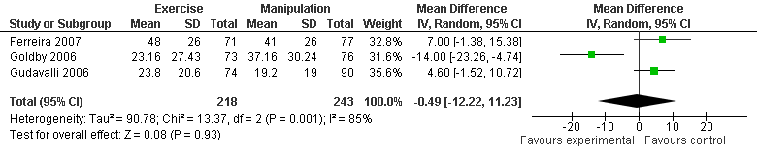

Analysis 3.5.5. Exercise therapy versus manual therapy/manipulation: disability at intermediate (6 months or nearby) follow-up
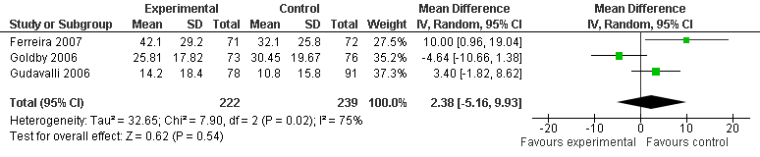

Analysis 3.5.6. Exercise therapy versus manual therapy/manipulation: pain intensity at long-term (12 months or nearby) follow-up
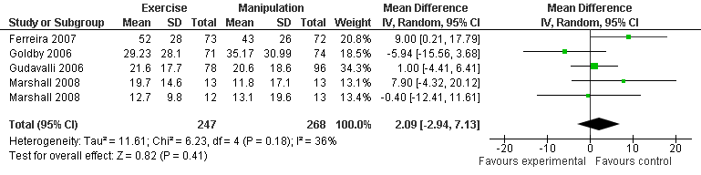

Analysis 2.5.8. Exercise therapy versus manual therapy/manipulation: disability at long-term (12 months or nearby) follow-up
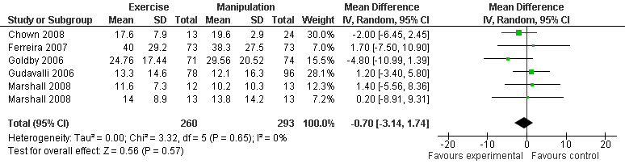

Analysis 3.6.1. Back school versus waiting list controls/ no treatment/ usual care: pain intensity post-treatment
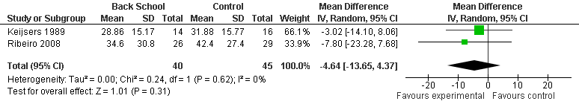

Analysis 3.6.2. Back school versus waiting list controls/ no treatment/ usual care: disability at short- term (3 months or nearby) follow-up

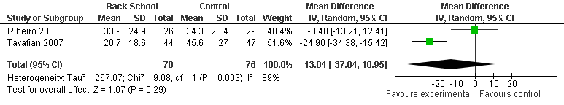

Analysis 3.7.1. Back school versus active treatment: pain intensity at short-term (3 months or nearby) follow-up
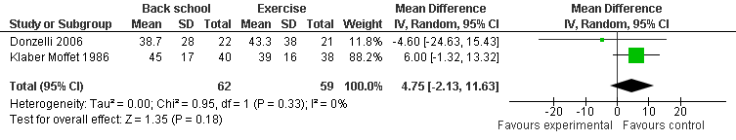

Analysis 3.7.2. Back school versus active treatment: disability at short-term (3 months or nearby) follow-up
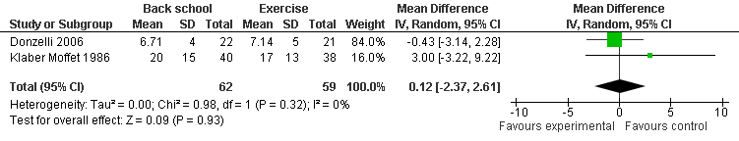

Analysis 3.7.3. Back school versus active treatment: pain intensity at intermediate (6 months or nearby) follow-up
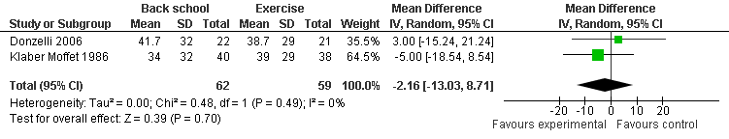

Analysis 3.7.4. Back school versus active treatment: disability at intermediate (6 months or nearby) follow-up
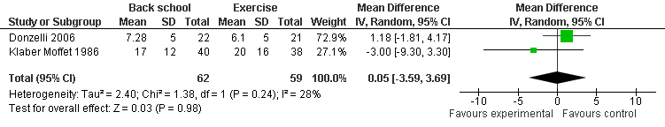

Analysis 3.8.1. TENS versus sham treatment: pain intensity post-treatment
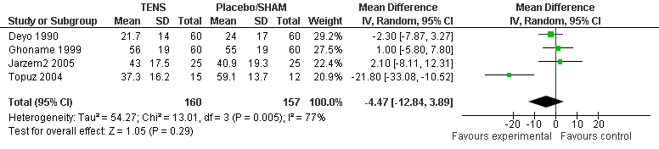

Analysis 3.8.2. TENS versus sham treatment: disability post-treatment
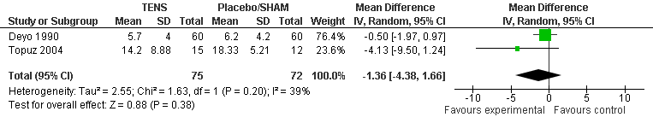

Analysis 3.9.1. TENS versus PENS/acupuncture: pain intensity post-treatment
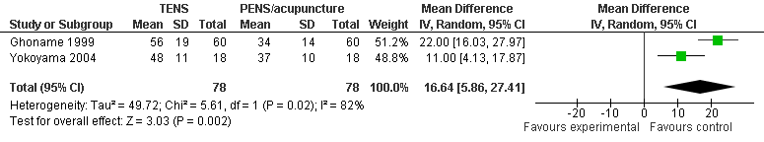

Analysis 3.9.2. TENS versus PENS/acupuncture: pain intensity short-term (3 months or nearby) follow-up
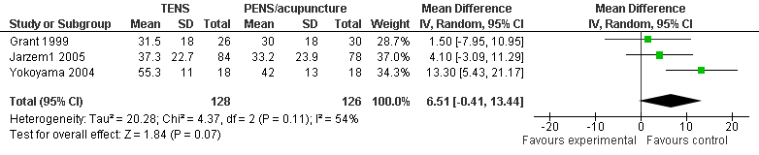

Analysis 3.10.1. Low Level Laser therapy (LLLT) + exercise versus SHAM LLLT + exercise: pain intensity at short-term follow-up
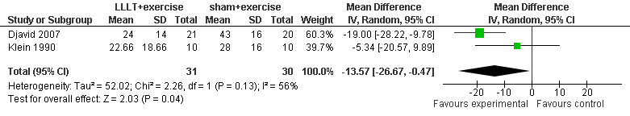

Analysis 3.10.2. Low Level Laser therapy (LLLT) + exercise versus SHAM LLLT + exercise: disability at short-term follow-up
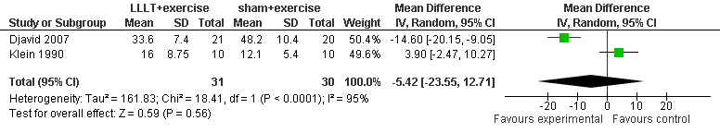

Analysis 3.11.1. Patient education versus active non-educational interventions: pain intensity at intermediate (6 months or nearby) follow-up
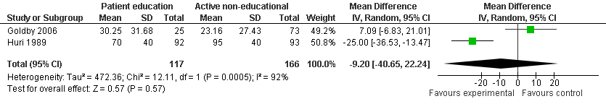

Analysis 3.11.2. Patient education versus active non-educational interventions: disability at intermediate (6 months or nearby) follow-up
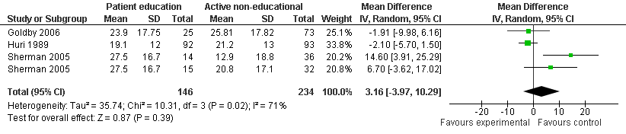

Analysis 3.11.3. Patient education versus active non-educational interventions: pain intensity at long- term (12 months or nearby) follow-up
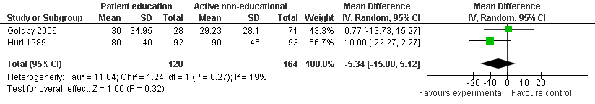

Analysis 3.11.4. Patient education versus active non-educational interventions: disability at long-term (12 months or nearby) follow-up
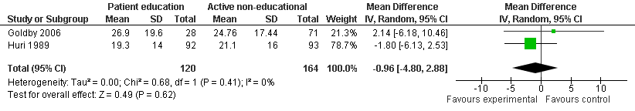

Analysis 3.12.1. Massage versus passive treatments: pain intensity post-treatment
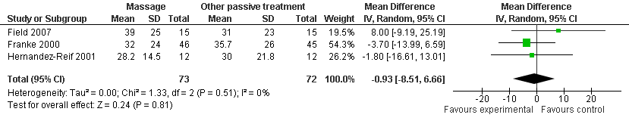

Analysis 3.13.1. Behavioural treatment versus no treatment/ waiting list controls/ placebo: pain intensity post-treatment
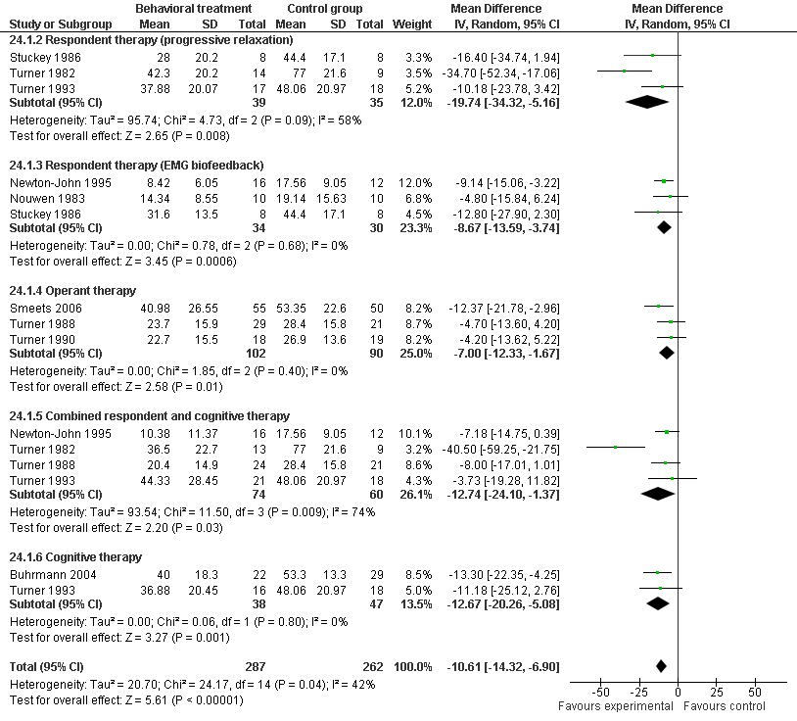

Analysis 3.13.2. Behavioural treatment versus no treatment/ waiting list controls/ placebo: disability post-treatment
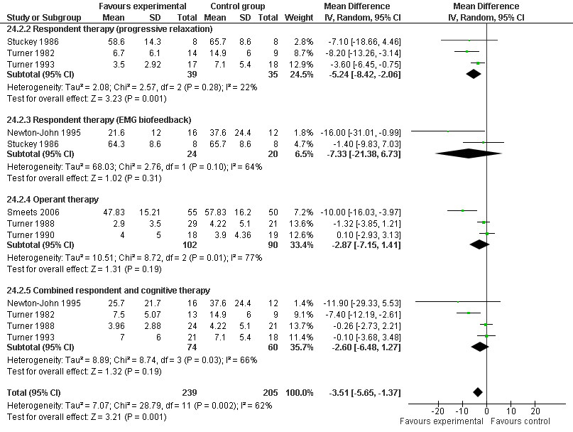

Analysis 3.14.1. Behavioral treatment in addition to another treatment versus the other treatment alone: pain intensity post-treatment
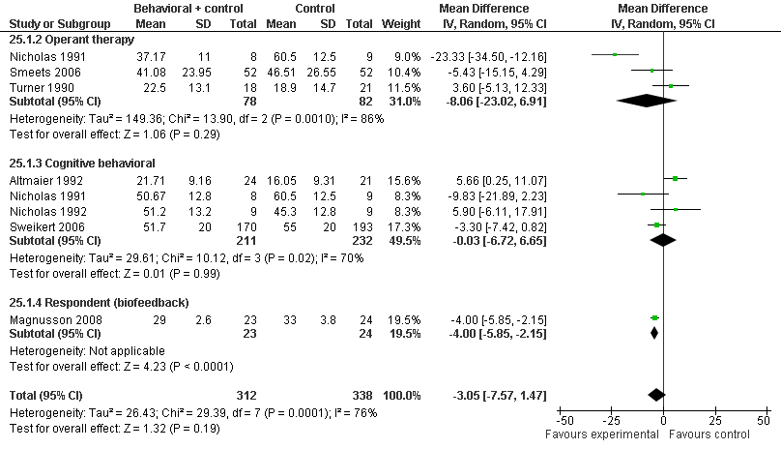

Analysis 3.14.2. Behavioral treatment in addition to another treatment versus the other treatment alone: disability post-treatment
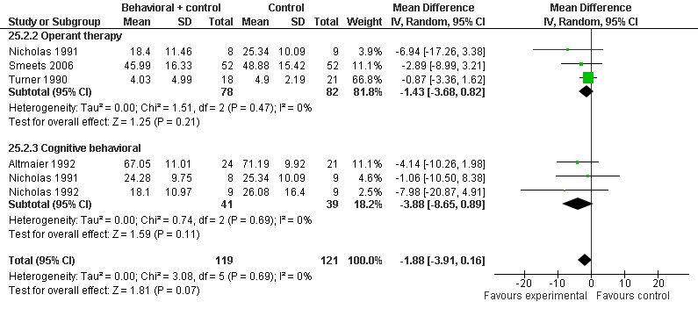

Analysis 3.14.3. Behavioral treatment in addition to another treatment versus the other treatment alone: pain intensity during intermediate (6 months or nearby) follow-up

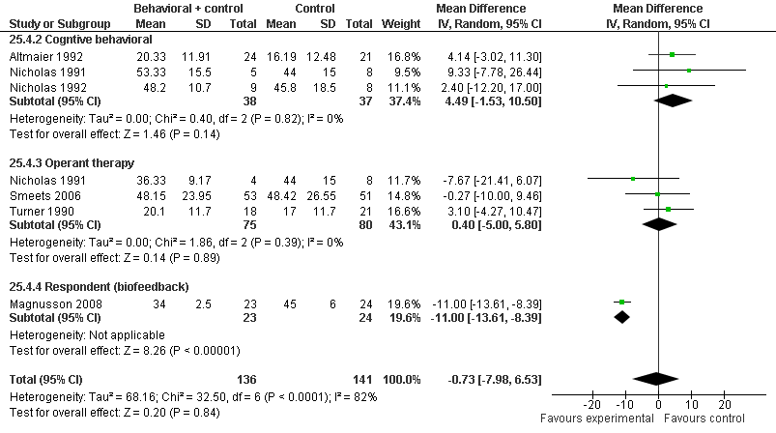

Analysis 3.14.4. Behavioral treatment in addition to another treatment versus the other treatment alone: disability intermediate (6 months or nearby) follow-up
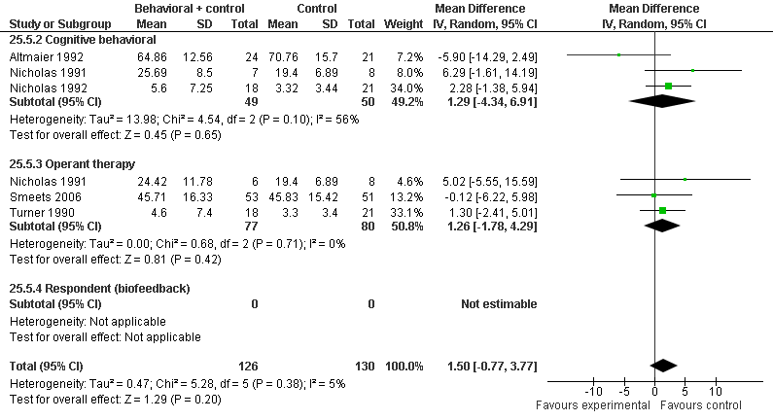

Analysis 3.14.5. Behavioral treatment in addition to another treatment versus the other treatment alone: pain intensity during long-term (12 months or nearby) follow-up

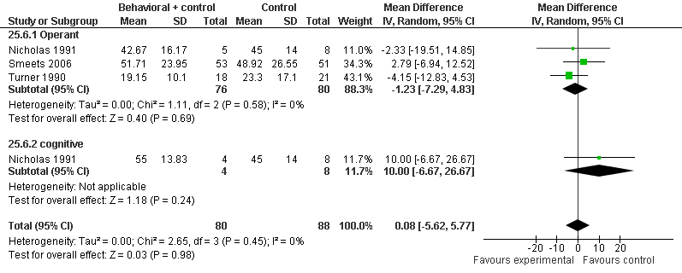

Analysis 2.14.7. Behavioral treatment versus other kinds of treatment: disability intermediate (6 months or nearby) follow-up
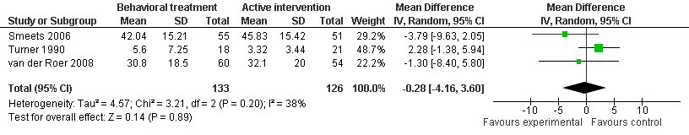

Analysis 3.14.8. Behavioral treatment in addition to another treatment versus the other treatment alone: disability long-term (12 months or nearby) follow-up
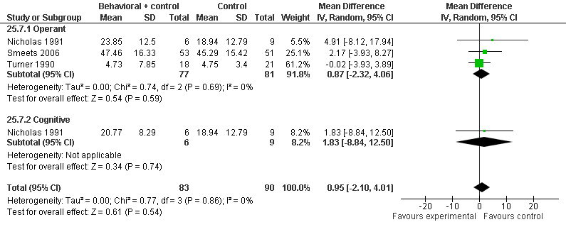

Analysis 3.15.1. Behavioral treatment versus other kinds of treatment: pain intensity post-treatment
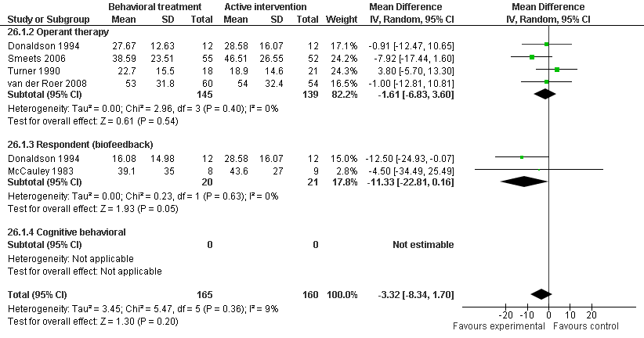

Analysis 3.15.2. Behavioral treatment versus other kinds of treatment: disability post-treatment
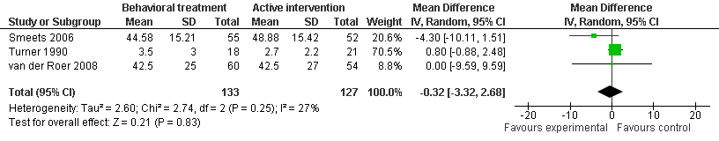

Analysis 3.15.3. Behavioral treatment versus other kinds of treatment: pain intensity short-term (3 months or nearby) follow-up
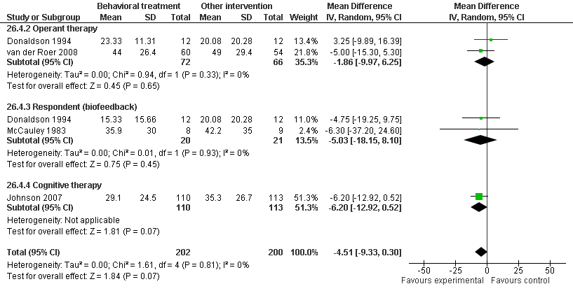

Analysis 3.15.4. Behavioral treatment versus other kinds of treatment: disability short-term (3 months or nearby) follow-up
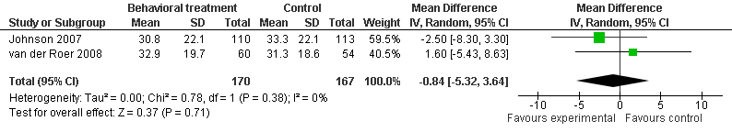

Analysis 3.15.5. Behavioral treatment versus other kinds of treatment: pain intensity intermediate (6 months or nearby) follow-up
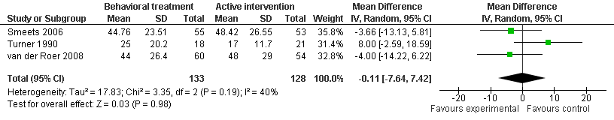

Analysis 3.15.6. Behavioral treatment versus other kinds of treatment: pain intensity long-term (12 months or nearby) follow-up
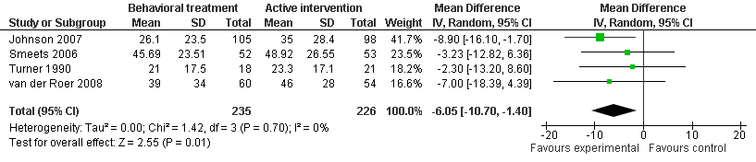

Analysis 3.15.7. Behavioral treatment versus other kinds of treatment: disability long-term (12 months or nearby) follow-up
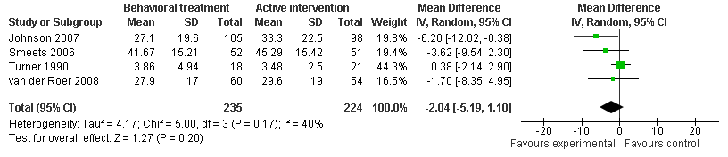

Analysis 3.16.1. Comparison among different types of behavioural treatment: pain intensity post-treatment
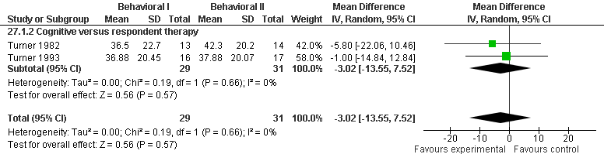

Analysis 3.16.2. Comparison among different types of behavioural treatment: disability post-treatment
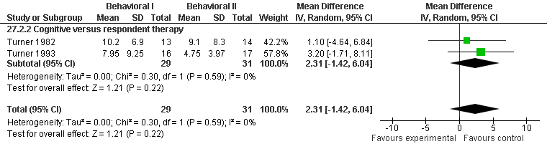

Analysis 3.17.1. Multidisciplinary treatment versus no treatment/ waiting list controls: pain intensity at short-term (3 months or nearby) follow-up
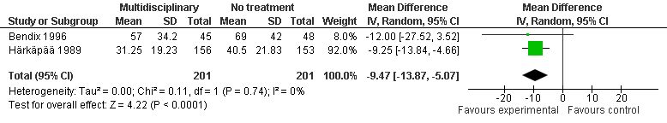

Analysis 3.17.2. Multidisciplinary treatment versus no treatment/ waiting list controls: disability at short-term (3 months or nearby) follow-up
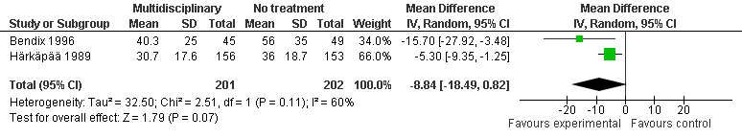

Analysis 3.17.3. Multidisciplinary treatment versus no treatment/ waiting list controls: pain intensity at long-term (12 months or nearby) follow-up
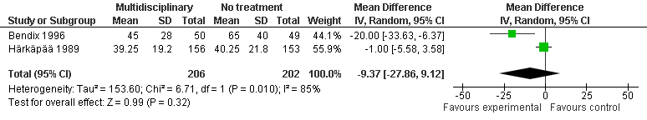

Analysis 3.17.4. Multidisciplinary treatment versus no treatment/ waiting list controls: disability at long-term (12 months or nearby) follow-up
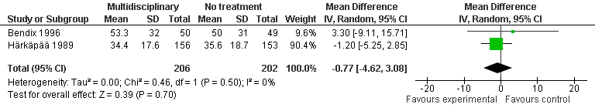

Analysis 3.18.1. Multidisciplinary treatment versus other kinds of active treatment: pain intensity at short-term (3 months or nearby) follow-up
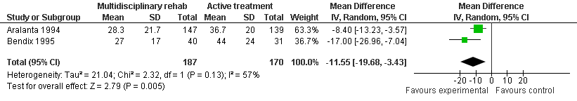

Analysis 3.18.2. Multidisciplinary treatment versus other kinds of active treatment: pain intensity at long-term (12 months or nearby) follow-up
