PHYSICAL EXAMINATION

Patient |  |  |  |  | DOB |  |  |  | M / F |  | Date |  |  |  |  | Doctor
Pulse: | L |  | R | Blood pressure |  | L  / |  | R  / |  | VBI: |  | L | R |  | Carotid / Sublcavian Auscultation |  |  | L | R

Temperature |  | Respiration |  | Height |  | Weight

CHIEF COMPLAINT

Development | Poor | Fair | Good

Posture ____________________________________

Gait _______________________________________

ACTIVE RANGE OF MOTION

Lumbar
Flexion (90)
Extension (30)
Lateral flexion (20)
Rotation (30)
Cervical
Flexion (45)
Extension (55)
Lateral flexion (45)
Rotation (70)
Shoulder
Flexion (180)
Extension (40)
Internal rotation (70)
External rotation (90)
Abduction (180)
Adduction (30)

TMJ AROM: _____________________

CRANIAL NERVES:
I  II - periph. vision  III, IV, VI - field. of gaze  V, VII - corneal reflex  VIII - watch  Weber  Rinne | II - light  III - accomodation  V - bite  VII - facial expression  IX, X - ahh  XI - trap, SCM  XII - tongue

PALPATION:
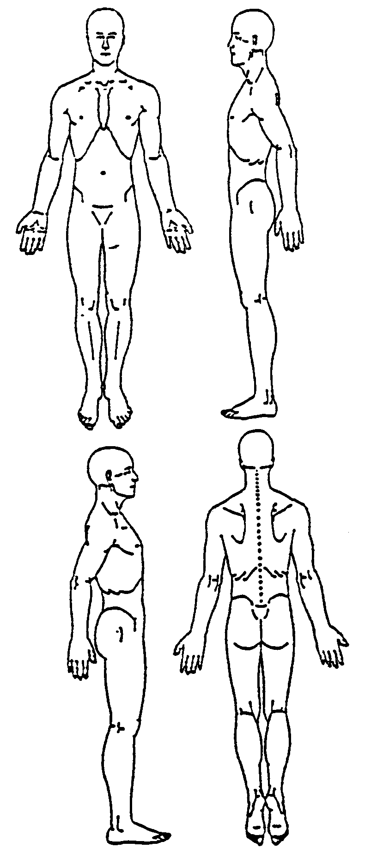

skin, temp, temp of extremities, moisture. Describe:

(circle) hamstrings, TFL, piriformis, gluteus maximus, gluteus, medius, SI, gastro-soleus, paraspinals, quadratus lumborum, other
Describe:

(circle) Parotid, masseters, thyroid, trachea, lymph nodes, SCM, suboccipitals, posterior cervical, trapezius, levator scapula.
Describe:

 |  |  | ABDOMEN |  |  |  | SENSORY |  |  |  | MOTOR
 |  |  | observation |  |  |  | - face |  |  |  | Deltoid C5, C6 (axillary)
 |  |  | auscultation |  |  |  | Light touch |  |  |  | Biceps C5, C6 (musculocutaneous)
 |  |  | percussion |  |  |  | Sharp / Dull |  |  |  | Brachioradialis C6, C7, C8 (radial)
 |  |  | palpation |  |  |  |  |  |  |  | Triceps C6, C7, C8, T1 (radial)
 |  |  | strength |  |  |  | - upper extremity |  |  |  | Wrist extensors C6, C7, C8 (radial)
 |  |  | Beevor’s sign |  |  |  | Light touch |  |  |  | Wrist flexors C6, C7 (ulnar, median)
 |  |  | inguinal nodes |  |  |  | Sharp / Dull |  |  |  | Finger flexors C7, C8, T1 (ulnar, median)
 |  |  | ASIS |  |  |  | Vibration |  |  |  | Interossei C7, C8, T1 (ulnar)
 |  |  |  |  |  |  |  |  |  |  | Tibialis anterior L4, L5 (deep peroneal)
 |  |  | FEET |  |  |  | - lower extremity |  |  |  | Extensor hallicus long. L4, L5, S1 (deep peron.)
 |  |  | dorsal pedal pulse |  |  |  | Light touch |  |  |  | Peronius long. L5, S1 (superficial peroneal)
 |  |  | posterior tibial pulse |  |  |  | Sharp / Dull
 |  |  | internal rotation |  |  |  | Vibration
 |  |  | external rotation
 |  |  |  |  |  |  | REFLEXES
 |  |  | Babinski |  |  |  | Patellar L2, L3, L4 (femoral) |  |  |  | Biceps C5, C6 (musculocutaneous)
 |  |  |  |  |  |  | Achilles S1, S2 (tibial) |  |  |  | Brachioradialis C6, C7, C8 (radial)
 |  |  |  |  |  |  |  |  |  |  | Triceps C6, C7, C8, T1 (radial)

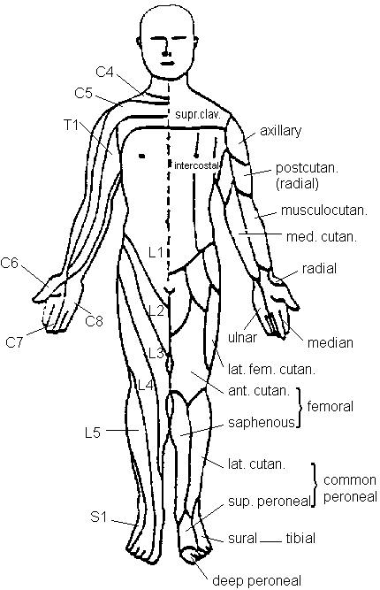 | 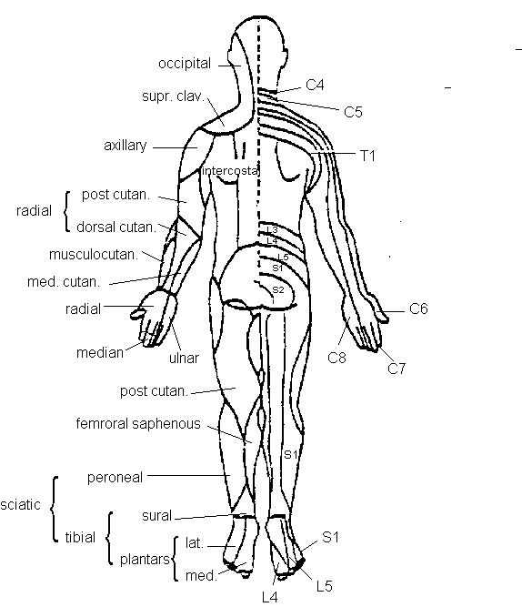 | Segmental Motion  __ C0 __  __ C1 __  __ C2 __  __ C3 __  __ C4 __  __ C5 __  __ C6 __  __ C7 __  __ __ T1 __ __  __ __ T2 __ __  __ __ T3 __ __  __ __ T4 __ __  __ __ T5 __ __  __ __ T6 __ __  __ __ T7 __ __  __ __ T8 __ __  __ __ T9 __ __  __ __ T10 __ __  __ __ T11 __ __  __ __ T12 __ __  __ L1 __  __ L2 __  __ L3 __  __ L4 __  __ L5 __  __ SI __  coccyx

 |  |  | heel walk L3, L4, L5 |  |  |  | SLR active | OTHER TESTS
 |  |  | toe walk S1 |  |  |  | DSLR
 |  |  | squat / rise |  |  |  | SLR passive (Lasegue’s)
 |  |  | finger to nose |  |  |  | Braggard’s
 |  |  | arm drop |  |  |  | Goldthwait’s
 |  |  | Adam’s sign |  |  |  | Patrick Fabere’s
 |  |  | Trendelenburg |  |  |  | Thomas
 |  |  | Cervical resistive muscle tests |  |  |  | Gaenslen’s
 |  |  | Cervical compression neutral, max L, R |  |  |  | Hip circumduction
 |  |  | Cervical distraction |  |  |  | SI distraction
 |  |  | Shoulder depression |  |  |  | Active hip abduction
 |  |  | Adson’s (anterior scalene) |  |  |  | Allis (>, <, =)
 |  |  | Eden’s (costoclavicular) |  |  |  | leg length (visualized)
 |  |  | Wright’s (pectoralis minor) |  |  |  | hip internal rotation
 |  |  | Spinous percussion |  |  |  | hip external rotation
 |  |  | Kemp’s (standing / seated) |  |  |  | active hip extension
 |  |  | Active cervical flexion (supine) |  |  |  | Nachlas, Ely’s, Hibb’s
 |  |  | Cervical PROM |  |  |  | Yeoman’s
 |  |  | Soto Hall / Brudzinski’s |  |  |  | SI provocation

